
<TOOLNAME> Design Report

Draft Version 1.1
Author: <YOUR NAME HERE>
LAMS INTERNATIONAL
<DD>/<MM>/<YEAR>

Revision History
Name | Date | Reason For Changes | Version
<Author> | DD Mon YYYY | Initial Draft | 1.1

Contents
1 Introduction 1
1.1 Scope 1
1.2 What need to be designed 1
1.3 Constraints 1
2 Functional model 2
2.1 Use Case Diagram 2
2.2 Use Cases 3
3 Presentation Tier Design 5
3.1 Learner Side Page Flow 5
3.2 Monitor Side Page Flow 5
3.3 GUI layout 6
3.4 Struts Work Flow Diagram 6
4 Business Model of <Tool NAme> 7
4.1 <Tool Name> Class Diagram 7
5 Run time data model 9
5.1 Database schema 9
5.2 Data Definition 10
5.3 Hibernate Value Object Model 11
6 Tool API 12
7 Design Export/Import 13
8 Portfolio Export 14

Figure 1 <NAME OF TOOL> Use Case Diagram 2
Figure 2 Learner Side Page Flow 5
Figure 3 Monitor Side page flow 5
Figure 4 <Page Title> 6
Figure 5 Struts work flow diagram 6
Figure 6 Survey tool business class diagram 7
Figure 7 Database schema for runtime data model 9
Figure 8 Hibernate value object diagram 11

Introduction

Scope
Describe the scope of this document. Example:
This document is design to illustrate the system design of survey tool and technology choices will be adopted for the development. It is not aim to explain the functionalities of survey tool because Ernie’s use case document already acts as a good feature guideline. Instead, it will capture the requirements into a use case diagram to clarify the design. Please consult Ernie’s document to understand what survey tool is trying to achieve.

What need to be designed
This describes what will be described in this document when the design is completed. Example:
To build a tool in LAMS from scratch, we need to consider the design from two perspectives. First of all, the author side allows the user to create and modify the design of the survey that learner needs to conduct at learner side. According to current LAMS system model, the data model of authoring is separated from learner side due to its static nature. The content package includes all related class fro current LAMS static data model. Survey tool will have to extend the content model to introduce new data structure. Based on the content data model, we need to generate XML library which provide the data structure that will be used by Flash to create Flash GUI.
Secondly, we need to design the runtime time data model and JSP interface for leaner side as well as monitor side. A set of sequence diagrams will be created according to Ernie’s use case document. Complex domain object will be explained using state diagram if necessary.

Constraints
Constraints on the design. You do not need to document the general constraints on LAMS. So you do not need to specify that it must be usable in Firefox, Internet Explorer and Safari. Example:
The design is based on LAMS 6.1 system design. Therefore, the data model and technologies that will be adopted are constrained by the current system design. For example, we want to introduce the latest framework, such as Struts 1.2.4. But it might not be feasible due to incompatibility of existing LAMS code.

Functional model

Use Case Diagram

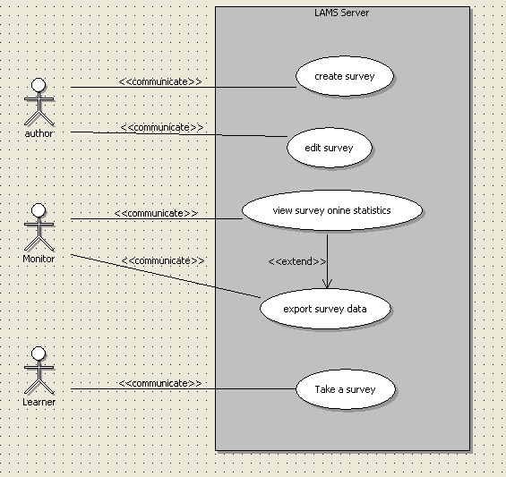
Figure 1 <NAME OF TOOL> Use Case Diagram

Use Cases
Primary Actor | Use Cases
Teacher | Create a learning design with …..
Learner | Participate in a learning design …..

Use Case ID: | LAMS1.1_<toolid>0001
Use Case Name: | Create a learning design with …..
Created By: | <Author> | Last Updated By:
Date Created: | <Date> | Date Last Updated:

Actors: | Teacher
Description:
Preconditions: | - Teacher is logged in, is in the authoring environment and is editing a learning design.
Postconditions:
Normal Flow: | - Teacher selects the <tool name>.  - <rest of steps for setting up tool content>.
Alternative Flows:
Exceptions:
Includes:
Priority:
Frequency of Use:
Business Rules:
Special Requirements:
Assumptions:
Notes and Issues:

Use Case ID: | LAMS1.1_<toolid>0002
Use Case Name: | Participate in a learning design …..
Created By: | <Author> | Last Updated By:
Date Created: | <Date> | Date Last Updated:

Actors: | Learner
Description:
Preconditions: | - Teacher is logged in, is in the authoring environment and is editing a learning design.
Postconditions:
Normal Flow: | - Teacher selects the <tool name>.  - <rest of steps for setting up tool content>.
Alternative Flows:
Exceptions:
Includes:
Priority:
Frequency of Use:
Business Rules:
Special Requirements:
Assumptions:
Notes and Issues:

Presentation Tier Design

Learner Side Page Flow
Example:
Following diagram illustrate the page flow design of learner side page flow.
Consent Page
Question Page
Summary Page
Accept
Submit
Decline
Next Task
Cancel
Figure 2 Learner Side Page Flow

Monitor Side Page Flow
Example:
Contribute Page
Html Survey Report
Export Page
View stats
Export
Question Report
Figure 3 Monitor Side page flow

GUI layout
All html prototypes are created inside prototype folder. Please open the page in browser to get real look and feel. Following are the screen shot of the pages:
<screenshot here>
Figure 4 <Page Title>
<Each screen shot must have its Figure number, so that it appears in the table of figures.>

Struts Work Flow Diagram
Example:
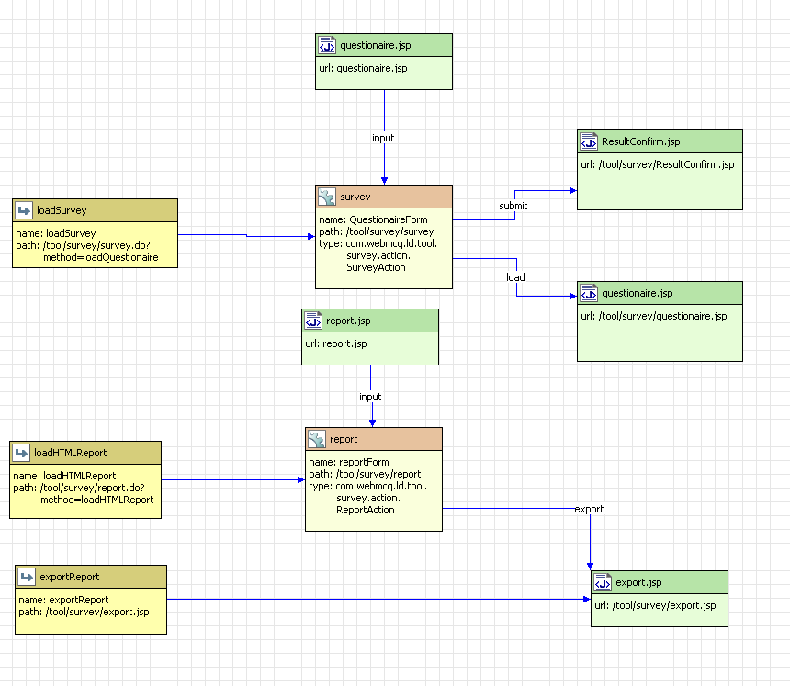
Figure 5 Struts work flow diagram

This diagram illustrates the page flow design and front controller design from Struts’ point of view. Both action servlets are designed to be Dispatch action so as to categorize the requests handling into action class.

Business Model of <Tool NAme>

<Tool Name> Class Diagram
Example:
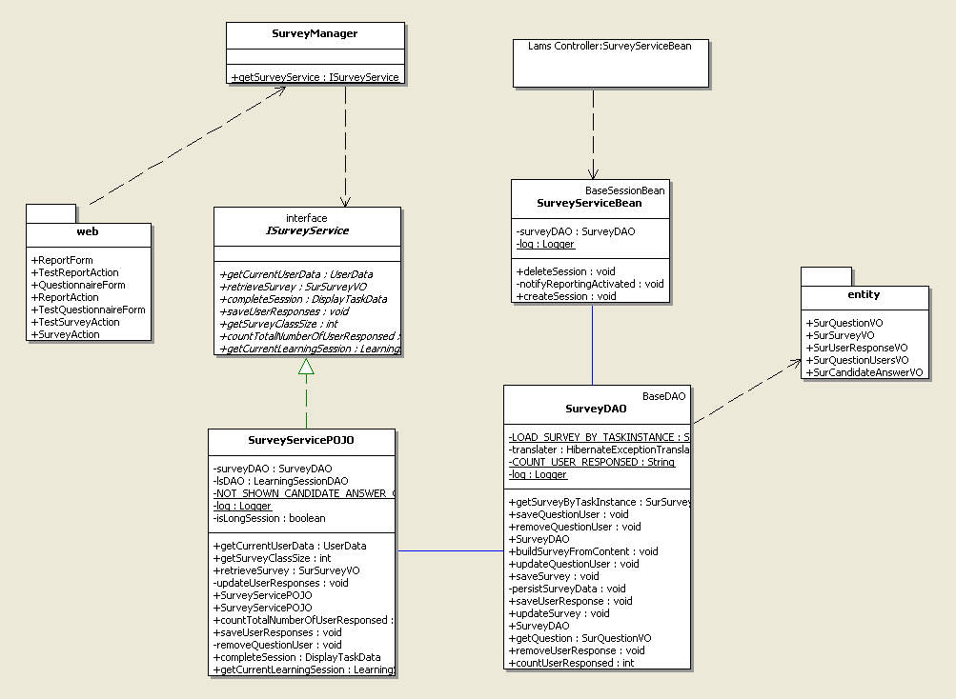
Figure 6 Survey tool business class diagram
This diagram gives us a picture of the business logic layer architecture of survey tool. The “SurveyManager” is designed to separate the coding logic between presentation tier and business layer completely. It will return an instance of survey service holder to presentation tier. Presentation tier will not be able to know how this instance is constructed. Therefore, we can plug in entirely new business layer implementation without changing a single line of Struts action servlet in the future.
The “ISurveyService” interface defines the contract that any survey service provider needs to follow. Currently, I provide a POJO implementation. But this implementation can be easily switched to EJB implementation or even WebService implementation if necessary.
SurveyServiceBean is design to follow the current LAMS controller model. It implements ToolEJBRomte contract. In this architecture, this service bean serves as a bridge between tools and LAMS controller rather than the session façade of survey tool. Arguably, the completeSession should be the controller logic rather than tool service. Considering it is only a delegation to LearnerServiceBean, it is not a big deal to move it controller layer in the future. I leave it in the tool service layer to make it consistent with all other tool implementations.
Finally, the “SurveyServiceDAO” is a database service façade of survey tool. It is used by business layer to achieve standard CRUD database operations. It probably needs to be further break down into separate dao for every value object with the grown of survey tool in the future. But refactoring won’t be hard because it have been separate cleanly as a standard alone data access layer. I believe no architecture will be correct forever because the user requirement is ever changing.

Run time data model

Database schema
Example:
The schema listed in this document ignores the dependency of survey tool on other lams system tables. To understand these dependencies, please study the lams database model.

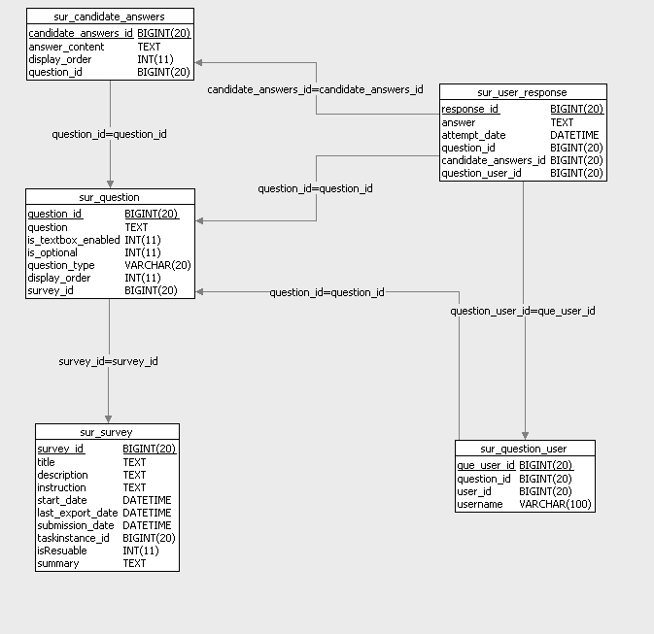
Figure 7 Database schema for runtime data model

Data Definition
Sur_survey
FIELD | Type | Length | Description
Survey_id | long | n/a | Survey id (primary key)
Title | text | n/a | The title defined by the author
Description | Text | n/a | The description defined by the author
Instruction | Text | n/a | The instruction created by the author.
Start_date | Date | n/a | The time that learner start the survey task
Last_export_date | Date | n/a | The last time that the survey was exported
Submission_date | Date | n/a | The time that the learner submit the survey
Taskinstance_id | Long | n/a | The reference to the taskinstance table, which record all runtime tool instances for learner side.
isResuable | Int | n/a | Can survey tool been reused after learner finished task. 0 indicate false and 1 indicate true.
Summary | Text | n/a | The survey conclusion defined by the author. It will be shown when leaner submit the survey.

Sur_question
FIELD | Type | Length | Description
Question_id | long | n/a | question id (primary key)
Question | text | n/a | The content of the question
Survey_id | Long | n/a | The reference to the survey table. One survey record referenced by many question record.(many to one)
Is_optional | Int | n/a | The column to tell valuator whether this question is optional.
Is_textbox_enabled | Int | n/a | The column to tell interface to include Other text field for a multi-choices question. 0 indicate false and 1 indicate true. If the question is text box question, this column is always 0.
Question type | Varchar | 20 | The type of the question. The candidate values are “Single answer Multiple choice”, “Multiple answers Multiple Choice” and “text box”. Note the candidate values can be changed according to survey standard mentioned by Yoichi.
Display_order | Int | n/a | The display order of the question on JSP.

Hibernate Value Object Model
Example:
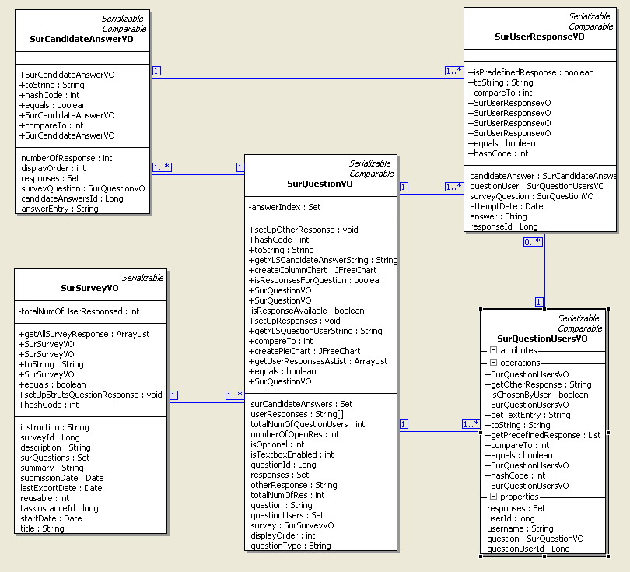
Figure 8 Hibernate value object diagram

Tool API
<Include any details about the tool API implementation. This section is optional.>

Design Export/Import
< Include any other details the export/import of designs. This section is optional.>

Portfolio Export
<Include any other details for the portfolio export. This section is optional.>

