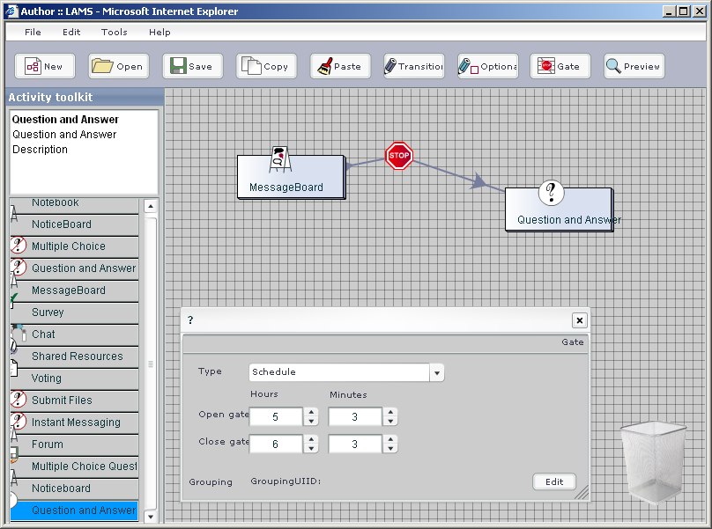
LFMenuBar
This contains a MM MenuBar component. It is assosiated with LFMenuBar in the lams_authoring.fla
Toolbar
Package: org.lamsfoundation.lams.authoring.tb
It has a container - Toolbar, and a Model, View and Controller.
The ToolbarView.as class is associated with this movie clip you see.
ToolKit
Package: org.lamsfoundation.lams.authoring.tk.
This displays the available template activities an the server.

Each row is an instance of the TemplateActivity.as class, associated with a movie clip in the .fla

The Toolkit.as container holds references to the M,V and C

When a template activity is dropped on the canvas, addActviity is called to add a copy of that activity to the DDM.
CanvasActivity
Package: org.lamsfoundation.lams.authoring.cv

This is the visual representation of an Activity. It is associated with a MovieClip in the .fla. It holds a reference to the Activity in the DDM.

Depending on the type of Activity it looks different, e.g the GateActivity looks like a Stop sign. ToolActivity load .swf images for the icon.
CanvasTransition
Package: org.lamsfoundation.lams.authoring.cv

This is the visual representation of a Transition. It is associated with a MovieClip in the .fla. It holds a reference to the Transition in the DDM.

Depending on the type of Activity it looks different, e.g the GateActivity looks like a Stop sign. ToolActivity load .swf images for the icon.

PropertyInspector
Package: org.lamsfoundation.lams.authoring.cv

This is a class assosicated with the ProeprtyInspector movieclip. It shows the proeprtyies of what ever is selected in the Canvas

Canvas
Package: org.lamsfoundation.lams.authoring.cv

This is where the design is built. The container Canvas.as holds the DesigDataModel. and also references to the M,V and C

The CanvasView.as is the class you can see and is associated with the CanvasView movie clip

Bin
Package: org.lamsfoundation.lams.authoring.cv
Has a bin MovieClip in the .fla
Elements in the design like CanvasActivities and CanvasTransitions can be deleted by dropping them here.

