
Theme Design Report

Version 1.1
Author: FIONA Malikoff
LAMS INTERNATIONAL
17 January 2006

Revision History
Name | Date | Reason For Changes | Version
Fiona Malikoff | 17 Jan 2006 | Initial document based on previous notes. | 1.1

Contents
1 Introduction 1
1.1 Scope 1
2 Implementation 2
3 Action Calls 4
3.1 getTheme(Long themeid) 4
3.2 Action: getThemes() 5
3.3 Store Theme Servlet 5

Introduction

Scope
LAMS supports limited theming or skinning.
LAMS 1.1 will be supplied with a set of themes (or skins). Authors will be able to select their theme in the authoring interface, and other users will have their theme set in the admin module.
The theme support can be accessed via the general action, ??, in lams-central.war.
In a future version of LAMS, author or staff may be able to define new themes for users. This will be done if we there is enough interest.

Implementation

Database and Java Objects
The theme details are stored in two places:
- in the *.css files in lams-central.war
- in the lams_css_* tables in the database.
The theme is implemented in stylesheet files for the HTML pages.
The theme is also stored in the database.
At present, the two sets of data must be set up separately – the database can be populated through the StoreTheme call (see later) but the css file needs to be created manually. In the future, we may create a utility that generates the css file from the database tables.
At present, the database entries are used to support the Flash client – the client calls getTheme() to get all the details for a theme and then styles items “on the fly” based on the theme values. At least, that is the plan – there are problems with Macromedia’s implementation of styling which may stop LAMS from applying themes in this manner.
The theme objects are in the org.lamsfoundation.lams.themes package in lams.jar The main objects (CSSThemeVisualElement, CSSStyle, CSSProperty) are based on the css style classes from Flash. A theme is made up of visual elements, and visual elements have one or more styles. Each style has one or more properties.
CSSThemeVisualElement models both a theme, and the visual elements that make up a theme. The method isTheme() identifies if it is a theme or a visual element. Visual elements are related back to their theme via the parentTheme attribute. If we ever have themes within themes then the can also be related via the parentTheme attribute.
PropertyType is used to convert the CSSProperty.value (stored as a String) to the appropriate type (Double, String, etc).
Each User may have a particular theme. If the user does not have a specific theme, then the default theme should be used. The theme name is included in the UserDTO object, so that the jsp files can select the appropriate stylesheet (<themename>.css).

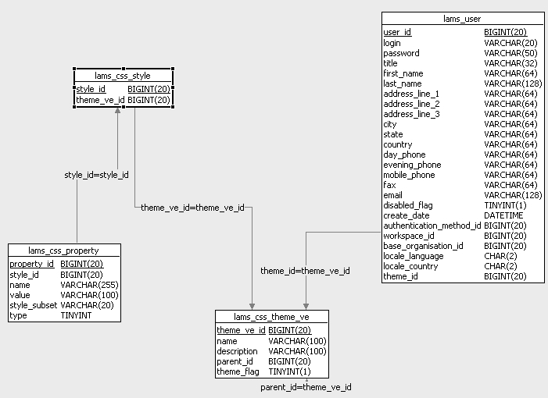
Figure 1: Database Model

CSS Tag
The CSS JSP tag should be used to include the stylesheets in each HTML file. This tag will write out an entry for the default stylesheet and the user’s theme stylesheet (if the user has a theme).
The standard use of the tag defines the stylesheet reference as a normal server reference. It has an optional attribute that causes local references to be created which should be used for the export portfolio pages.

Action Calls

ThemeAction: getTheme(Long themeid)
<This needs to be moved from the authoring action to the new action and then we need to tell Dave the new url to call!>
Get a theme based on the theme’s unique id.
Parameters: themeID
URL: http://<server>/lams/?????.do?method=getTheme&themeID=<value>
Returns: WDDX Packet with CSSThemeDTO in the messageValue field.
Sample WDDX Packet
<wddxPacket version='1.0'><header/><data>
<struct type='Lorg.lamsfoundation.lams.util.wddx.FlashMessage;'>
<var name='messageKey'><string>getTheme</string></var>
<var name='messageType'><number>3.0</number></var>
<var name='messageValue'>
<struct type='Lorg.lamsfoundation.lams.themes.dto.CSSThemeDTO;'>
<var name='baseStyleObject'><struct>
<var name='borderStyle'><string>outset</string></var>
<var name='_tf'><struct>
<var name='color'><number>1.2452097E7</number></var>
</struct></var>
<var name='rollOverColor'><number>1.671168E7</number></var>
</struct></var>
<var name='description'><string>cut down ruby theme for testing</string></var>
<var name='id'><number>1.0</number></var>
<var name='name'><string>ruby</string></var>
<var name='visualElements'><array length='1'>
<struct type='Lorg.lamsfoundation.lams.themes.dto.CSSVisualElementDTO;'>
<var name='name'><string>button</string></var>
<var name='styleObject'><struct>
<var name='_tf'><struct>
<var name='display'><string>block</string></var>
</struct></var>
<var name='selectionColor'><number>1.6711681E7</number></var>
</struct></var>
</struct>
</array></var>
</struct>
</var>
</struct></data></wddxPacket>

ThemeAction: getThemes()
<This needs to be moved from the authoring action to the new action and then we need to tell Dave the new url to call!>
Parameters:
URL: http://<server>/lams/???.do?method=getThemes
Returns: WDDX Packet with an array of CSSThemeDTO objects in the messageValue field.
Sample WDDX Packet:
<wddxPacket version='1.0'><header/><data>
<struct type='Lorg.lamsfoundation.lams.util.wddx.FlashMessage;'>
<var name='messageKey'><string>getThemes</string></var>
<var name='messageType'><number>3.0</number></var>
<var name='messageValue'><array length='2'>
<struct type='Lorg.lamsfoundation.lams.themes.dto.CSSThemeBriefDTO;'>
<var name='description'><string>cut down ruby theme for testing</string></var>
<var name='id'><number>1.0</number></var>
<var name='name'><string>ruby</string></var>
</struct>
<struct type='Lorg.lamsfoundation.lams.themes.dto.CSSThemeBriefDTO;'>
<var name='description'><string>theme used for testing</string></var>
<var name='id'><number>3.0</number></var>
<var name='name'><string>AuthoringTestTheme</string></var>
</struct>
</array></var></struct>
</data></wddxPacket>

Store Theme Servlet
<This needs to be moved out of authoring to a general area and then we need to tell Dave the new url to call! This needs to be a servlet as the wddx packet comes in the body, rather than as parameters.>
POST Body: Theme packet
URL: http://<server>/lams/storeTheme
Returns:
A WDDX packet containing the
themeid Unique id for this theme
Sample Input Packet:
<wddxPacket version=1.0><header /><data><struct>
<var name=baseStyleObject><struct>
<var name=borderStyle><string>outset</string></var>
<var name=rollOverColor><number>16711680</number></var>
<var name=selectionColor><number>16711680</number></var>
<var name=themeColor><number>16711680</number></var>
<var name=_tf><struct>
<var name=font><string>_sans</string></var>
<var name=size><number>10</number></var>
<var name=color><number>12452097</number></var>
<var name=display><string>block</string></var>
</struct> </var>
</struct></var>
<var name=name><string>AuthoringTestTheme</string></var>
<var name=description><string>theme used for TestAuthoringService</string></var>
<var name=visualElements>
<array length=1>
<struct>
<var name=name><string>button</string></var>
<var name=styleObject><struct>
<var name=borderStyle><string>outset</string></var>
<var name=rollOverColor><number>16711680</number></var>
<var name=selectionColor><number>16711680</number></var>
<var name=themeColor><number>16711680</number></var>
<var name=_tf><struct>
<var name=color><number>7174353</number></var>
<var name=display><string>block</string></var>
</struct></var>
</struct></var>
</struct>
</array>
</var>
</struct></data></wddxPacket>;

Sample Output Packet:
<wddxPacket version='1.0'><header/><data>
<struct type='Lorg.lamsfoundation.lams.util.wddx.FlashMessage;'>
<var name='messageKey'><string>storeTheme</string></var>
<var name='messageType'><number>3.0</number></var>
<var name='messageValue'><number>9.0</number></var>
</struct></data></wddxPacket>

ThemeAction: setTheme(Long userId, Long themeId)
<This is a new call that needs to be written. A theme service object should be created in lams.jar and create a method to set the theme. The method should then be called from action class in lams-central.war. It will also be called from the admin interface, hence the service needs to be available to both lams-central and lams-admin.
The other methods (for storing and getting themes should probably also be moved to the theme service object. >
Parameters:
URL: http://<server>/lams/???.do?method=setTheme&userId=<userId>&themeId=<themeId>
Returns: WDDX Packet with an acknowledgement or error if the user cannot be updated (e.g. if theme id is invalid).
Sample Output Packet:
<wddxPacket version='1.0'><header/><data>
<struct type='Lorg.lamsfoundation.lams.util.wddx.FlashMessage;'>
<var name='messageKey'><string>setTheme</string></var>
<var name='messageType'><number>3.0</number></var>
<var name='messageValue'><number>User theme saved.</number></var>
</struct></data></wddxPacket>

