
Administrator’s Guide
For LAMS v 1.0.1

Version 1.1
LAMS INTERNATIONAL
April 2005

Revision History
Name | Date | Reason For Changes | Version
Fiona Malikoff,  Yoichi Takayama | April 2005 | Released with LAMS v 1.0.1 | 1.1

Contents
1. Introduction 1
2. User Administration Screens 2
2.1 Administration Screen 2
2.2 Maintain Users in Organisation 2
2.3 Staff User Management 4
2.4 Learner User Management 5
2.5 Add New Session Class 6
2.6 Maintain Session Class 7
2.7 Task: Create a New School 9
2.8 Task: Add a New Staff Member to a School 9
2.9 Task: Add a New Learner to a School 9
2.10 Task: Create a New Session Class 9
2.11 Task: Add a User (Staff/Learner) to a Session Class 10
2.12 Task: Add Existing Users (Staff/Learner) to a Session Class 10
2.13 Task: Change a User’s Personal Details (As Teacher) 10
2.14 Task: Change a User’s Password 11
3. System Administration Screens 12
3.1 Introduction 12
3.2 Administration Screen 12
3.3 Maintain Organisations and Users 13
3.4 User Management 15
3.5 Add Existing User 16
3.6 Remove Users 17
3.7 Maintain Session Class 17
3.8 Task: Create a New School 17
3.9 Task: Add a New Staff Member to a School 18
3.10 Task: Add a New Learner to a School 18
3.11 Task: Adding Existing Users to a School 19
3.12 Task: Maintaining Session Classes 19
3.13 Task: Change a User’s Personal Details 20
4. Summary of Access Rights 21

Introduction

This user guide will explain how to use the user administration screens. For each screen (and dependent screens), the standard screen will be covered first, and then the extra options available on the system administration screens will be covered second. This allows the user guide to be split up into a two guides relatively easily.
After a description of the screens is given, step-by-step instructions are given for a list of common tasks.

Home Organisations
All users must belong to at least one organisation, a home organisation. The details about the user (username, first name, last name, address, etc) are accessed via their home organisation screen. Most users belong to one organisation only.
These organisations are also used for the management of learning designs. In the authoring tool, a staff member should see their home organisation in the drop down menu in the open/save dialogue box. This is used to share the learning design with other staff members in the same organisation.

Session Classes
A session class is a grouping of existing users into a “class” for the purposes of running a learning design session. It can be used many times (e.g. a biology group that may do multiple sessions together).
A session class is a list of learners who may join a learning design session. When a learning design session is created (using the Monitor screen), a session organisation is assigned to the session. Learners in the session organisation do not have to join the session. Therefore the list of learners who participate in a session is a subset of the learners in the session organisation.
When a user brings up the learner interface, only the sessions that appear are the sessions that are attached to a session class to which the learner belongs.

Screen Flow
The screens are accessed via the following paths.
Administration
- Maintain Users In Organisation
- Staff User Management
- Learner User Management
- Maintain Session Class
- Add Staff Users
- Add Learner Users
- New Session Class
- Maintain Session Class
- Change Password
- Help

User Administration Screens

Administration Screen
Clicking on the “User Administration” link on the main LAMS screen will bring up the main administration screen in a new window.
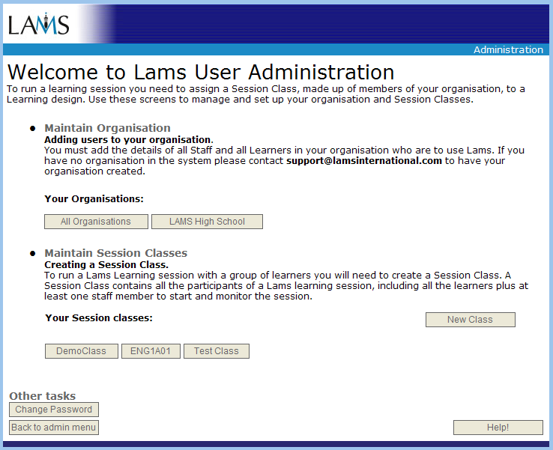

Maintain Organisation
Use this section to add new learners to the system or to change the user details for learners. You will not be able to add new staff members using this screen but you can change the user details for the staff members. Usually only one organisation, your home organisation, will appear here.

Maintain Session Classes
Use this section to add/remove existing staff and learners to a session class. All the existing session classes that you can modify are listed, along with a button to create new session classes.

Change Password
Change your password.

Maintain Users in Organisation
This screen allows you to create new learners, and to update the personal details of learners and staff. To return to the main administration screen, click the “Administration Menu” button.
This screen lists all the users who have this organisation as their home organisation. There may be other users who have access to this organisation (such as the main administration user) but they will not be shown on this screen.
Clicking on the “Update User” button next to a staff member will bring up the Staff User Management screen and allows you to modify the user details, including changing the password.
Clicking on the “Update User” button next to a learner will bring up the Learner User Management screen and allows you to modify the user details, including changing the password.
You can create a new learner for your organisation using the “Add New Learner” button. If you need a new staff member created, you can do it from the System Administration pages.

Using an Excel Spreadsheet File
Alternatively, you can create users from Excel spread sheet file. Use the Import Existing Users from File button to batch import users from a file uploaded. The importer must have the Right to add/modify users in all the organisations concerned. Use the link “download template file” to get a sample import file to view the syntax used.
The example file looks like this.
Populate the template file with appropriate user data to replace the dummy entries in the file. Then, upload the file as a normal web file upload. The LAMS parses the file and creates new users.
Pay special attention to the “roles” and “right” columns as these specify how the user interacts with the organisation.
The roles indicate what the user can do in the rest of the system with respect to this organisation. For example, if a user has the 'author' role in an organisation then the user can access the organisation from authoring module.
The rights indicate what the user can do 'to' the organisation within the administration module. For example, if the user has the 'modification' right then they can add users the organisation.
The organisation listed in the spreadsheet is part of the user’s “address” details. It is not the LAMS organisation in which they are placed. All the users in the spreadsheet are put in the organisation shown on the Maintain Users screen. For example, in the following screenshot, if the file uploaded contained the data given about, the users imported using the Excel file will be put in the “LAMS High School” organisation, but their personal details would like “Sydney High” as their organisation.
Caution: The current release of the LAMS does not have a feature to delete users. Therefore, a care must be taken with regard to what organisation you are importing the users to and that the usernames are all correct. Errors in other columns can be corrected manually after the import.
Importing the same file a second time will not corrupt the system. An error will appear on the screen for each duplicated username and the duplicate usernames will be ignored. Similarly, if you import a different file that contains users with the same username as existing users, the entries with the duplicated username will be ignored and errors will be reported on the screen.
If you can, it is a good idea to stop other users from using the LAMS while you are running the import and to backup the database before the import. This will allow you to roll back to your unchanged version if the users are placed in the wrong organisations.
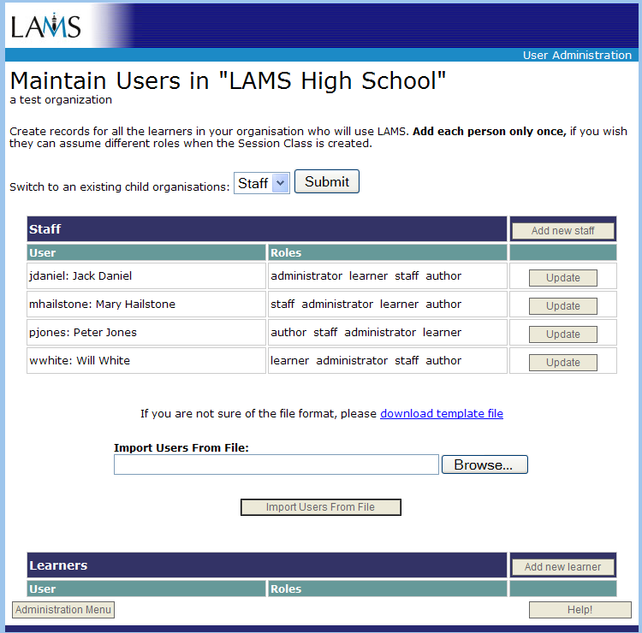

Staff User Management
This screen appears when you click the “Add New Staff” button, or the “Update User” button next to a staff entry on the “Maintain Users in Organisation” screen.
The top part of the screen lists all the organisations and session classes to which this user has some access. This section of the screen cannot be changed. To add this user to a session class, you need to go to the session class screen and add them there. Removing a user from a session class or organisation is not possible using these screens.
If you are resetting the password of an existing user, type a new password in the two password fields and click save. If you are modifying any of the other details for an existing user and do not wish to change the password, do not enter anything in the password fields.
Staff will usually have the learner, staff, author and administrator checkboxes all ticked. Remove a tick only if you know that this role is not needed for the user. The roles give access to the following screens:
- administrator: user management screen
- author: authoring screens
- staff: monitor screens
- learner: learner screens
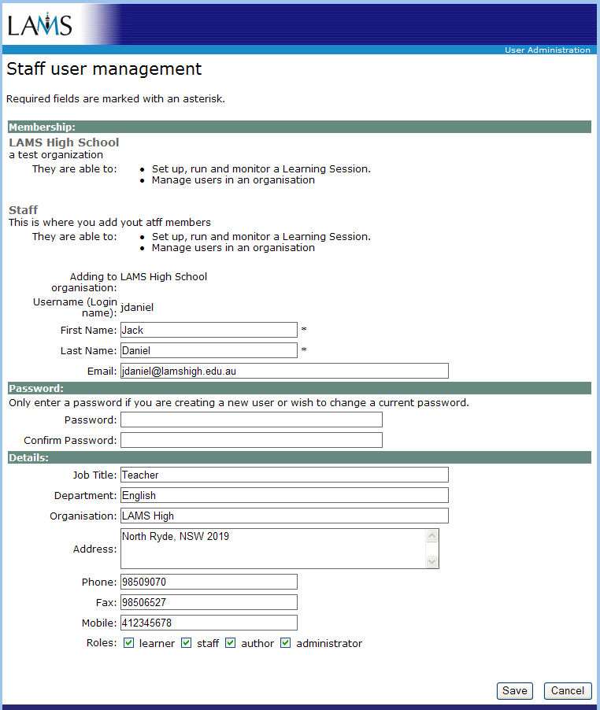

Learner User Management
This screen appears when you click either the “Add New Learner” or “Update User” next to a learner’s entry, on the “Maintain Users In Organisation” screen.
The username must be unique to this installation of LAMS. If you choose a username already in use, and error message will be displayed when you click save. Please fill in (as a minimum) the Membership and Password fields when setting up a learner for the first time.
If the learner is to participate using the learner screens only, select the learner check box at the bottom of the page. If you want the learner to be able to run the monitor screen (and hence start sessions, view monitor pages, etc) then check both the learner and staff checkboxes.
If you are resetting the password of an existing user, type a new password in the two password fields and click save. If you are modifying any of the other details for an existing user and do not wish to change the password, do not enter anything in the password fields.
The screen sample below was taken when adding a new user.

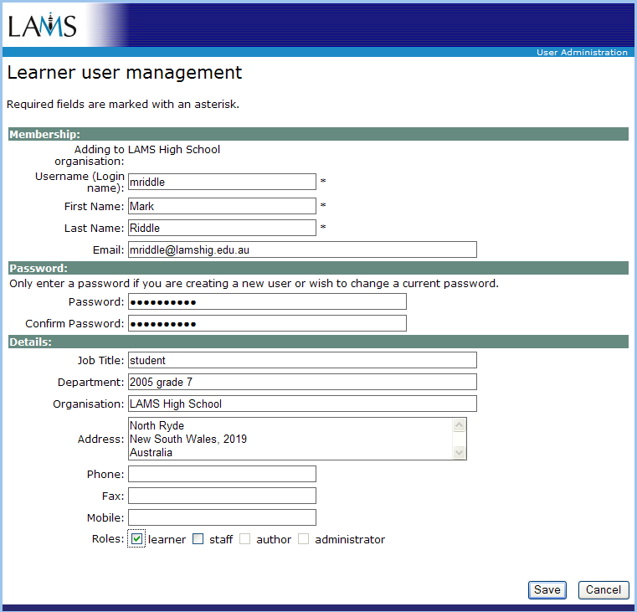

Add New Session Class
This screen allows you to create a new session class. Set up the name and description of the class. Be careful because you cannot change the name or the description afterwards.
When you click Save, you will be taken to the Maintain Session Class screen to add users to your new session class. To abandon this new class, you need to click Cancel on this screen. Once you click Save, the class is created and cannot be removed.
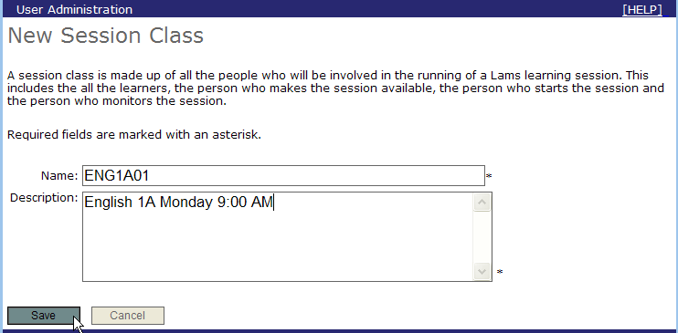

Maintain Session Class
This screen allows you to add existing users to a session class.
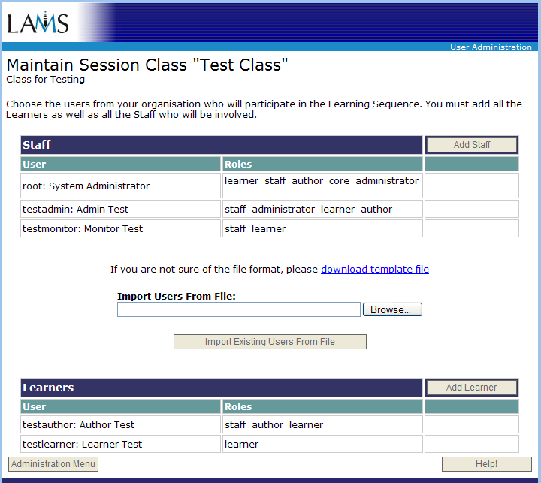

Use the Add Staff button to bring up the Add Staff Users screen, and the Add Learner button to bring up the Add Learner Users screen.
On either of these screens, select your organisation from the drop down list and click “Show Users”. This will display a list of people in your organisation. Click the checkbox against the people who you wish to add to this session class.
When using the staff screen, only add users who were set up with staff privileges. These people will be able to start sessions using this session class.
When using the learner screen, you may add any user on the list. These users will only be able to join a learning session that belongs to this session class - they will not be able to create a session using this session class.
If you add a user using the staff screen, and then add them again using the learner screen, then they will be reset to only the learner privileges for this session class and lose the staff privilege for this session class.
Note: you will not be able to “re-add” yourself to the session class – your entry in the list will not have a checkbox. If you re-add yourself as a learner, then you would lose your ability to change the details of the session class, so this is done to protect your privileges. If you want to make your privileges (for this session class) to be learner only, then you will need to get another staff member to log in and re-add you to the session class as a learner.
You can also add users to a Session Class by uploading an Excel file which has all users to be added. The user may belong to different organisations. Different from creating the users for organisations, the user must have been already created in organizations in the case of adding them to a session class. Therefore, the most of the columns in the spread sheet are ignored. The only relevant columns are the username and the Right.
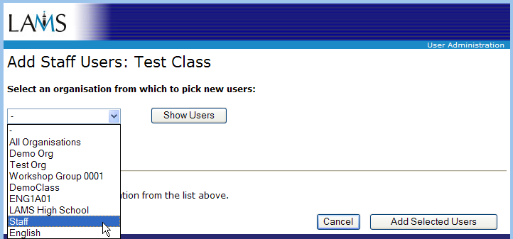

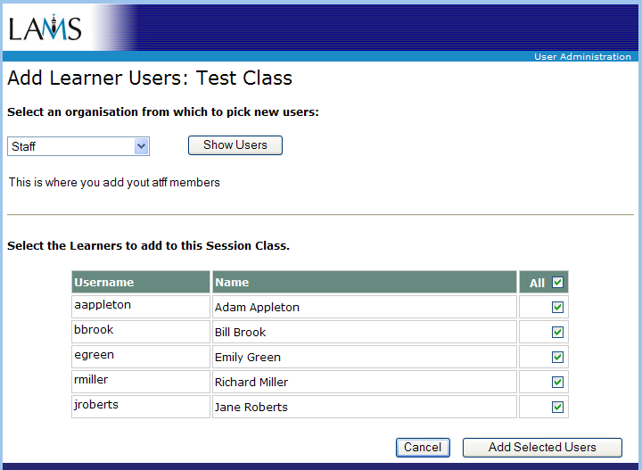

Task: Create a New School
This cannot be done using the standard User Management screens. Contact system administrator to set up a new school.

Task: Add a New Staff Member to a School
This cannot be done using the standard User Management screens. Contact system administrator to set up a new staff member.

Task: Add a New Learner to a School
- Start LAMS.
- Log in as a teacher who belongs to the school.
- Click on the user administration link to bring up the administration screens.
- Select your organisation button user “Maintain Organisation”.
- On the “Maintain Users” screen, click “Add new learner”.
- On the “Learner User Management” screen:
- Set up the fields under Membership and Password. For a new learner the password, username and name fields are mandatory. Fill in the details section if you wish (they are optional).
- If the learner is to participate using the learner screens only, select the learner check box at the bottom of the page. If you want the learner to be able to run the monitor screen (and hence start sessions, view monitor pages, etc) then check both the learner and staff checkboxes.
- Click Save.
- The system will check the username when you click save, and will report an error if the username is already used. If this happens, try another username (and refill in the password fields) and then try saving again. Keep changing the username (and doing the password fields) until the system accepts the record.
- After saving, a screen will display the values you have saved. Click “Return to Organisation” to go back to the “Maintain Users” screen to add new users, or if no more users are needed, return to the “Maintain Users” screen and then click “Administration Menu” to return to the main administration screen.

Task: Create a New Session Class
- Start LAMS.
- Click on the user administration link to bring up the administration screens.
- Click on the “New Class” button under “Maintain Session Classes”.
- On the “New Session Class” screen, set up the name and description of the class. Be careful because you cannot change the name or the description afterwards. Click Save to create the class. To abandon this new class, you need to click Cancel on this screen. Once you click Save, the class is created and cannot be removed.
- When saved, the Maintain Session Class screen should appear. Add users to your new session class. See Task: Add a User (Staff/Learner) to a Session Class, starting at step 5.

Task: Add a User (Staff/Learner) to a Session Class
- Start LAMS.
- Click on the appropriate session class button under the “Maintain Session Classes” section (i.e. the one with the name of the class to be modified shown on the button).
- The “Maintain Session Class” screen should appear with the current details of the session class.
- To add a new staff member (i.e. someone who can add users to this class, can start sessions) click the “Add Staff” button. On the ‘Add Staff Users” screen, select your organisation from the drop down list and click “Show Users”. This will display a list of people in your organisation.
Click the checkbox against the people who you wish to add to this session class as staff members, then click “Add Selected Users”. This will add the users to this session class as staff and will return you to the “Maintain Session Class” screen.
Note: You should only add users who “staff” list in their roles on the “Maintain Users” screen – if they do not have the “staff” role then they will not be able to start sessions, even if you add them here as staff!
- To add a new leaner (someone who will participate in the session), click the “Add Learner” button. On the ‘Add Learner Users” screen, select your organisation from the drop down list and click “Show Users”.
This will display a list of people in your organisation. Any users in your organisation can be set up as a learner. Click the checkbox against the people who you wish to add to this session class as learners, then click “Add Selected Users”. This will add the users to this session class as learners and will return you to the “Maintain Session Class” screen.
Note: if you set up someone as a learner and they were previously set up as staff, then they will lose the staff privilege for this session class only. If you do that by accident, use “Add Staff” (on the Maintain Session Class screen) to change them back to Staff.

Task: Add Existing Users (Staff/Learner) to a Session Class
Follow the instructions in Task: Add a User (Staff/Learner) to a Session Class but use the file import option.
The user may belong to different organisations. Different from creating the users for organisations, the user must have been already created in organizations. Therefore, the most of the columns in the spread sheet are ignored. The only relevant columns are the username and the Right.

Task: Change a User’s Personal Details (As Teacher)
- Start LAMS.
- Log in as a teacher who belongs to the school.
- Click on the user administration link to bring up the administration screens.
- Select your organisation button user “Maintain Organisation”.
- On the “Maintain Users” screen, click on the “Update User” button on the same line as the user. Depending on whether the user is a staff member or a learner, either the “Staff User Management” or “Learner User Management” screen will appear.
- On the “Staff User Management” screen:
- Change the name, email or general details fields. You cannot change a person’s username. If you want to change the password, enter the new password in the password fields. If you do not want to change the password, then leave the two password fields blank.
- Staff will usually have the learner, staff, author and administrator checkboxes all ticked. Unless there is a problem with them not being able to access something they should be able to access, leave the checkboxes as they are. For more information on these checkboxes, see the details given in the earlier section on the “Staff User Management” screen.
- Click Save.
- On the “Learner User Management” screen:
- Change the name, email or general details fields. You cannot change a person’s username. If you want to change the password, enter the new password in the password fields. If you do not want to change the password, then leave the two password fields blank.
- Learners will usually have just the learner checkbox ticked. Unless there is a problem with them not being able to access something they should be able to access, leave the checkboxes as they are. For more information on these checkboxes, see the details given in the earlier section on the “Learner User Management” screen.
- Click Save.
- The system will check the username when you click save, and will report an error if the username is already used. If this happens, try another username (and refill in the password fields) and then try saving again. Keep changing the username (and doing the password fields) until the system accepts the record.
- After saving, a screen will display the values you have saved. Click “Return to Organisation” to go back to the “Maintain Users” screen.

Task: Change a User’s Password
To change your own password, bring up the main User Administration screen and use the “Change Password” button. Learners (who do not have access to the User Administration screen) cannot change their own password.
Follow the instructions for “Task: Change a User’s Personal Details”, making sure you fill in the two password fields.

System Administration Screens

Introduction
This section describes the System Administration screens, which are the “power user” version of the User Management screens. It assumes that you are familiar with the standard screens.

Screen Flow
The screens are accessed via the following paths.
Administration
- Maintain Organisations and Users
- Update Organisation
- Add (Child) Organisation
- Create New User
- Add Existing User
- Remove Users
- Add (Top Level) Organisation
- Maintain Session Class
- Update Organisation
- Add Existing User
- Remove Users
- New Session Class
- Maintain Session Class
- Change Password
- Help

Administration Screen
The main administration screen in the System Administration section has one new button, “Add new top level organisation”. This will be done very rarely – usually the system has an “All Organisations” top organisation and new account organisations should be added under this organisation.

Maintain Organisations and Users
The “Maintain Organisations and Users” screen is the System Administration version of the "Maintain Users in Organisation” screen. This screen, and the following User Edit screen give access to functions not available on the normal screens, such as create new organisation, adding an existing users to an organisation (so that the user has more than on organisation), removing extra users from organisations, etc.

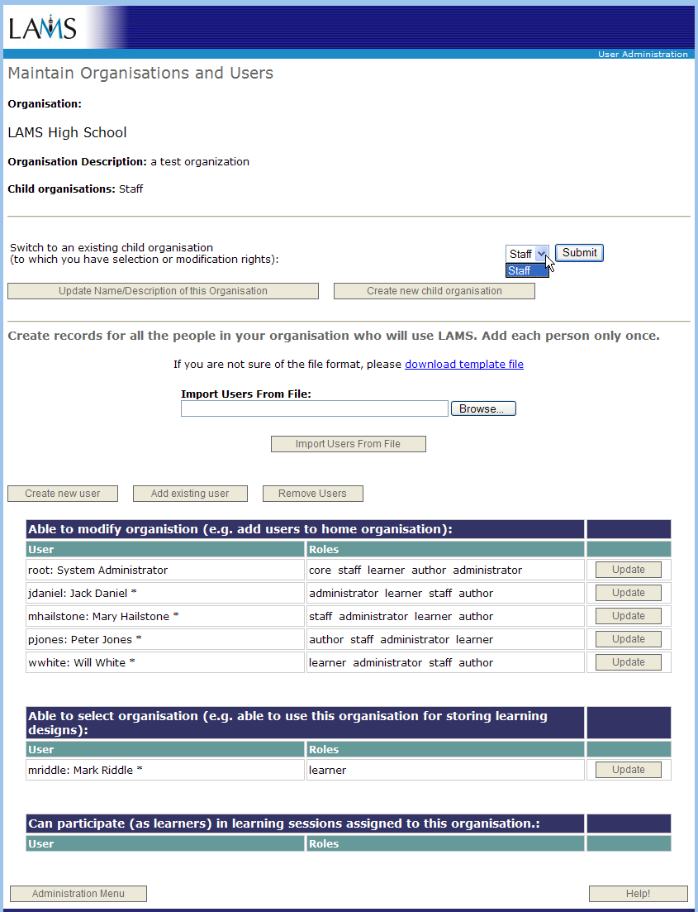

Organisations
The organisation(s) shown on the main screen shows only the “top” of the organisation hierarchy. To get to an organisation lower down the hierarchy, you need to come to this screen and use the drop down box to step “down” the organisation hierarchy.
The drop down box shows the “child” organisations for the currently displayed organisation. As you select a new organisation (in the hierarchy), this screen is redisplayed with the users for the new organisation, and the drop down box is updated to show the children of the new organisation.

Update Name/Description
Change the name or the description of an organisation. This functionality is only available in the System Administration screens.

Create New Child Organisation
Creates a new account organisation as a child of the current organisation. You are automatically given modification privilege to this new organisation (and hence you are a member of the organisation, although it is not your “home” organisation.
Generally new organisations should only be created while logged in as admin. This way we have one account (admin) that can access all account organisations.

User Listing
The normal screen only lists the users who have this organisation as their home organisation. This screen shows all the users who have rights to this organisation. The users who have this as their home organisation are marked with an asterisk.
In the example screen, user “root” is shown as having membership right to this organisation, but she/he does not have this organisation as her/his home organisation. Her/his home organisation is “All Organisations” (which you cannot tell from this screen). So they are members of more than one account organisation.
In a production system, only admin (or similar administration users) should belong to the “All Organisations” organisation.

Create New User
Creates a new user with this organisation as their home organisation. See the section on the “User Management: System Administration” screen for more information.

Add Existing User
Adds a user who already exists in the system and gives them rights to this organisation. This will bring up the same screen used to add people to a session class. See the section on the “Add Existing Users: System Administration” screen for more information.

Remove Users
Remove users that have rights to this class but who have a different home organisation. This option brings up a screen which lets you pick which users to remove.
There is no way to remove a user from their home organisation, as this would require disabling the user in the system (which is not implemented). There is no way to move users to a different home organisation either.

Update User
Change the user details for a particular user. See the section on the “User Management: System Administration” screen for more information.

User Management
This screen is the same as the Learner User Management and Staff User Management screen except that it doesn’t guide you about which roles you should set up for a user and you have to select the organisation right. (The Staff User Management screen sets the rights to modification automatically, and the Learner User Management screen sets the rights to membership automatically.)
The Roles checkboxes match the LAMS roles:
- administrator: user management screen
- author: authoring screens
- staff: monitor screens
- learner: learner screens
The three rights levels are:
- membership: Can participate (as learner) in learning sessions
- selection: Can select this organisation for running a learning session
- modification: Can select for a learning session, can add/remove users to this organisation
See the section on “Summary of Access Rights” for help with selecting an appropriate right/role combination.
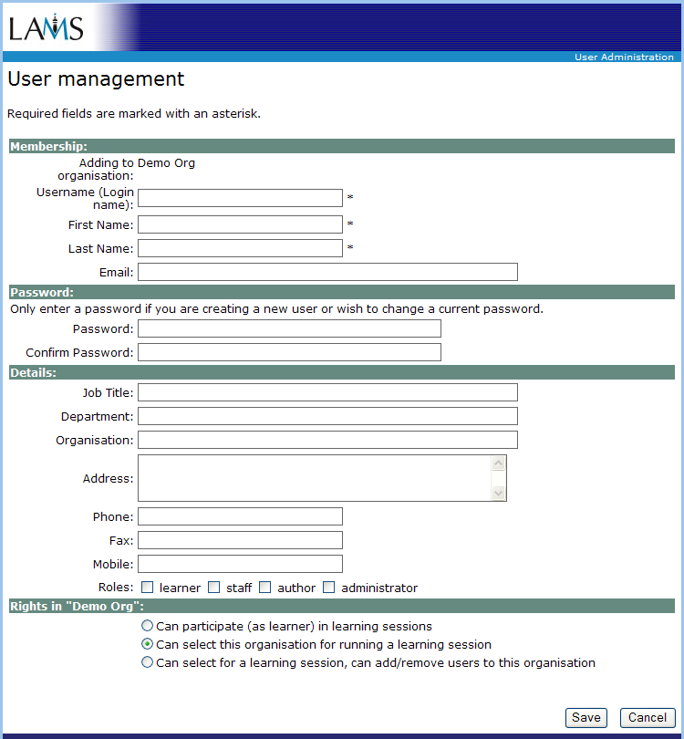

Add Existing User
This screen allows you to add users who already exist (and hence belong to an account organisation) to another account organisation. It is similar to the screen which allows a teacher to assign users to a session class (using the normal pages).
From the drop down list, select the account organisation containing the desired users you and then click “Submit”. All the users that have the selected organisation as their home organisation are displayed. Select the Right from the pull down menu for each user you want to add. For users that you do not want to add to your organisation, do not select any Right from the pull down menu.
The rights are the same as the rights on the User Management screen.
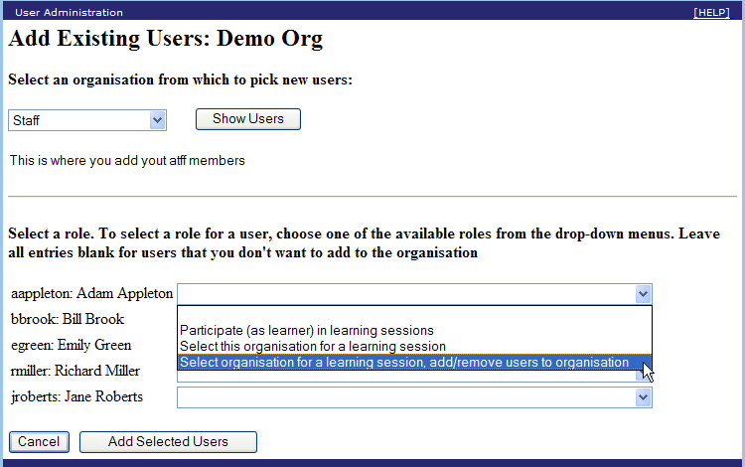

Remove Users
This screen lists all the users who are in this organisation but do not have this organisation as their home organisation. That is, these users belong to more than one account organisation.
To remove a user, bring up this screen, click the checkbox next to their name and then click Remove Users.
There is no way to remove a user from their home organisation, as this would require disabling the user in the system. There is no way to move users to a different home organisation either.
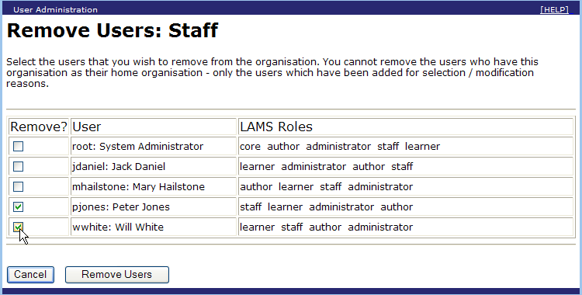

Maintain Session Class
This screen is the same as the “Maintain Organisations and Users” screen except that you cannot create new users and the ability to nest session classes is removed (i.e. cannot step down into child classes or create child classes).
The restriction on nested classes is a user interface restriction – the server would cope with nested session classes but as we are using a flat structure for session classes in the normal screens, we may as well keep it flat in the System Administration screens as well.
Changing the user details (via the Update User) button is available on this screen. This is a difference from the standard screens – they only allow you change the user details from the organisation page and not the session class page.

Task: Create a New School
This can only be done from the System Admin screens. These instructions can be used for any new account (home) organisation but they are tailored for a school
- Start LAMS.
- Log in as admin. This is important as it allows admin to access all account organisations for maintenance purposes.
- Click on the user administration link to bring up the administration screens. Change the URL from /lams/admin/admin.do?method=getAdmin to /lams/sysadmin/admin.do?method=getAdmin. This should bring up the system administration version of the screens. For the system administrator (“root”), this is not necessary as she/he will be presented with the System Administration button.
- Select the “All Organisations” button (the current top organisation).
- Using the drop down menu, step down the hierarchy until you have reached the organisation that should be the parent for your new school. Usually the parent will be the organisation for a group of schools (e.g. all state schools).
- Click the “Create New Child Organisation” button. The “Organisation Entry” screen should appear.
- Enter the name and description of the new organisation and then click “Save”.
- The “Maintain Organisations and Users” screen will be displayed. Create the initial staff members using the instructions for “Task: Add a New Staff Member to a School”, starting at point 6.

Task: Add a New Staff Member to a School
This can only be done from the System Admin screens.
- Start LAMS.
- Log in as admin. This is important as it allows admin should have access all account organisations.
- Click on the user administration link to bring up the administration screens. Change the URL from /lams/admin/admin.do?method=getAdmin to /lams/sysadmin/admin.do?method=getAdmin. This should bring up the system administration version of the screens.
- Select the “All Organisations” button (the current top organisation).
- Using the drop down menu, step down the hierarchy until you have reached the school.
- Click “Create New User” and the “User management” screen should appear.
- Set up the fields under Membership and Password. For a new staff member the password, username and name fields are mandatory. Fill in the details section if you wish (they are optional).
- Set up the roles to have all roles checked (i.e. learner, staff, author and administrator all checked)
- Set the right to Modification (option “Can select for a learning session, can add/remove users to this organisation”).
- Click Save.
- The system will check the username when you click save, and will report an error if the username is already used. If this happens, try another username (and refill in the password fields) and then try saving again. Keep changing the username (and doing the password fields) until the system accepts the record.
- After saving, a screen will display the values you have saved. Click “Return to Organisation” to go back to the “Maintain Organisations and Users” screen to add new users, or if no more users are needed, return to the “Maintain Organisations and Users” screen and then click “Administration Menu” to return to the main administration screen.

Task: Add a New Learner to a School
If working as admin, you will need to do this from the System Administration screens, so that you can work down the hierarchy to the individual school
- Start LAMS.
- Log in as admin. This is important as it allows admin should have access all account organisations.
- Click on the user administration link to bring up the administration screens. Change the URL from /lams/admin/admin.do?method=getAdmin to /lams/sysadmin/admin.do?method=getAdmin. This should bring up the system administration version of the screens.
- Select the “All Organisations” button (the current top organisation).
- Using the drop down menu, step down the hierarchy until you have reached the school.
- Click “Create New User” and the “User management” screen should appear.
- Set up the fields under Membership and Password. For new learners the password, username and name fields are mandatory. Fill in the details section if you wish (they are optional).
- Roles: Check the learner checkbox. In a small number cases, you may need to also set the staff checkbox – but only if the learner should be running sessions themselves.
- Set the right to Selection (option “Can select this organisation for running a learning session”). Most learners would only require the Membership option (“Participate…”) but some learners may be allowed to start sessions and for this they need Selection rights.
Granting all learners Selection rights is a side-effect of having only a two level staff or learner distinction on the normal user administration screens – we cannot differentiate the rights of a learner with access to start to sessions from a learner who doesn’t have access to start sessions.
- Click Save.
- The system will check the username when you click save, and will report an error if the username is already used. If this happens, try another username (and refill in the password fields) and then try saving again. Keep changing the username (and doing the password fields) until the system accepts the record.
- After saving, a screen will display the values you have saved. Click “Return to Organisation” to go back to the “Maintain Organisations and Users” screen to add new users, or if no more users are needed, return to the “Maintain Organisations and Users” screen and then click “Administration Menu” to return to the main administration screen.

Task: Adding Existing Users to a School
Follow the same instruction as for “Task: Add a New Learner to a School”, but use “Import Existing Users from File” option. The importing instruction is described in the section: “Maintain Users in Organisation”.

Task: Maintaining Session Classes
Follow the same instructions as for “Task: Create a New Session Class” and “ Task: Add a User (Staff/Learner) To a Session Class”. User admin can create a new session class but can only update an existing session class if admin has been granted access to the session class. If admin has not been granted access to the session class then you will need the username and password of a staff member in the session class.

Task: Change a User’s Personal Details
This can only be done from the System Admin screens.
- Start LAMS.
- Log in as admin.
- Click on the user administration link to bring up the administration screens. Change the url from /lams/admin/admin.do?method=getAdmin to /lams/sysadmin/admin.do?method=getAdmin. This should bring up the system administration version of the screens.
- Select the “All Organisations” button (the current top organisation).
- Using the drop down menu, step down the hierarchy until you have reached the school.
- Click “Create New User” and the “User management” screen should appear.
- Change the name, email or general details fields. You cannot change a person’s username. If you want to change the password, enter the new password in the password fields. If you do not want to change the password, then leave the two password fields blank.
- Staff will usually have the learner, staff, author and administrator checkboxes all ticked. Set up the fields under Membership and Password. For a new staff member the password, username and name fields are mandatory. Fill in the details section if you wish (they are optional).
Staff will usually have the rights set to Modification (option “Can select for a learning session, can add/remove users to this organisation”).
- Learners will usually have just the learner checkbox ticked.
Learners will usually have the rights set to Selection (option “Can select this organisation for running a learning session”).
- Click Save.
- After saving, a screen will display the values you have saved. Click “Return to Organisation” to go back to the “Maintain Organisations and Users”.

Summary of Access Rights
The following tables summarise the access rights to LAMS, based on role and rights. Note: a user can have multiple system wide roles. Teachers will usually have “administrator”, “author”, “staff” and ”learner” while students will usually have “learner” or sometimes “staff” and “learner”.

Typical Role/Rights
The following table shows some typical sets of roles and rights that are assigned to users.
Job Function | Role | Right (in home organisation)
Set up of student accounts only | administrator | modification
Teachers/Lecturers | administrator, author, staff, learner | modification
Tutors/Students leading sessions | staff, learner | selection
Students | learner | selection

Administration Screens: Role Administrator.
The user administration screens are only available to users with the administrator role.
Both the User Administration and System Administration screens are available using the same rights.
The “User Administration” link on the main LAMS page points to the /lams/admin/admin.do?method=getAdmin and to use the System administration screens, the user has to manually change the URL to /lams/sysadmin/admin.do?method=getAdmin.
Organisation/Session Class Rights Level | Gives
Modification | Account organisations:  Can add a new home organisation below this organisation  Can add/remove users to/from this organisation.  Can modify the user details of users in this organisation.  Can select users from the organisation to set up in a new organisation.  Session classes:  Can add/remove users to/from this session class.
Selection | Account organisations:  Can select users from the organisation to set up in a new organisation.  Can view users in the organisation, but not change the users.
Membership or no right to organisation/session class | Should not be able to see organisation/session class listed on screen.

Authoring Screens
The authoring screens are only available to users with the author role. The home organisations to which the user has modification and selection rights appear in the drop down list on the Open and Save dialogue boxes in the authoring tool, along with Public and Private.
Organisation/Session Class Rights Level | Gives
Modification and Selection | Account organisations:  Can select this organisation for either read or write access control to a learning design definition.  Can select any learning design definitions that have been saved with this organisation as read access allowed.  Can modify any learning design definitions that have been saved with this organisation as write access allowed.
Membership or no right to organisation/session class | Should not be able to see organisation listed in the drop down box.

Monitor Screens
The monitor screens are only available to users with the staff role.
Organisation/Session Class Rights Level | Gives
Modification and Selection | Account organisations:  Can select any learning design definitions that have been saved with this organisation as read access allowed. The account organisations appear in the drop down list in the Create Session dialogue box.  Session classes:  Can assign the session class to a particular learning design session (using the Select Session Class button).
Membership or no right to organisation/session class | Should not be able to see organisation/session class listed in the drop down boxes (for either selecting a design or a session organisation).

Learner Screens
The learner screens are only available to users with the learner role.
Organisation/Session Class Rights Level | Gives
Modification, Selection, Membership | Session classes:  Can join all the learning design sessions set with this session class.
No right to organisation/session class | Session classes:  Should not be able to see the learning design sessions for session classes to which the learner does not belong.

