Monitoring Functionality
Author: Manpreet Minhas

For detailed explanation on each of the following methods listed below please refer to
lams_monitoring\src\java\org\lamsfoundation\lams\monitoring\service\ IMonitoringService.java

initializeLesson()
Parameters:
method=initializeLesson
lessonName
lessonDescription
learningDesignID
userID
URL sample
<action url>?method=initializeLesson&lessonName=<name>&
lessonDescription=<description>&learningDesignID=<number>&
userID=<number>
Example URL:
http://localhost:8080/lams/monitoring/monitoring.do?method=initializeLesson&learningDesignID=1&lessonName=title&lessonDescription=MyDescription&userID=1

Sample Input WDDX Packet
<wddxPacket version='1.0'><header/><data><struct type='Lorg.lamsfoundation.lams.util.wddx.FlashMessage;'><var name='messageKey'><string>initializeLesson</string></var><var name='messageType'><number>3.0</number></var><var name='messageValue'><number>9.0</number></var></struct></data></wddxPacket>

NOTE: messageValue is the lesson ID which is initialized.

CreateLesson()
CreateLession Servlet Sample URL:
http://localhost:8080/lams/monitoring/monitoring/createLesson

Sample Input WDDX Packet
<wddxPacket version="1.0"><header /><data><struct><var name="lessonID"><number>1</number></var><var name="organisationID"><number>10</number></var><var name="staff"><array length="2"><number>7</number><number>8</number></array></var> <var name="learners"><array length="6"><number>1</number><number>2</number><number>3</number><number>4</number><number>5</number><number>6</number></array></var> </struct></data></wddxPacket>

Sample Output WDDX Packet
<wddxPacket version='1.0'><header/><data><struct type='Lorg.lamsfoundation.lams.util.wddx.FlashMessage;'><var name='messageKey'><string>createLesson</string></var><var name='messageType'><number>3.0</number></var><var name='messageValue'><boolean value='true'/></var></struct></data></wddxPacket>

startLession()
Parameters:
lessonID
Sample WDDX Packet
<wddxPacket version='1.0'><header/><data><struct type='Lorg.lamsfoundation.lams.util.wddx.FlashMessage;'><var name='messageKey'><string>startLesson</string></var><var name='messageType'><number>3.0</number></var><var name='messageValue'><boolean value='true'/></var></struct></data></wddxPacket>

archieveLession()
Parameters:
lessonID
Sample WDDX Packet
<wddxPacket version='1.0'><header/><data><struct
type='Lorg.lamsfoundation.lams.util.wddx.FlashMessage;'><var name='messageKey'><string>archiveLesson</string></var><var name='messageType'><number>3.0</number></var><var name='messageValue'><boolean value='true'/></var></struct></data></wddxPacket>

removeLession()
Parameters:
lessonID
Sample WDDX Packet
<wddxPacket version='1.0'><header/><data><struct type='Lorg.lamsfoundation.lams.util.wddx.FlashMessage;'><var name='messageKey'><string>removeLesson</string></var><var name='messageType'><number>3.0</number></var><var name='messageValue'><boolean value='true'/></var></struct></data></wddxPacket>

startOnScheduleLesson
Parameters:
LessonID
lessonStartDate
Example in start date:
Date: 24/01/2006 14:51:00
After URL encoded: 24%2F01%2F2006+14%3A51%3A00
So the sample URL will like this:
http://<actionURL>?lessonStartDate=24%2F01%2F2006+14%3A51%3A00&lessonID=12

Sample WDDX Packet
<wddxPacket version='1.0'><header/><data><struct type='Lorg.lamsfoundation.lams.util.wddx.FlashMessage;'><var name='messageKey'><string>startOnScheduleLesson</string></var><var name='messageType'><number>3.0</number></var><var name='messageValue'><boolean value='true'/></var></struct></data></wddxPacket>

finishOnScheduleLesson
Parameters:
LessonID
lessonFinishDate
Example in start date:
Date: 24/01/2006 14:51:00
After URL encoded: 24%2F01%2F2006+14%3A51%3A00
So the sample URL will like this:
http://<actionURL>?lessonStartDate=24%2F01%2F2006+14%3A51%3A00&lessonID=12

Sample WDDX Packet
<wddxPacket version='1.0'><header/><data><struct type='Lorg.lamsfoundation.lams.util.wddx.FlashMessage;'><var name='messageKey'><string> finishOnScheduleLesson</string></var><var name='messageType'><number>3.0</number></var><var name='messageValue'><boolean value='true'/></var></struct></data></wddxPacket>

getAllLessons()

Sample WDDX Packet
<wddxPacket version='1.0'><header/><data><struct type='Lorg.lamsfoundation.lams.util.wddx.FlashMessage;'><var name='messageKey'><string>getAllLessons</string></var><var name='messageType'><number>3.0</number></var><var name='messageValue'><array length='2'><struct type='Lorg.lamsfoundation.lams.lesson.dto.LessonDTO;'><var name='lessonDescription'><string>This is for testing</string></var><var name='lessonID'><number>1.0</number></var><var name='lessonName'><string>Test_Lesson</string></var><var name='lessonStateID'><number>3.0</number></var></struct><struct type='Lorg.lamsfoundation.lams.lesson.dto.LessonDTO;'><var name='lessonDescription'><string>Test_Description</string></var><var name='lessonID'><number>2.0</number></var><var name='lessonName'><string>Test_Lesson</string></var><var name='lessonStateID'><number>3.0</number></var></struct></array></var></struct></data></wddxPacket>

getLessonDetails(lessonID)
Parameters:
lessonID

Sample WDDX Packet
<wddxPacket version='1.0'><header/><data><struct type='Lorg.lamsfoundation.lams.util.wddx.FlashMessage;'><var name='messageKey'><string>getLessonDetails</string></var><var name='messageType'><number>3.0</number></var><var name='messageValue'><struct type='Lorg.lamsfoundation.lams.lesson.dto.LessonDetailsDTO;'><var name='createDateTime'><dateTime>2005-2-23T17:37:25+10:0</dateTime></var><var name='duration'><number>-111111.0</number></var><var name='learningDesignID'><number>1.0</number></var><var name='lessonID'><number>1.0</number></var><var name='lessonStateID'><number>3.0</number></var><var name='licenseID'><number>-111111.0</number></var><var name='licenseText'><string>string_null_value</string></var><var name='organisationDescription'><string>Root Organisation</string></var><var name='organisationID'><number>1.0</number></var><var name='organisationName'><string>Root</string></var><var name='startDateTime'><dateTime>1970-1-1T10:0:0+10:0</dateTime></var><var name='workspaceFolderID'><number>2.0</number></var></struct></var></struct></data></wddxPacket>

getLessonLearners(lessonID)
Parameters:
lessonID

Sample WDDX Packet
<wddxPacket version='1.0'><header/><data><struct type='Lorg.lamsfoundation.lams.util.wddx.FlashMessage;'><var name='messageKey'><string>getLessonLearners</string></var><var name='messageType'><number>3.0</number></var><var name='messageValue'><array length='1'><struct type='Lorg.lamsfoundation.lams.usermanagement.dto.UserDTO;'><var name='firstName'><string>Kevin</string></var><var name='lastName'><string>Han</string></var><var name='login'><string>test</string></var><var name='userID'><number>2.0</number></var></struct></array></var></struct></data></wddxPacket>

getLearningDesignDetails(Long lessonID)
Parameters:
lessonID
Returns:
A copy of the sample WDDX packet returned by this method has been uploaded into the CVS under lams_documents/lams_authoring/sample_wddx_packets/ learning_design.xml. It was too large to copy here.

getAllLearnersProgress(Long lessonID)

Return (copy from 1.0 monitoring document)
WDDX Packet containing:
lessonID : integer
learners[] : array
name : string
username : string
learnerID : integer
attempted[] : array
activity_id : integer
completed[] : array
activity_id : integer
current : integer

There was no sample data available so I couldn’t generate the sample WDDX packet here.

getAllContributeActivities(Long lessonID)
Parameters:
lessonID
Returns:
A copy of the sample WDDX packet returned by this method has been uploaded into the CVS under lams_documents/ UI_Design_docs/ monitor/ getAllContributeActivities_3.xml. It was too large to copy here.

getLearnerActivityURL(Long activityID,Integer userID)
Parameters:
activityID
userID

Sample WDDX Packet
<wddxPacket version='1.0'><header/><data><struct type='Lorg.lamsfoundation.lams.util.wddx.FlashMessage;'><var name='messageKey'><string>getLearnerActivityURL</string></var><var name='messageType'><number>3.0</number></var><var name='messageValue'><struct type='Lorg.lamsfoundation.lams.learningdesign.dto.ProgressActivityDTO;'><var name='activityID'><number>29.0</number></var><var name='activityURL'><string>/lams_tool_survey/tool/survey/survey.do?method=loadQuestionnaire&amp;mode=teacher&amp;sessionId=1</string></var></struct></var></struct></data></wddxPacket>

getActivityContributionURL(activityID)
Parameters:
activityID

Sample WDDX Packet
<wddxPacket version='1.0'><header/><data><struct type='Lorg.lamsfoundation.lams.util.wddx.FlashMessage;'><var name='messageKey'><string>getActivityContributionURL</string></var><var name='messageType'><number>3.0</number></var><var name='messageValue'><string>contribute_url</string></var></struct></data></wddxPacket>

moveLesson(lessonID, folderID, userID)
Parameters:
lessonID
folderID
userID

Sample WDDX Packet
<wddxPacket version='1.0'><header/><data><struct type='Lorg.lamsfoundation.lams.util.wddx.FlashMessage;'><var name='messageKey'><string>moveLesson</string></var><var name='messageType'><number>3.0</number></var><var name='messageValue'><number>3.0</number></var></struct></data></wddxPacket>

renameLesson(lessonID, name, userID)
Parameters:
lessonID
name
userID

Sample WDDX Packet
<wddxPacket version='1.0'><header/><data><struct type='Lorg.lamsfoundation.lams.util.wddx.FlashMessage;'><var name='messageKey'><string>renameLesson</string></var><var name='messageType'><number>3.0</number></var><var name='messageValue'><string>New name after renaming</string></var></struct></data></wddxPacket>

checkGateStatus(activityID, lessonID)
Parameters:
activityID
lessonID
Returns: A WDDX packet containing fields:
activityID
activityLevelID - the gate activity level
activityTypeID – the gate type id
gateOpen – true if the gate is open, false if the gate is shut
learnersWaiting – the number of learners waiting at the gate
(The following are only applicable to schedule gates)
gateStartTime - The time the gate is scheduled to open
gateEndTime - The time the gate is scheduled to close

Description: checkGateStatus will return information about the gate and its status, whether it is open or shut. If the gate is a:

Sync Gate (activityTypeID is 3)– the packet returned will include the fields: activityID, activityTypeID, activityLevelID, gateOpen and learnersWaiting.

Permission Gate (activityTypeID is 5) - the packet returned will include the fields: activityID, activityTypeID, activityLevelID, gateOpen and learnersWaiting.

Schedule Gate (activityTypeID is 4) - the packet returned will include the fields: activityID, activityTypeID, activityLevelID, gateOpen, learnersWaiting, gateStartTime and gateEndTime.

Example URL: /lams/monitoring/monitoring.do?method=checkGateStatus&activityID=33&lessonID=2

Sample WDDX Packet
<wddxPacket version='1.0'><header/><data>
<struct type='Lorg.lamsfoundation.lams.util.wddx.FlashMessage;'>
<var name='messageKey'><string>checkGateStatus</string></var>
<var name='messageType'><number>3.0</number></var>
<var name='messageValue'><struct>
<var name='activityTypeID'><number>3.0</number></var>
<var name='activityID'><number>33.0</number></var>
<var name='gateOpen'><boolean value='false'/></var>
<var name='activityLevelID'><number>3.0</number></var>
<var name='learnersWaiting'><number>0.0</number></var>
</struct></var></struct></data></wddxPacket>

Example URL for a schedule gate
/lams/monitoring/monitoring.do?method=checkGateStatus&activityID=34&lessonID=2

Sample WDDX Packet
<wddxPacket version='1.0'><header/><data>
<struct type='Lorg.lamsfoundation.lams.util.wddx.FlashMessage;'>
<var name='messageKey'><string>checkGateStatus</string></var>
<var name='messageType'><number>3.0</number></var>
<var name='messageValue'><struct>
<var name='activityTypeID'><number>4.0</number></var>
<var name='activityID'><number>34.0</number></var>
<var name='activityLevelID'><number>3.0</number></var>
<var name='gateOpen'><boolean value='false'/></var>
<var name='learnersWaiting'><number>0.0</number></var>
<var name='gateStartTime'><dateTime>2005-6-24T11:33:49+10:0</dateTime></var>
<var name='gateEndTime'><dateTime>2005-6-24T11:34:49+10:0</dateTime></var>
</struct></var></struct></data></wddxPacket>

releaseGate(activityID)
Parameters:
activityID
Returns: true if the gate is opened
False is the gate is still shut.

Description: releaseGate will open the gate activity specified by activityID, by calling openGate(activityID) specified in MonitoringService.java. A WDDX packet is returned containing the boolean value true to acknowledge that the gate is open or false if the gate is still shut.

Example URL:
/lams/monitoring/monitoring.do?method=releaseGate&activityID=33

Sample WDDX Packet
<wddxPacket version='1.0'><header/>
<data>
<struct type='Lorg.lamsfoundation.lams.util.wddx.FlashMessage;'>
<var name='messageKey'><string>releaseGate</string></var>
<var name='messageType'><number>3.0</number></var>
<var name='messageValue'>
<boolean value='true'/>
</var></struct></data></wddxPacket>

For detailed explanation on each of the following actions listed below please refer to
lams_monitoring\src\java\org\lamsfoundation\lams\monitoring\web\GateAction.java

Note: the following return JSP pages and do not output a FlashMessage WDDX packet. It is meant to be used for a java development debugging purposes only and so is not meant to be used for Flash.

public ActionForward viewGate(ActionMapping mapping,
ActionForm form,
HttpServletRequest request,
HttpServletResponse response)

Parameters:
lessonId – The lesson id of the lession
activityId – The gate activity id

Description: Allows the teacher to view the status of the gate and force the gate to open, if the gate is closed. The information displayed on the page will vary according to what type of gate it is. If the gate is a:-
Sync Gate – the JSP page will output how many learners are waiting and the size of the class. Displays the current status of the gate and contains the option to open the gate.
Permission Gate- the JSP page will output how many learners are waiting and the size of the class. Displays the current status of the gate and contains the option to open the gate.
Schedule Gate- the JSP page will output how many learners are waiting and the size of the class. Displays the time in which the gate will open and the time at which the gate will close.

Some example screen shots:

Example 1: viewing the status of a sync gate
/lams/monitoring/gate.do?method=viewGate&activityId=33&lessonId=2

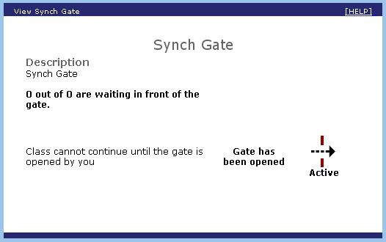

Example 2: viewing the status a Schedule gate
/lams/monitoring/gate.do?method=viewGate&activityId=34&lessonId=2

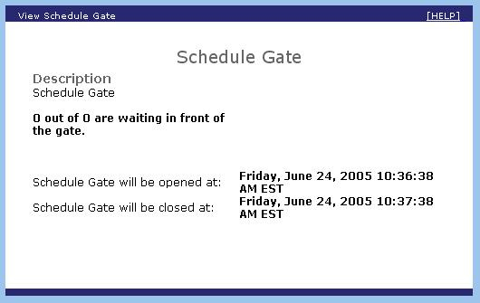

Example 3: viewing the status of a Permission gate
/lams/monitoring/gate.do?method=viewGate&activityId=35&lessonId=2

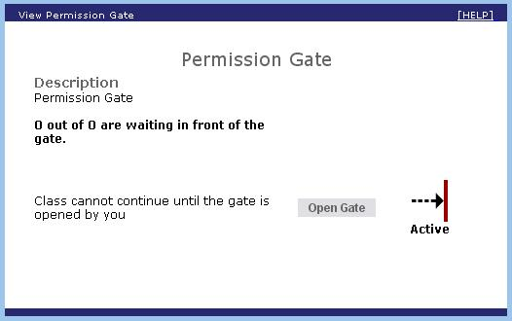

After pressing Open Gate button:

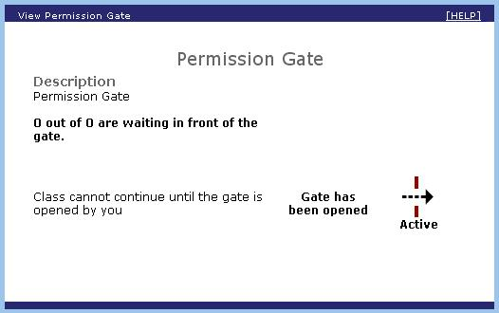

public ActionForward openGate(ActionMapping mapping,
ActionForm form,
HttpServletRequest request,
HttpServletResponse response)

Parameters:
activityId – The gate activity Id

Description: When called, it will navigate to the page and displays options to open the gate, if the gate is closed. The JSP page shown will depend on what type of gate it is and the description of what each page displays, is described in viewGate() function above.

