
AUTHORING Design Report

Version 1.3
Author: FIONA Malikoff
LAMS INTERNATIONAL
17 November 2005

Revision History
Name | Date | Reason For Changes | Version
Fiona Malikoff | 19 Aug 2005 | Replaces authoring notes document | 1.1
Fiona Malikoff | 14 Sept 2005 | Updated paths for lams_central move, and modified store paths for the new servlets | 1.2
Fiona Malikoff | 17 Nov 2005 | Clarified grouping | 1.3

Contents
1 Introduction 1
1.1 Scope 1
2 Learning Design and Related Notes 2
2.1 Grouping Examples 6
2.2 Store Learning Design Servlet 9
2.3 Authoring Action: getToolContentID(Long toolID) 9
3 Themes 10
3.1 Authoring Action: getTheme(Long themeid) 10
3.2 Authoring Action: getThemes() 11
3.3 Store Theme Servlet 11

Introduction

Scope
The authoring module supports the Flash authoring client. It primarily stores and retrieves learning designs and activity libraries.
For the moment, it also supports the definition of styles. This functionality may move to the central area.
For detailed explanation on each of the following methods listed below please refer to lams_central\src\java\org\lamsfoundation\lams\authoring\service\ IAuthoringService.java

Learning Design and Related Notes

Here is a list of entities in authoring and their properties.
Please note that it may be that not of all of these need to be sent to the UI (i.e. flash via WDDX) indicated by [f]
Note on ID’s: In general there is an id (previously ‘id’) for flash and also an equivalent pk id (previously ‘sid’). Flash will always use the internal id except for the learning_design_id which will be sent to flash on the initial save. We should introduce a standard way of identifying the flash id, perhaps ****_ui_id? As sometimes it is ambiguous – E.G. grouping_id is a a pk, so I have named it grouping_ui_id
Key:
+ = property added
- = property removed
# = property altered
??? = property that doesn't exist right now but probably should
//<blah> = a comment or question by me
pk = primary key = db identifier
[f] = needed by flash
Learning Design
learning_design_id (integer, 20 figures, DB PK - supplied at save time) [f]
id (int, nullable - used by flash?) [d.c: shoulc not be needed anymore]
description (text, nullable) [f]
title (255 characters, nullable)[f]
first_activity_id (int, PK of first activity, nullable)
first_id(flash generated id to indicate which is first activity, as above but not pk version)[f]
max_id (int, nullable - used by flash) [f]
valid_design_flag( 1 = true or 0 = false - indicates if this LD can be run as a lesson)[f]
read_only_flag(1 = true or 0 = false) [f][d.c: depends on how workspace/folder stuff works out]
date_read_only (date time nullable) [f?]
user_id (int, pk of creating user) [f?]
help_text (text, nullable) [f]
lesson_copy_flag ( 1 = true, 0 = false - indicates if this LD is a copy created for a lesson) [d.c:should not appear to authoring, lesson/monitor only]
create_date_time (datetime) [f]
# version (56 characters, nullable) //changed to nullable [f?]
parent_learning_design_id (int, nullable: pk of parent LD - could be the LD this is a copy of, or the previous version of the LD) [f?]
- open_date_time (datetime, nullable - first datetime when learners can begin the LD) //in lesson now
- close_date_time (datetime, nullable - last datetime when learners can being LD) //in lesson now
duration (int, nullable: milleseconds indicating how long the LD should run for)
workspace_folder_id (int, pk of folder where this LD resides) //replace by a join table instead?
??? some more metadata fields (ernie?)[f??]
Transition
learning_transition_id (int pk supplied at save time)
id (int nullable, used by flash) [f]
description (text nullable) [f]
title (255 characters nullable)[f]
to_acitivity_id (int nullable, pk of the activity this transition leads to) //why is this nullable?
from_activity_id (int nullable, pk of the activity this transition leads to) //why is this nullable?
learning_design_id (int, pk of LD this transition belongs to)
create_date_time (datetime)
+ to_id (int nullable used by flash)[f]
+from_id (int nullalbe used by flash)[f]

Activity
activity_id (int pk supplied at save time)
id (int, nullable, used by flash) [f]
description (text, nullable) [f]
title (255 characters, nullable)[f]
xcoord (int, nullable) [f]
ycoord (int, nullable) [f]
parent_activity_id (pk of parent activity, nullable - this will be set if this activity is inside a complex
activity which will be the parent activity)
parent_id (int, nullable used by flash ti indicate parent relationship)[f]
learning_activity_type_id (int enumeration: values indicate type of activity:(1='TOOL', 2='GROUPING_RANDOM', 3= 'GROUPING_CHOSEN', 4= 'GATE_SYNCH', 5='GATE_SCHEDULE', 6='GATE_PERMISSION', 7='PARALLEL', 8='OPTIONS', 9='SEQUENCE') [f]
grouping_id (int nullable: the pk of the grouping to be applied to this activity)
grouping_ui_id(?new name? Need some consistent way to identify the flash generated id system)[f]
order_id (int nullable, activities within a complex activity use this field to show order) [f]
define_later_flag (1 = true, 0 = false, default false) //not currently used [f: will need some way of flagging this to flash if this is not used]
learning_design_id (int nullable ,pk of learning design this activity is part of, activity must have either this or the learning_design_id set) <<?chris should this be library?
learning_libary_id (int nullable, pk of learning library this is part of, see above) [f]
create_date_time (datetime)
offline_instructions (text, nullable, instructions for use offline) [f]
GroupingActivity
createGroupingID (int, pk of grouping to be created by this activity)
createGroupingUIID (int) [f]
PermissionGateActivity
as Activity plus
gate_activity_level_id (int enumeration: 1 = learner, 2 = group, 3 =
class) [f]
ScheduleGateActivity
as Activity plus
- gate_start_date_time (datetime nullable, either this, the next one
or both should be set) //removed: replace with gate_start_time_offset [f]
- gate_end_date_time (datetime nullable, see above) ///removed: replace with gate_end_time_offset[f]
gate_activity_level_id (int enumeration: 1 = learner,2 = group, 3 =
class) //leave as 1 right now [f]
- gate_start_time_offset (long int, nullable, number of milliseconds from start of lesson to open gate, either this or the following or both should be set)[f]
- gate_end_time_offset (long int, nullable, number of milliseconds from start of lesson to close gate, either this or the one above or both should be set)[f]
SynchGateActivity
as Activity plus
gate_activity_level_id (int enumeration: 1 = learner, 2 = group, 3 =
class) //only 2 and 3 make sense for this one [f]
ToolActivity
as Activity plus
tool_id (int, pk of tool this activity uses)
tool_content_id (int, key used to identify content to tool)
tool_ui_id[f]
tool_content_ui_id[f]
ComplexActivity
<complext activities include an ordered set of other activities - in the db this is indicated by parent_activity_id and order_id>
ParallelActivity
as ComplexActivity
SequenceActivity (not used in 1.1)
as ComplexActivity
OptionsActivity
as ComplexActivity plus
max_number_of_options (int 5 figures, default 0) [f]
max_number_of_options (int 5 figures, nullable) [f]
+ option instructions (text, nullable)[f]
Grouping
groupingID (integer pk supplied at save time)
groupingUIID [f]
groupingTypeId (int enum: 1 = RandomGrouping, 2 = ChosenGrouping [f]
+ id (int nullable used by flash)[f]
ChosenGrouping
as Grouping
RandomGrouping
as Grouping plus
numberOfGroups (int, number of groups to create, one of either
this one or the following) [f]
learnersPerGroup (int, number of learners in each created group,
see above) [f]
LearningLibrary //not needed right now by UI
[f:each library activity is contained within one LearningLibrary. Should this be represented in the flash WDDX??]
learning_library_id (integer pk)
description (text)
title (255 characters)
create_date_time (datetime)
[f: To be decided]
Workspace
workspace_id (integer pk supplied at save time)
root_folder_id (pk of root folder: should be created when workspace is created)
+ name field (255 characters)
WorkspaceFolder
workspace_folder_id (integer pk supplied at save time)
parent_folder_id (pk of parent folder, nullable)
name (64 characters)

Grouping Examples
The grouping is a bit hard to understand, so a couple of examples are given below to illustrate the structure.
Each grouping activity creates a grouping. An activity that is grouped is related to a grouping – and not to the grouping activity.
Example 1: Q&A activity done with a Random Grouping. This is would be like splitting a high school class into groups to answer the question. Initial data on client. The UIID fields are used to link the objects.
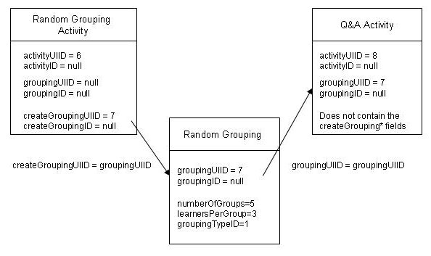
When the data is sent from the client to the server, only the grouping activities should include the createGroupingUIID, createGroupingID fields.
When the data is sent back from the server to the client, only the grouping activities should include the createGroupingUIID, createGroupingID fields. In the current example packet learning_design.xml, it shows all activities with the createGrouping* fields – this is not correct. While these fields exist in our flattened AuthoringActivityDTO, the fields should be null and hence should not be included in the wddx packet (null fields not sent from server to client).
The details required to make up the groups (numberOfGroups, leanersPerGroup) are in the grouping, not in the grouping activity. The grouping activities are in an array of their own – the groupings are not stored as part of the activity structure.
Example 2: Noticeboard, done with a Random Grouping. After saving onto server (which sets the ID fields).
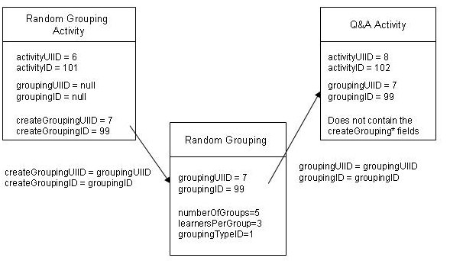
Example 3: Two levels of grouping. The entire lesson is split into groups using a chosen grouping, and then the chosen groups are further split using random grouping. The Q&A activity is done with the Random Grouping. This is would be like splitting an entire course (e.g. 600 people) into 6 streams, and then randomly grouping student from a stream into a tutorial size group. The diagram below shows the initial data on client. The UIID fields are used to link the objects.
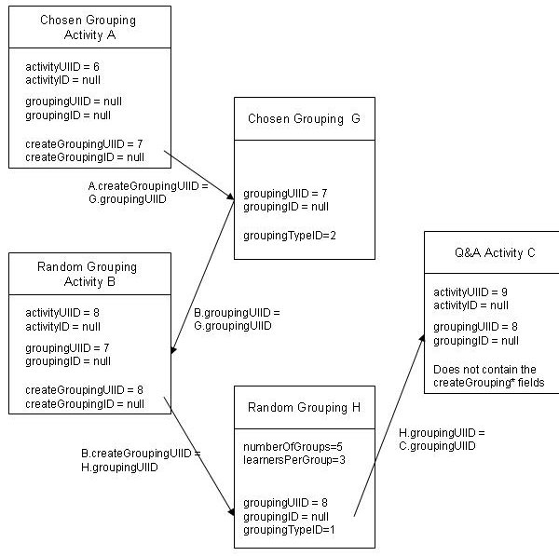

Store Learning Design Servlet
POST Body: Learning Design packet
URL: http://<server>/lams/authoring/ authoring/storeLD
Returns:
A WDDX packet containing the
design id Unique id for this theme
Sample Input Packet:
See storeLearningDesignDetails.xml for a sample packet.

Sample Output Packet:
<wddxPacket version='1.0'><header/><data>
<struct type='Lorg.lamsfoundation.lams.util.wddx.FlashMessage;'>
<var name='messageKey'><string>storeLearningDesignDetails</string></var>
<var name='messageType'><number>3.0</number></var>
<var name='messageValue'><number>6.0</number></var></struct></data></wddxPacket>

Authoring Action: getToolContentID(Long toolID)
This method generates a new tool content id for an activity. It uses the ToolContentIDGenerator to get the next tool content id.
Parameters: toolID
URL: http://<server> /lams/authoring/author.do?method=getToolContentID&toolID=<value>
Returns:
A WDDX packet containing the
toolContentID the new tool content id required

Sample Output Packet:
<wddxPacket version='1.0'><header/><data>
<struct type='Lorg.lamsfoundation.lams.util.wddx.FlashMessage;'>
<var name='messageKey'><string>getToolContentID</string></var>
<var name='messageType'><number>3.0</number></var>
<var name='messageValue'><number>6.0</number></var></struct></data></wddxPacket>

Themes

Authoring Action: getTheme(Long themeid)
Get a theme based on the theme’s unique id.
Parameters: themeID
URL: http://<server>/lams/authoring/author.do?method=getTheme&themeID=<value>
Returns: WDDX Packet with CSSThemeDTO in the messageValue field.
Sample WDDX Packet
<wddxPacket version='1.0'><header/><data>
<struct type='Lorg.lamsfoundation.lams.util.wddx.FlashMessage;'>
<var name='messageKey'><string>getTheme</string></var>
<var name='messageType'><number>3.0</number></var>
<var name='messageValue'>
<struct type='Lorg.lamsfoundation.lams.themes.dto.CSSThemeDTO;'>
<var name='baseStyleObject'><struct>
<var name='borderStyle'><string>outset</string></var>
<var name='_tf'><struct>
<var name='color'><number>1.2452097E7</number></var>
</struct></var>
<var name='rollOverColor'><number>1.671168E7</number></var>
</struct></var>
<var name='description'><string>cut down ruby theme for testing</string></var>
<var name='id'><number>1.0</number></var>
<var name='name'><string>ruby</string></var>
<var name='visualElements'><array length='1'>
<struct type='Lorg.lamsfoundation.lams.themes.dto.CSSVisualElementDTO;'>
<var name='name'><string>button</string></var>
<var name='styleObject'><struct>
<var name='_tf'><struct>
<var name='display'><string>block</string></var>
</struct></var>
<var name='selectionColor'><number>1.6711681E7</number></var>
</struct></var>
</struct>
</array></var>
</struct>
</var>
</struct></data></wddxPacket>

Authoring Action: getThemes()
Parameters:
URL: http://<server>/lams/authoring/author.do?method=getThemes
Returns: WDDX Packet with an array of CSSThemeDTO objects in the messageValue field.
Sample WDDX Packet:
<wddxPacket version='1.0'><header/><data>
<struct type='Lorg.lamsfoundation.lams.util.wddx.FlashMessage;'>
<var name='messageKey'><string>getThemes</string></var>
<var name='messageType'><number>3.0</number></var>
<var name='messageValue'><array length='2'>
<struct type='Lorg.lamsfoundation.lams.themes.dto.CSSThemeBriefDTO;'>
<var name='description'><string>cut down ruby theme for testing</string></var>
<var name='id'><number>1.0</number></var>
<var name='name'><string>ruby</string></var>
</struct>
<struct type='Lorg.lamsfoundation.lams.themes.dto.CSSThemeBriefDTO;'>
<var name='description'><string>theme used for testing</string></var>
<var name='id'><number>3.0</number></var>
<var name='name'><string>AuthoringTestTheme</string></var>
</struct>
</array></var></struct>
</data></wddxPacket>

Store Theme Servlet
POST Body: Theme packet
URL: http://<server>/lams/authoring/ authoring/storeTheme
Returns:
A WDDX packet containing the
themeid Unique id for this theme
Sample Input Packet:
<wddxPacket version=1.0><header /><data><struct>
<var name=baseStyleObject><struct>
<var name=borderStyle><string>outset</string></var>
<var name=rollOverColor><number>16711680</number></var>
<var name=selectionColor><number>16711680</number></var>
<var name=themeColor><number>16711680</number></var>
<var name=_tf><struct>
<var name=font><string>_sans</string></var>
<var name=size><number>10</number></var>
<var name=color><number>12452097</number></var>
<var name=display><string>block</string></var>
</struct> </var>
</struct></var>
<var name=name><string>AuthoringTestTheme</string></var>
<var name=description><string>theme used for TestAuthoringService</string></var>
<var name=visualElements>
<array length=1>
<struct>
<var name=name><string>button</string></var>
<var name=styleObject><struct>
<var name=borderStyle><string>outset</string></var>
<var name=rollOverColor><number>16711680</number></var>
<var name=selectionColor><number>16711680</number></var>
<var name=themeColor><number>16711680</number></var>
<var name=_tf><struct>
<var name=color><number>7174353</number></var>
<var name=display><string>block</string></var>
</struct></var>
</struct></var>
</struct>
</array>
</var>
</struct></data></wddxPacket>;

Sample Output Packet:
<wddxPacket version='1.0'><header/><data>
<struct type='Lorg.lamsfoundation.lams.util.wddx.FlashMessage;'>
<var name='messageKey'><string>storeTheme</string></var>
<var name='messageType'><number>3.0</number></var>
<var name='messageValue'><number>9.0</number></var>
</struct></data></wddxPacket>

