Monitoring Functionality
Author: Manpreet Minhas

For detailed explanation on each of the following methods listed below please refer to
lams_monitoring\src\java\org\lamsfoundation\lams\monitoring\service\ IMonitoringService.java

getAllLessons()

Sample WDDX Packet
<wddxPacket version='1.0'><header/><data><struct type='Lorg.lamsfoundation.lams.util.wddx.FlashMessage;'><var name='messageKey'><string>getAllLessons</string></var><var name='messageType'><number>3.0</number></var><var name='messageValue'><array length='2'><struct type='Lorg.lamsfoundation.lams.lesson.dto.LessonDTO;'><var name='lessonDescription'><string>This is for testing</string></var><var name='lessonId'><number>1.0</number></var><var name='lessonName'><string>Test_Lesson</string></var><var name='lessonStateId'><number>3.0</number></var></struct><struct type='Lorg.lamsfoundation.lams.lesson.dto.LessonDTO;'><var name='lessonDescription'><string>Test_Description</string></var><var name='lessonId'><number>2.0</number></var><var name='lessonName'><string>Test_Lesson</string></var><var name='lessonStateId'><number>3.0</number></var></struct></array></var></struct></data></wddxPacket>

getLessonDetails(lessonID)
Parameters:
lessonID

Sample WDDX Packet
<wddxPacket version='1.0'><header/><data><struct type='Lorg.lamsfoundation.lams.util.wddx.FlashMessage;'><var name='messageKey'><string>getLessonDetails</string></var><var name='messageType'><number>3.0</number></var><var name='messageValue'><struct type='Lorg.lamsfoundation.lams.lesson.dto.LessonDetailsDTO;'><var name='createDateTime'><dateTime>2005-2-23T17:37:25+10:0</dateTime></var><var name='duration'><number>-111111.0</number></var><var name='learningDesignID'><number>1.0</number></var><var name='lessonID'><number>1.0</number></var><var name='lessonStateID'><number>3.0</number></var><var name='licenseID'><number>-111111.0</number></var><var name='licenseText'><string>string_null_value</string></var><var name='organisationDescription'><string>Root Organisation</string></var><var name='organisationID'><number>1.0</number></var><var name='organisationName'><string>Root</string></var><var name='startDateTime'><dateTime>1970-1-1T10:0:0+10:0</dateTime></var><var name='workspaceFolderID'><number>2.0</number></var></struct></var></struct></data></wddxPacket>

getLessonLearners(lessonID)
Parameters:
lessonID

Sample WDDX Packet
<wddxPacket version='1.0'><header/><data><struct type='Lorg.lamsfoundation.lams.util.wddx.FlashMessage;'><var name='messageKey'><string>getLessonLearners</string></var><var name='messageType'><number>3.0</number></var><var name='messageValue'><array length='1'><struct type='Lorg.lamsfoundation.lams.usermanagement.dto.UserDTO;'><var name='firstName'><string>Kevin</string></var><var name='lastName'><string>Han</string></var><var name='login'><string>test</string></var><var name='userID'><number>2.0</number></var></struct></array></var></struct></data></wddxPacket>

getLearningDesignDetails(Long lessonID)
Parameters:
lessonID
Returns:
A copy of the sample WDDX packet returned by this method has been uploaded into the CVS under lams_documents/lams_authoring/sample_wddx_packets/ learning_design.xml. It was too large to copy here.

getAllLearnersProgress(Long lessonID)

There was no sample data available so I couldn’t generate the sample WDDX packet here.

getAllContributeActivities(Long lessonID)
Parameters:
lessonID
Returns:
A copy of the sample WDDX packet returned by this method has been uploaded into the CVS under lams_documents/ UI_Design_docs/ monitor/ getAllContributeActivities_3.xml. It was too large to copy here.

getLearnerActivityURL(Long activityID,Integer userID)
Parameters:
activityID
userID

Sample WDDX Packet
<wddxPacket version='1.0'><header/><data><struct type='Lorg.lamsfoundation.lams.util.wddx.FlashMessage;'><var name='messageKey'><string>getLearnerActivityURL</string></var><var name='messageType'><number>3.0</number></var><var name='messageValue'><struct type='Lorg.lamsfoundation.lams.learningdesign.dto.ProgressActivityDTO;'><var name='activityID'><number>29.0</number></var><var name='activityURL'><string>/lams_tool_survey/tool/survey/survey.do?method=loadQuestionnaire&amp;mode=teacher&amp;sessionId=1</string></var></struct></var></struct></data></wddxPacket>

getActivityContributionURL(activityID)
Parameters:
activityID

Sample WDDX Packet
<wddxPacket version='1.0'><header/><data><struct type='Lorg.lamsfoundation.lams.util.wddx.FlashMessage;'><var name='messageKey'><string>getActivityContributionURL</string></var><var name='messageType'><number>3.0</number></var><var name='messageValue'><string>contribute_url</string></var></struct></data></wddxPacket>

moveLesson(lessonID, folderID, userID)
Parameters:
lessonID
folderID
userID

Sample WDDX Packet
<wddxPacket version='1.0'><header/><data><struct type='Lorg.lamsfoundation.lams.util.wddx.FlashMessage;'><var name='messageKey'><string>moveLesson</string></var><var name='messageType'><number>3.0</number></var><var name='messageValue'><number>3.0</number></var></struct></data></wddxPacket>

renameLesson(lessonID, name, userID)
Parameters:
lessonID
name
userID

Sample WDDX Packet
<wddxPacket version='1.0'><header/><data><struct type='Lorg.lamsfoundation.lams.util.wddx.FlashMessage;'><var name='messageKey'><string>renameLesson</string></var><var name='messageType'><number>3.0</number></var><var name='messageValue'><string>New name after renaming</string></var></struct></data></wddxPacket>

checkGateStatus(activityID, lessonID)
Parameters:
activityID
lessonID

Example URL: /lams/monitoring/monitoring.do?method=checkGateStatus&activityID=33&lessonID=2

Sample WDDX Packet
<wddxPacket version='1.0'><header/>
<data>
<struct type='Lorg.lamsfoundation.lams.util.wddx.FlashMessage;'>
<var name='messageKey'><string>checkGateStatus</string></var>
<var name='messageType'><number>3.0</number></var>
<var name='messageValue'>
<struct>
<var name='activityID'><number>33.0</number></var>
<var name='gateOpen'><boolean value='false'/></var>
<var name='waitingLearners'><number>0.0</number></var>
<var name='activityLevelID'><number>3.0</number></var>
</struct></var></struct></data></wddxPacket>

checkGateStatus(activityID)
Parameters:
activityID

Example URL:
/lams/monitoring/monitoring.do?method=releaseGate&activityID=33

Sample WDDX Packet
<wddxPacket version='1.0'><header/>
<data>
<struct type='Lorg.lamsfoundation.lams.util.wddx.FlashMessage;'>
<var name='messageKey'><string>releaseGate</string></var>
<var name='messageType'><number>3.0</number></var>
<var name='messageValue'>
<boolean value='true'/>
</var></struct></data></wddxPacket>

For detailed explanation on each of the following actions listed below please refer to
lams_monitoring\src\java\org\lamsfoundation\lams\monitoring\web\GateAction.java

public ActionForward viewGate(ActionMapping mapping,
ActionForm form,
HttpServletRequest request,
HttpServletResponse response)

Parameters:
lessonId – The lesson id of the lession
activityId – The gate activity id

Description: Allows the teacher to view the status of the gate and force the gate to open, if the gate is closed. The information displayed on the page will vary according to what type of gate it is. If the gate is a:-
Sync Gate – the JSP page will output how many learners are waiting and the size of the class. Displays the current status of the gate and contains the option to open the gate.
Permission Gate- the JSP page will output how many learners are waiting and the size of the class. Displays the current status of the gate and contains the option to open the gate.
Schedule Gate- the JSP page will output how many learners are waiting and the size of the class. Displays the time in which the gate will open and the time at which the gate will close.

Some example screen shots:

Example 1: viewing the status of a sync gate
/lams/monitoring/gate.do?method=viewGate&activityId=33&lessonId=2

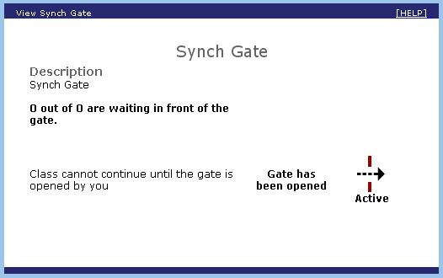

Example 2: viewing the status a Schedule gate
/lams/monitoring/gate.do?method=viewGate&activityId=34&lessonId=2

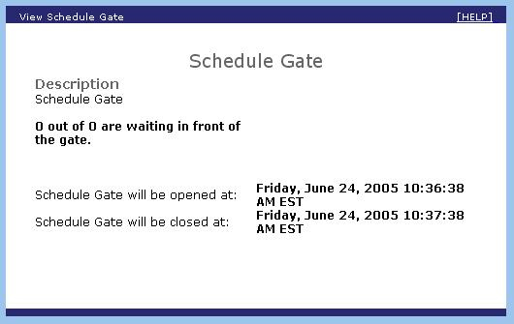

Example 3: viewing the status of a Permission gate
/lams/monitoring/gate.do?method=viewGate&activityId=35&lessonId=2

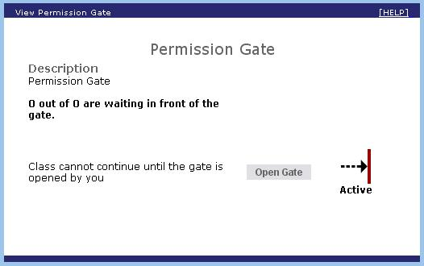

After pressing Open Gate button:

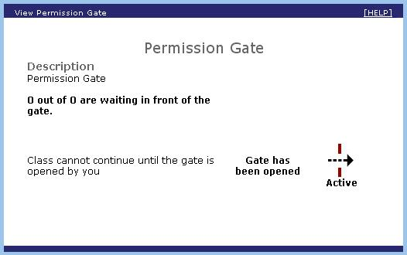

public ActionForward openGate(ActionMapping mapping,
ActionForm form,
HttpServletRequest request,
HttpServletResponse response)

Parameters:
activityId – The gate activity Id

Description: When called, it will navigate to the page and displays options to open the gate, if the gate is closed. The JSP page shown will depend on what type of gate it is and the description of what each page displays, is described in viewGate() function above.

