

Content Repository Design

Draft Version 1.1
Author: Fiona Malikoff
LAMS INTERNATIONAL
08/04/2005

Contents
Introduction 3
1.1 Scope 3
1.2 Design Overview 3
1.3 Constraints 3
1.4 References 3
1.5 Glossary 3
Overall Requirements 4
1.6 Future Requirements 4
Content Repository Use Cases 5
Content Repository: Functional Description 6
1.7 Repository and Workspaces 6
1.8 1.12 Authorisation 6
1.9 Content / Node Types 6
1.10 Content Storage and Retrieval 7
1.11 Transactions 9
Content Repository: Object Data Model 10
1.12 Installation and Use of the Content Repository 10
1.13 Content Repository Class Diagram: Core Interfaces 10
1.14 Node Types and Property Values 12
1.14.1 Supported Node Types 13
1.14.2 Supported Property Values 14
Runtime Data Model 15
1.15 Database schema 15
1.16 Data Definition 16
Appendix A JSR-170 Comparisons 18
Appendix C Open Source Products / Frameworks Reviewed 20

Figure 1 Content Repository object diagram: Core Interfaces 11
Figure 2 Content Repository object diagram: Interface Implementations and Hibernate Objects 11
Figure 2 Database schema for runtime data model 15

Revision History
Name | Date | Reason For Changes | Version
Fiona Malikoff | 9 DEC 2004 | Initial Version - contained details for content repository and file manager. | 0.5
Fiona Malikoff | 13 DEC 2004 | Added more detail on file manager plus a few other notes on content repository. | 0.6
Fiona Malikoff | 15 DEC 2004 | Major overhaul based on review. Removed file manager functionality - to be specified separately. Content repository functionality simplified for LAMS 1.1 | 0.7
Fiona Malikoff | 15 APR 2005 | Updated based on actual implementation. Initial version placed in CVS | 1.1

Introduction

Scope
This document is design to illustrate the system design of a content repository for LAMS 1.1. It is an overall design description of the repository service, with some background notes on the design. The actual API for the repository is available as Javadoc.

Design Overview
LAMS 1.1 will need a Content Repository to store the various content. The content repository will be used by various tools to store files. This will include the LAMS “Workspace” component and the IMS Content Package tool, which will use the content repository to store files.
For LAMS 1.1, the content repository will only store files and packages of files. In future versions of LAMS, the content repository will be extended to include support for arbitrary bits of text.
The LAMS Workspace component will be specified elsewhere. The Authoring Environment will not store the sequence details in the content repository in LAMS 1.1.
The Content Repository side was designed after reviewing the JSR-170 Content Repository API for JavaTM Technology specification. Some of the concepts of the specification have been used but the LAMS content repository will (initially) be much simpler.
Reusing an existing open source products/frameworks for the repository does not appear to be viable at this point. See Appendix A for some brief notes on frameworks that were considered for use. If we extend the content repository functionality in the future, we will look again at using a third party product. Hopefully more there will be more choices of products compatible with JSR-170 at that time.

Constraints

References
LAMS Glossary Document:
JSR-170 Specification: Content Repository API for JavaTM Technology Specification JSR-170 (Draft)

Glossary
For a complete glossary of LAMS related terms, see the LAMS Glossary Document.
UUID: universally unique identifier. Term comes from JSR-170

Overall Requirements

The content repository / file manager components have the following requirements.
- Various types of file content (text and binary) will need to be persisted and retrieved.
- Files will need to be persisted in the filesystem. A download to many people of a very large file delivered almost simultaneously from a database will not meet performance requirements.
- Content needs to be immediately accessible. That is, we cannot create the content now and then publish it later – which is the model used for many website development content repositories.
- Each piece of content requires a unique identifier (item_id).
- Content needs to be versioned, with a unique version identifier (version_id). Each version will have the same item_id but a unique version. Therefore item_id has a 1-to-many relationship with version_id.
- Need to be able to support “packaged” or “linked” content.
For example, the teacher has an html file and 6 images. All 7 files need to be stored in the content repository and must be able to be returned to a tool or to a browser to rendered to the user as a normal web page.
Another example is an IMS Package. An IMS Package tool must be able to store a set of files into the repository, and be able to access them as a structured package later.
- Content should be removable. That is, if content is inappropriate, there should be a method of hard deletion.
- Content access will be based on the tool identifying itself to a repository. Once identified, the tool has access to a set of content applicable to that tool. User based security will need to be implemented by the tool – it will not be supported by the repository.

Future Requirements
These requirements may be needed in the future.
- Fragments of data need to be persisted. e.g. journal entries.
- Content could be archived. For example, move content relating to an older sequence onto a DVD. This is a large feature to implement, as all the data for a sequence would need to be archived together, so it isn’t just a matter of the content repository involved. This is for the future and will not implemented in the immediate versions of LAMS.

Content Repository Use Cases
User cases for the content repository are yet to be compiled in detail. The initial uses of the repository will be as follows:
LAMS Workspace tool uses content repository to store/retrieve files and packages of files for display in workspaces.
IMS Content Package tool uses content repository to access previously uploaded packages to display content to users.

Content Repository: Functional Description

Repository and Workspaces
There will be one repository made up of multiple workspaces.
The content repository will stored a list of associated tools against each workspace. A tool that is associated with a workspace may make any changes to content in that workspace – create new content, update content or delete content.
It is up to the tool to enforce all user based restrictions in its own workspace. A tool may have more than one workspace if needed.
Workspace names will use a similar naming convention as the database table naming convention. It is probable that in most cases, there will be only one tool (or multiple versions of the same tool) that access a workspace.
Note: The workspaces that are views in the LAMS Workspace component are different to the content repository workspaces. The LAMS Workspace component will have one (or more) workspaces in the content repository and the component will layer its own workspaces over the top. The repository will not know anything about the LAMS Workspace component’s workspaces.
Content repository workspaces will be accessed via a ticket. There is a 1-1 relationship with a “ticket” used to access the repository. Therefore, to access more than one workspace requires more than one ticket to be used at a time.
Repository configuration (such as the location of the files) will be done using Spring configuration methods or via an MBean interface.

1.12 Authorisation
A client tool will connect to the repository by providing a Creditionals object, specifying a particular workspace in the repository. Logging into the repository with the Creditionals results in a Ticket being created. The Ticket is then used to access the nodes (and properties) in the node tree.
Tools will need to have a way to identify themselves, and this identity will be checked against the security settings stored in the workspace. Initially the identification will be a simple object such as a string – similar to a password.
Presumably we will still need someone with the privilege to clean up any content. Can this easily tap into the existing super administrator?

Content / Node Types
Content will be represented in a tree form, with each piece of content stored as a node. Each workspace has its own root node, and the content for that workspace will be keep in a fairly flat tree under the root node.
There is one Node class, but it can have one of many types. All nodes will have a single primary node type and may have one or more mixin types. Types of nodes include a simple type for fragment of text, a file type for files, a package type for sets of files (e.g. an HTML file and its related images). See Node Types under Data Model for the supported Node Types.
All nodes will be referenceable and versioned. The universally unique identifier (UUID) will be unique across the whole repository. So all nodes will have a mixin node type of referenceable (i.e. the node has a UUID ).
All simple content nodes, file and folder nodes will go directly under the root node. The package nodes (e.g. html page and set of images) will also go directly under the root node and will form the root of a sub-tree containing the nodes for the package.
All content must be timestamped for legal/accountability reasons, so the basic node type will include a date/timestamp. The timestamps will be stored in human readable form (not number of milliseconds or some other form requiring calculation) for ease of reporting/viewing. They will be stored in UTC (universal time, roughly equivalent to GMT) to ensure compatibility across time zones.
Nodes can be accessed by their unique id, their absolute path or by traversing the nodes. The most common use will be by their unique id. The traversal method will only be useful for complex content.
Node changes are not persisted automatically. The node is updated, then Node.save() or Ticket.save() is used to update the data. Whenever a node is saved, a new version will be created. When a node is retrieved, a specific version will be retrieved if a version is supplied, otherwise the current version will be retrieved. Note: Versioning will not be done in a JSR-170 manner (see Appendix A for more details).
Each node will have a node entry, stored in XML format, in the file system. There will be one node entry file for each version of the node. For simple node types, the data will be stored in the node entry. The nodes representing files will require two files - If we use XML and store the nodes in the file system, then the small chunks of text for a text type or a journal type node could have the node data stored in the node file itself. The file type nodes would require two files – one for the node and one for the file.

Content Storage and Retrieval
All files are to be stored in the file system. If it unlikely that any database would be able to simultaneously large media files (e.g. movies) to a large number of users without severe service degradation. Note: this is something we are going to need to test extensively to ensure we serve the files fast enough anyway!
We can assume that the number of content items will be large. For example, assume a sequence has 5 points in which the learner creates a journal entry. One Lesson running this sequence with 20 users will result in 100 journal entries. This sequence run 10 times will result in 1000 journal entries alone.
Simple content will be represented as a node and stored using an XML formatted file.
Each file has an id <item_id> and a version id <version_id>. Each item_id is split into a series of 2 characters and this becomes a directory path. The node meta-data will be stored in the database. The data file will be stored as <version_id> (i.e. no extension).
In the future when we store fragments of text in the content repository, we may put the text in the node details in the database, or create a text file containing the text in the filesystem.
In this manner, each piece of content will have its own directory, which will contain all the versions of this content. All higher level directories will have a maximum of 99 directories, reducing the look up time in the filesystem. Should any piece of content have hundreds of revisions, then there may be some performance impact in filesystem lookups but it should only be for that file.
For example, say there is a file MyReport.doc, that is stored as item #4522. The first time the document is saved, a directory path “45/22” will be created (mkdir -p /45/22) and the file will be stored as “1”. A second version of the file would be stored as “2”.
When the file is returned to the user, the user should still see it as “MyReport.doc”.
So the directories will look like:
45
| ¬ 22
| | — 1
| | — 2
All content will be accessed by a call to the content repository. The files will be returned as stream (e.g. a servlet is called which retrieves the file and writes it as a stream back to the response output stream) rather than giving direct access to the web app address.
Returning content via a stream is preferred for security reasons. If the client tools have to request the data from repository software explicitly, then we can check the creditionals of the user/tool. If we give the “direct” path to a tool, then it can store that path and reuse it later without any reference to our security model. Allowing any software except the repository to know the format of the storage is a security risk.
Ideally, any URL used to access the content repository should not contain the id of the data - the id should be stored in the session if possible. The initial prototype code does put the id on the URL, and if it proves too difficult to put it in the session (as the data will be persisted long after the id is no longer applicable) then the id will be placed in the URL.
Returning files via a stream allows the repository directories to exist anywhere in the filesystem. That is, they do not need to be under the webapp.
Package data (such as a set of html files) will be broken into a node for each of its parts and an overall grouping node. When the data is uploaded, the tool may supply an “entry point” for the content e.g. index.html. If the tool doesn’t supply an entry point then it will be assumed to be “index.html”. Each package will have an id, and access to files within this package will be via a combination of the package id and a relative path.

Transactions
A tool using the content repository creates a ticket, makes a series of calls to get content nodes, updates various nodes and then calls IRepository.updateFileItem() or IRepository.updatePackageItem () to save the changes. Each change will create a new version.
Putting a transaction around changes is hard as filesystem changes cannot be rolled back easily. As the node data will be stored in the database, the database locking will be used as the initial check of whether the content may be updated.
Out Of Order Updates
The content repository stores the updates as supplied by the calling web module – no checking that a change has been made to a node between the node being read and the node being updated will be done.
For example: Assume a node is accessed by a tool for User A, and then read again for User B. User B makes a change and the tool calls updateFileItem() based on the changes of User B. If User A then makes changes and the tool calls updateFileItem(), then the change made by User B is “lost”. As a new version is created each time an update occurs, and there are very few properties stored against content, this should not be a major issue. If the content repository is to be used to store many properties against the content, then this will need to be changed.
The transactioning is designed to support the repository running as a standalone server, or to be run as multiple instances all using the same database (i.e. in a cluster). The only caching used is the JBOSS cache, which will (hopefully) detect the change and clear the caches. This needs to be tested during the testing phase!!!!
Transaction Order
For each node to be updated, the node record (in the database) will then be updated with the new details. This will take a database lock on node in the database. (Note: this may allow deadlocks to arise if two calls are trying to update the nodes in a different order).
If all nodes can be updated, then for each node the repository will attempt to store all the files in the filesystem. If there are conflicting files, then the update will fail and the database will be rolled back. An administrator will need to remove the conflicting file manually. If it fails on anything but the first file, then there will be invalid files in the filesystem that will need to be erased manually.
We need to build an admin screen for managing the file problems!!!!

Content Repository: Object Data Model

Installation and Use of the Content Repository
The content repository is delivered as a jar file, lams_content_repository.jar.
There is a war file that may be built (lams_content_repository.war). This is for illustration purposes only and should not be installed in a production environment. The war file shows how a servlet may be used to return the files in the repository to the browser. In particular, it shows how to get a series of related pages such as an HTML page and the related images, in a manner suitable for a web browser.

Content Repository Class Diagram: Core Interfaces
These diagrams specify the main interfaces used to model the content repository. All of these interfaces will be implemented with concrete classes. They have been modeled as interfaces to allow the implementations to be modified in the future if desired. The use of interfaces also allows for factory creation, such that supported by the Spring framework.
Figure 1 gives the core interfaces.
All access to the content repository will be via the RepositoryProxy object. Tools will call the RepositoryProxy, which will return an IRepositoryService object.
Tools “login” to the repository using an ICredentials object. The login returns an ITicket object, which is used in any further calls to identify the tool to the repository. Once the tool has an ITicket, it can add and update files and packages (addFileItem, addPackageItem, updateFileItem, updatePackageItem), get previously stored items and delete previously stored items.
Each item may have multiple versions. When a tool requests a stored item, an IVersionedNode object is returned. This represents a particular version of an item. Each IVersionedNode has a set of properties, and each property is of type IValue. The IVersionedNode may also have child nodes (if it is a package node).
The tool can also request a list of all the versions for a node (getVersionHistory()). The version history is a list of IVersionDetail items.
There are also two Admin interfaces. They should be ignored by tools – they are used to define extra methods needed for management of the repository.

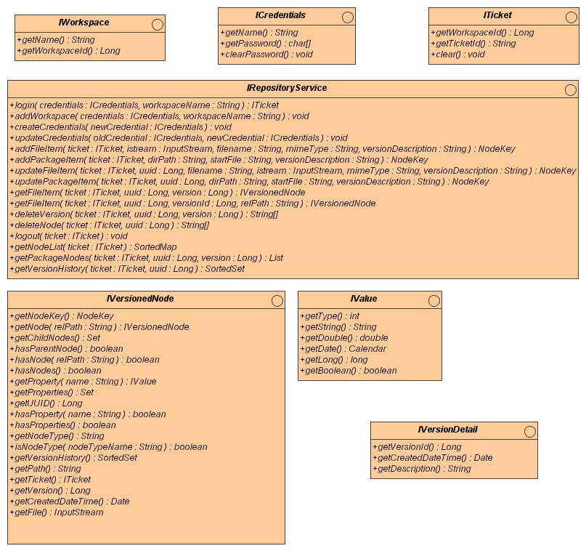
Figure 1 Content Repository object diagram: Core Interfaces

Figure 2 Content Repository object diagram: Interface Implementations and Hibernate Objects
(See next page)
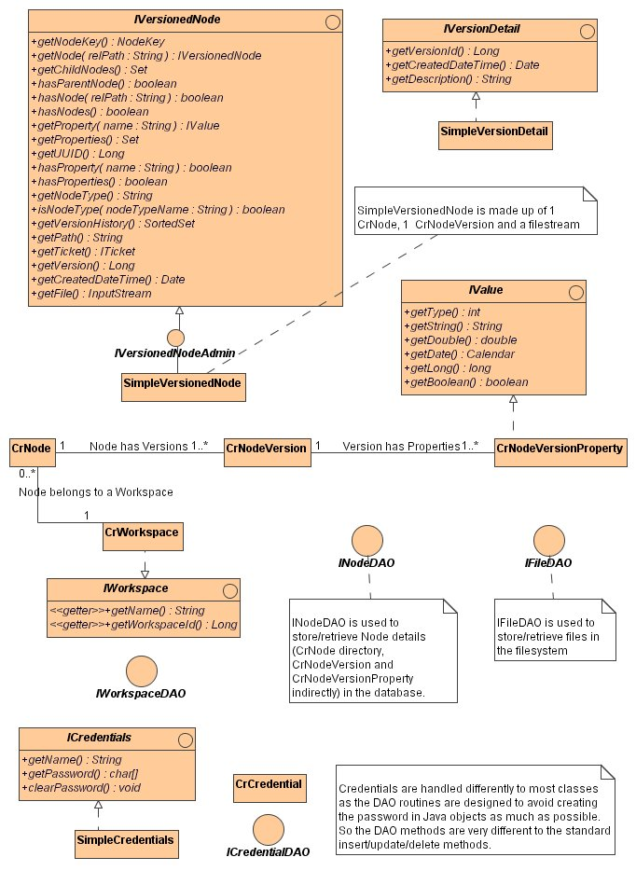

Node Types and Property Values
There is one Java class representing a node, but a node may have one of many primary node types. Initially, LAMS will support two node types – “package” and “file”. When arbitrary content is added later, then we may add a third type of “simple”.
Initially it was proposed to define the node types in a manner used in JSR-170, where the allowed properties and children of nodes are defined declaratively. This will not be implemented in LAMS 1.1 although it may be revisited later. Instead, we have hardcoded the checking for mandatory properties against node type.
The prototype objects will be built using Spring factories. For applications that wish to use the content repository but do not use the Spring framework, a node creation factory which uses the Spring framework will be supplied.
Note: all nodes have a type, a UUID, a path and a created date. As they are not stored as properties, they are not described in the Supported Node Type tables to follow. They have the following (Java) types and default values. All the values are read only.
Name | Type | DefaultValue | Source?
UUID | String | None | Autogenerated
TYPE | int | lams:package | Autogenerated
PATH | String | None | Supplied when node is created
CREATION_DATE | Date | UTC Date & time of creation of the node | Autogenerated

Supported Node Types
Note: we are using a namespace notation of “lams:” to indicate that these are basic types supported by LAMS. They are based on the node types from JSR-170 with changes to support our requirements. The Mandatory and Read Only columns are given as indicators– they may or may not be validated. However, if tools do not respect the guidelines, the system may not function correctly.
Note: more properties may be added during development of the repository.
lams:file
This represents a single file.
These nodes may have other arbitrary properties that the tool may add.
A lams:file cannot have child nodes.
Property Definitions:
Name | Type | DefaultValue | Mandatory | ReadOnly
DATA | BINARY | None | true | false
MIMETYPE | STRING | None | false | false
<any value> | <any type> | None | false | false

lams:package
This represents a group of related content, such as a webpage and related images or an IMS package. A zip file will be uploaded to a tool and the tool will pass the repository a directory path containing the files. The tool may supply the entry path. The system relies on the files in the package being internally consistent, using relative paths.
These nodes may have other arbitrary properties that the tool may add.
When a new version of a package node is created, all the sub-nodes will need to be compared with the new package version. Any modified nodes will need to be versioned, along with the package node.
A lams:package can have any number of child nodes. These will be the actual files in the package. They are expected to be of type lams:file.
Property Definitions:
Name | Type | DefaultValue | Mandatory | ReadOnly
ENTRYFILE | String | “index.html” | true – will use default if not supplied | false
<any value> | <any type> | None | false | false

Supported Property Values
All properties will be defined as Value objects. A Value object has a type STRING, BINARY, LONG, DOUBLE, DATE and BOOLEAN.
All nodes can have at most one property of type BINARY, and this is the file to be stored in the filesystem. Even a text file will have a type of BINARY.
All other types are stored in the database. The type is used to convert the values to/from Strings for persisting in the database. A property type of STRING is preferred, as that requires no conversion.
Any dates formatted as strings will be in the ISO8601-compliant format: YYYY-MM-DDThh:mm:ss.sssTZD

Runtime Data Model

Database schema
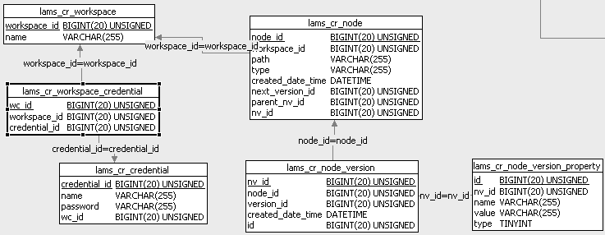
Figure 3 Database schema for runtime data model

The content repository tables are set up as part of the lams_common tables. They all have a “lams_cr” prefix. See the clay model in the lams_common CVS module for table details.
The data definition tables have not been included. See the clay model for more details.

Appendix A JSR-170 Comparisons
Repository and Workspaces
The JSR-170 concept of a workspace is a tree of content nodes, which may or may not have a universally unique identifier (UUID). Each node can only belong to only one workspace. If nodes in different workspaces have the same UUID then they are corresponding nodes, but they are not the same node. Cloning an existing node creates a second node with the same UUID but in a different workspace. Once cloned, the properties of the nodes can be changed independently. An update method is given to bring the nodes back to the same values.
This is suited to the development of a website, where a new major version may need to be created, so a new workspace could be created for the new major version, and all the existing nodes cloned into the new workspace. Work could then continue in both versions while the new release is prepared.
However this workspace concept is not useful to LAMS. While we wish to version content, we do not create “major releases” of content. Instead, LAMS delineates content by its accessibility (public, private), the user and the tool used to create the content.
Nodes
Each piece of content in JSR-170 is a node. Each node has a node type, where the node types control what child nodes and properties may (or must) exist for a node. A much simpler version of nodes is implemented in the LAMS repository. The declarative definition of types is not supported nor are mixin. Validation of node type is minimal or non-existant. Therefore the standard node types of JSR-170 have not been implemented.
As all nodes in the LAMS repository have to be referenceable and versioned therefore the standard two mixins would be used on every node. Given that they are on every node, and that we are not allowing new types to be defined declaratively, mixins do no give any particular functionality.
In JSR-170, a node may have multiple parents. This will not be possible in the LAMS repository.
In JSR-170, each node may have a node type or it may be left optional. If it left optional then the node type is assigned base on the value assigned to the node. This is the primary type. We will enforce that the type is set as soon as the node is created.
JSR-170 Nodes also have mixins to add additional features to the node. JSR-170 uses the mixins to control which nodes are referenceable (ie the node has a universally unique identifier or UUID ) and versioning. and the declarative definition of times is not being used, the concept of mixim
In JSR-170, the UUID must be unique within a workspace. In LAMS, the UUID will be unique across the whole repository.
In JSR-170, a property may have multiple values. This will not be possible in LAMS – this simplifies storing the data in the database.
The concept of “Same Name Siblings” on child nodes is not supported. All paths on nodes within a package node must be unique. The combination of package id/path and the node path is unique across the repository.
Versioning
Versioning is a Level 2 Repository function for JSR-170. The versioning method used involves creating a version hierarchy in a special version area of the repository. There is only one “real” node for an item – when a new version is created, a version node is created and the values stored in the version node. When an older version needs to be restored, the values from a version node are copied back to the “real” node.
While this will support our versioning needs, it appears to turn the repository “on its head”. All of our content will be versioned, requiring the creation of at least three nodes for a single item in the repository (the real node, the version history node and the initial version node).
Therefore for our initial implementation, we will implement a simplified version model, where a new node file will be created for each version, combining the “real” node and the version nodes. Versioning will be done automatically when Node.save() or Ticket.save() is called.
Nodes will not be marked with the nt:versionable mixin. This mixin will be left for future use in case we want to users to create specific flagged versions, rather than the automatic versioning. The special versioning API for JSR-170 (checkin(), checkout(), restore()) etc will not be required.
Namespaces
JSR-170 supports the use of namespaces in the naming of items. This name is additional to the unique id. We can use the namespaces to form a tool specific unique id if we implement this functionality. We could insist that all names for items start with the tool namespace. If a name is not supplied, the name is <namespace>:<item_id> where item_id is the true unique id converted to a string.
However, implementation of namespaces is a large portion of work, so it will not be attempted in the initial LAMS content repository.

Appendix C Open Source Products / Frameworks Reviewed
Reusing an existing framework had the potential to reduce the work but none appear to be “pluggable” enough to our situation to be worth using. The products were reviewed primarily based on their match to our requirements, the available documentation (as a basis for how easy it would be to integrate) and the license.
This review was done in late 2004. The comments were made after doing a quick look at the repositories, and any comments are not intended as criticisms. The state of various repositories has probably changed since that time, so any new review may come up with very different results.
The main contenders for open source frameworks that could be used are JackRabbit (not yet released), Slide (aimed WebDAV) at or Daisy (also new).
Of the open source products, only JackRabbit and Magnolia seem to use JSR-170, and Magnolia may use JackRabbit for the content repository. Daisy looked promising but doesn’t follow the proposed standard (it was started before the proposal was made).
OpenCMS is a mature product compared to others, but access to the content repository is non-obvious. Similarly Nukes on JBoss is designed to run a website, not give access to a repository.
The requirement that our content is immediately accessible is different to how many CMS work – most requires items to be "authored" and stored in one place then "published", possibly to another place. This makes it harder to reuse a full CMS – we really only want to access their content repository, not their management, facilities. Using a full CMS would only be useful if we can easily tap into their content repository and it helps us deal with the “linked content” complexity.
One possible bonus of reusing an existing product would be to get free text searching implemented.
http://incubator.apache.org/jackrabbit/index.html JackRabbit
No releases yet.
From the website: “an open source implementation of the Content Repository for Java Technology API (JCR), being specified within the Java Community Process as JSR-170”
“Jackrabbit's implementation began as a proposal within the Jakarta Slideproject, but has since attracted interest from multiple projects with the Apache Software Foundation, including Slide, Cocoon, Lenya, XML Indexing, Axion, and Derby. We are also looking at integration with projects such as Beehive, Maven, and Portals.”
This project needs to be built from scratch and this was difficult. It is in the Apache incubator at the moment and this uses a different set of tools – Subversion and Maven. There is little documentation apart from the API, and it isn’t obvious how to join the mailing lists. It appears to be in state where they are looking for submissions at present, rather than being able to supply a useable system.
http://www.magnolia.info/ Magnolia.
Magnolia accesses content using JSR-170, the "Java Content Repository API".
Will run on any J2EE compliant server, including JBoss.
Magnolia 2.0 may use the open-source licensed JSR-170-implementation "Jackrabbit". The website suggests that it is, then sort of hints that it doesn’t. See Jackrabbit below. I tried running the package to see if would show anything about Jackrabbit but couldn’t draw any conclusions.
http://new.cocoondev.org/daisy/ Daisy
Open source content management application framework. Designed to be the sort of thing we want but pretty new - released as an open source project Oct 2004. Doesn’t support JSR-170
Daisy appears to have not use filesystem directories, implying that files would be stored in the database?
Fully text indexed.
http://jakarta.apache.org/slide/ Slide
To quote from their site: “The Slide project main module is a content repository, which can be seen as a low-level content management framework. Conceptually, it provides a hierarchical organization of binary content which can be stored into arbitrary, heterogenous, distributed data stores. In addition, Slide integrates security, locking, versioning, as well as many other services.”
Aimed to be used with WebDAV but can be accessed directly by Java applications. It a much larger system than we require – we would only want to tap into the repository section.
http://www.infoglue.org/ InfoGlue v 1.2
General CMS that follows the “author” and “publish” model. The API was partially documented and appeared to miss the part we would need. Appears to support import of existing structures content either by keep the individual objects in the system (converting on input), or import it as a zip and extract when published.
http://lenya.apache.org/ Lenya
Built on top of Cocoon
Apache Lucene is integrated into Lenya to offer full-text and field search. Documentation is really detailed in some areas but not the parts useful for evaluating our requirements.
http://www.opencms.org/opencms/en/support/features.html OpenCMS
Has search engine support. Looks like one of the more mature products – started in 1999.
Not obvious support for direct access to repository, and documentation is scanty.
http://ion-cms.sourceforge.net/section/s0.htm Ion
To quote from their site: “You can use ion as an opensource content management framework to help you building your own CMS application, or either use the ion content server as an out of box product to build your web site.”
http://www.jboss.org/ Nukes on JBoss
Like a lot of the other systems, this is more about serving pages than providing a repository. No obvious API for accessing the content repository functionality.
Summary Comparison

Product | JackRabbit | Magnolia 2.0 | Daisy | Slide 2.0 | InfoGlue 1.3 | Lenya 1.2 | OpenCMS 5.0 | Ion 0.6 beta
Licence | Apache | LGPL | Apache | Apache | GPL | Apache | LGPL | GPL
Persists Files Where? | Unknown | Unknown | Probably in database. | Unknown | Unknown | Unknown | As files in “galleries” | Unknown
Versioning | Unknown | Versioning appears to be in 2.2 | Yes | DeltaV according to the WebDAV DeltaV specification. | Versioned each time published. | Yes | Yes | Unknown
API | Online | API online. | Online | Online | Partial | Unknown | Unknown | Online

