
Moodle Integration Report

Version 1.2
Author: Fiona Malikoff
LAMS INTERNATIONAL
24 May 2005

Revision History
Name | Date | Reason For Changes | Version
Fiona Malikoff | May 2005 | Initial Draft | 1.1
Fiona Malikoff | 24 May 2005 | Updated based on Discussions with Martin Dougiamas. | 1.2
Ernie Ghiglione | 31-May-2005 | Exporting and importing web services and XML-RPC. Appendix | 1.3

Contents
1 Introduction 1
1.1 Scope 1
1.2 What need to be designed 1
1.3 Constraints 2
1.4 Issues 2
2 Integration Look and Feel 3
2.1 LAMS Course Format 3
2.2 LAMS Activity 5
3 Use Cases 7
3.1 Use Cases 7
4 Moodle to LAMS Interactions 13
5 User Authentication and Lesson Management 16
6 Moodle Changes 18
6.1 LAMS Module 18
6.2 Core Moodle Changes 18
7 LAMS Modifications 19
7.1 Core Changes 19
7.2 UI 19
7.3 URLs 19
7.4 Web Services 19
7.5 Export / Import LAMS Sequences 20
8 LAMS Installation 21
9 Technology Alternatives 22
9.1 Single Sign-On 22
9.2 Moodle <-> LAMS Communications 23
Appendix LAMS and Moodle Integration Walkthrough 25

Figure 1: LAMS as a Course format 4
Figure 2: LAMS Activity Creation 6
Figure 3: Creating A New Activity 13
Figure 4: Learner Participates in Activity 14
Figure 5: Teacher Participates in Activity 15
Figure 6: General Moodle / LAMS Interaction 15

Introduction

Scope
Moodle (http://moodle.org) is an open source course management system. LAMS is to be integrated with Moodle, with LAMS acting as either a course format or as an activity within Moodle.
The initial integration will be done using Moodle 1.5 and LAMS 1.0.1.
This document describes the overall design of the integration.

What need to be designed
LAMS and Moodle integration is about Moodle being able to call LAMS. This is the opposite approach to wrapping a third party tool up for use with LAMS.
The following areas need to be addressed by the integration:
User Authentication
LAMS should not require users to log in – it should carry over the user and their privileges from Moodle. There are two aspects to this:
- setting up of users and session classes to support the Moodle users, and
- single sign-on.
Creation/Authoring of Sequences
The teacher must be able to create LAMS learning designs, or sequences from within Moodle. This will require the integration of the LAMS authoring module into Moodle.
A teacher must also be able to select an existing design for using in a Moodle course. This involves LAMS functionality, which is currently made available via monitoring.
Lesson Management
The LAMS Moodle activity will need to trigger the automatic set up of a lesson, along with the appropriate session class, based on a design previously selected in Moodle.
The LAMS Moodle will also need to inform Moodle of certain basic information, such as what the user is doing. This will be kept as limited as possible.
Learner
Last but certainly not least, the integration must support a Moodle learner being able to participate in a LAMS sequence. This will involve the LAMS Moodle Activity calling the LAMS Learner module.
Note: The integration of LAMS and Moodle will not support LAMS accessing Moodle tools. For example, if a teacher wants to run a forum within a LAMS sequence, they must use the LAMS forum, not the Moodle forum. If the teacher wishes the students to use the Moodle forum, they should put in a Noticeboard activity, which tells the students to go to the Moodle forum.

Constraints
Moodle is an existing system, written in PHP and runs on Apache. LAMS is written in Java and requires a J2EE engine to run, including (in the case of LAMS 1.0.1) EJB support. Current LAMS runs on JBOSS 3.2.4.
JBOSS can be run with Apache, using the mod_jk2 module, so it should be possible to run Moodle and LAMS on the same server. Some more investigation may be needed here – most examples given for JBOSS use Apache2, but PHP needs a prefork MPM version of Apache 2, or Apache 1.x to run reliably.
However some institutions may wish to run with LAMS and Moodle on separate servers. So an integration that is capable of working across servers would be ideal.

Issues
These are the issues which have been identified as difficult to resolve for the initial integration.
Session Class Management: In Moodle users can join a course and leave a course on the fly. See “User Authentication and Lesson Management” for more details.
Look and Feel: The LAMS look and feel is very different to Moodle, and cannot be easily reskinned in 1.0.1. Even if we did reskin it to suit standard Moodle, Moodle itself can be skinned! Moodle could be reskinned to suit LAMS 1.0.1, but that is probably a backward step.
In later versions of LAMS this will be less of a problem, as there will be more opportunity for skinning in LAMS 1.1.

Integration Look and Feel

LAMS Course Format
An integrated Moodle and LAMS will behave in two distinct manners – LAMS running as course format and LAMS running as an activity in another course format.
When the teacher wishes to make heavy use of LAMS to run a number of sequences within a course, they will use the LAMS course format. In this manner, LAMS will occupy the bulk of the Moodle window and will remain in the window while the user is in the course. LAMS will probably be inserted using an IFRAME.
When using LAMS as a Course format, other Moodle activities will still be available. They will appear at the bottom of the screen (under the LAMS IFRAME). Clicking on such an activity needs to pop up a new window, with the breadcrumbs at the top altered to start with the Activity Name (e.g. Forums). That is, the entries for Moodle and the course name will need to be removed to stop the user bringing up the main course window in the popup window, as that would result in LAMS being displayed twice.

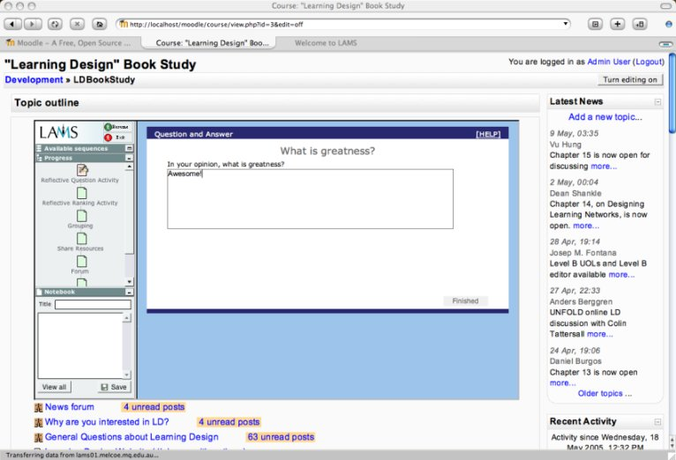
Figure 1: LAMS as a Course Format

LAMS Activity
When the teacher wishes to use a few of LAMS sequences within much larger Moodle courses, they may use the activity manner. In this way, the teacher selects LAMS as they would any Moodle activity, uses an activity creation page to link across to the authoring module. Once the activity is created, the lesson is started automatically.
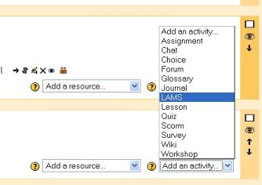
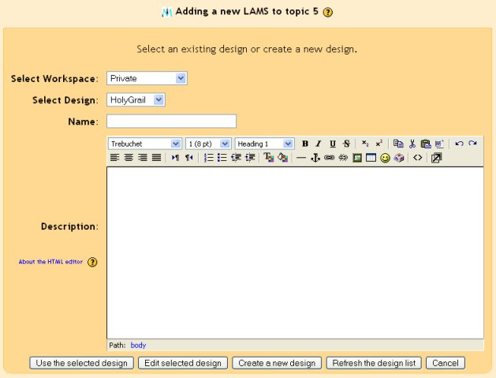
Figure 2: LAMS Activity Creation

It will display a simple screen in the activity page, similar to the base LAMS screen. It would open a popup window(s) for LAMS. This will allow the maximum amount of screen space for the LAMS interface. As with the standard LAMS, if the user has only one role (e.g. a learner) then the appropriate interface will pop up automatically. If the user has multiple roles (e.g. teacher) then the user will have to select which interface they want.

Use Cases
The Use Cases below outline common uses of the combined Moodle and LAMS.

Use Cases
Use Cases List
Primary Actor | Use Cases
Author / Editing Teacher | Create a LAMS course
Author / Editing Teacher | Create LAMS sequences in a LAMS course.
Author / Editing Teacher | Creates a LAMS activity in a Topic Course
Learner | Participate in a LAMS course
Learner | Participate in a LAMS activity in a Topic Course
Staff / Non-Editing Teacher | Monitor a LAMS course or activity

Use Case ID: | LAMS1.0.1_MOODLE0001
Use Case Name: | Create a LAMS course
Created By: | FionaMalikoff | Last Updated By:
Date Created: | 23/05/2005 | Date Last Updated:

Actors: | Author / Editing Teacher
Description:
Preconditions: | - Teacher is logged into Moodle.
Postconditions:
Normal Flow: | - Teacher creates a new course, and selects the LAMS course format.  - Teacher sets up Moodle course details, such as enrolment details.  - The course window is displayed, as in Figure 1, LAMS as a Course format.  - Teacher now creates activities as per LAMS1.0.1_MOODLE0002 Create LAMS sequences in a LAMS course.
Alternative Flows:
Exceptions:
Includes:
Priority:
Frequency of Use:
Business Rules:
Special Requirements:
Assumptions:
Notes and Issues:

Use Case ID: | LAMS1.0.1_MOODLE0002
Use Case Name: | Create LAMS sequences in a LAMS course.
Created By: | FionaMalikoff | Last Updated By:
Date Created: | 23/05/2005 | Date Last Updated:

Actors: | Author / Editing Teacher
Description:
Preconditions: | - Teacher is logged into Moodle and a course of type LAMS exists.  - The course window is displayed, as in Figure 1, LAMS as a Course format.
Postconditions:
Normal Flow: | - Teacher selects editing mode.  - Teacher clicks on the authoring button to bring up the LAMS authoring interface in a new window.  - Teacher then creates/edits a sequence. All sequences available to a teacher are shown in authoring – this allows a teacher to select a sequence created during work on another course.  - When ready, teacher closes the authoring window.  - Teacher clicks on the monitoring button to bring up the LAMS monitoring interface in a new window.  - Teacher sets up lessons as they would in standalone LAMS.
Alternative Flows:
Exceptions:
Includes:
Priority:
Frequency of Use:
Business Rules:
Special Requirements:
Assumptions:
Notes and Issues: | While in editing mode, the teacher can set up ordinary Moodle activities in the normal way.

Use Case ID: | LAMS1.0.1_MOODLE0003
Use Case Name: | Creates a LAMS activity in a Topic Course
Created By: | FionaMalikoff | Last Updated By:
Date Created: | 23/05/2005 | Date Last Updated:

Actors: | Author / Editing Teacher
Description:
Preconditions: | - Teacher is logged into Moodle.
Postconditions:
Normal Flow: | - Teacher creates a new activity, and selects the LAMS activity type.  - The “Adding a new LAMS” window is displayed. Lists of the teacher’s current workspaces and sequences are displayed.  - Teacher opts to create a new design (using a button on the screen).  - The LAMS authoring interface is displayed. Teacher creates a new design, saves it and closes the authoring interface.  - The list of sequences shown to the teacher is updated.  - Teacher selects a sequence from the list and indicates that this sequence should be used as the activity.  - The Moodle activity details are saved. During the saving process, a new session class and lesson are set up in LAMS to run this sequence.
Alternative Flows: | - Instead of creating a new design, the teacher could select an existing design and choose to edit the design. This would also bring up the LAMS authoring interface. The rest of the steps remain the same.  - The teacher does not have to create or edit a design at all – the teacher could just select an existing design, skipping steps 3. to 5.
Exceptions:
Includes:
Priority:
Frequency of Use:
Business Rules:
Special Requirements:
Assumptions:
Notes and Issues:

Use Case ID: | LAMS1.0.1_MOODLE0004
Use Case Name: | Participate in a LAMS course
Created By: | FionaMalikoff | Last Updated By:
Date Created: | 23/05/2005 | Date Last Updated:

Actors: | Learner
Description:
Preconditions: | - Learner is logged into Moodle
Postconditions:
Normal Flow: | - Learner selects a course with course format LAMS.  - The course window is displayed, as in Figure 1, LAMS as a Course format. Only the LAMS activities relating to this course are displayed.  - The learner selects the lesson from the progress bar in the LAMS window. The learner then interacts with LAMS in the normal LAMS manner.
Alternative Flows: | To participate in a one of the other Moodle activities, the learner selects the Moodle activities listed at the bottom of the screen, in the usual Moodle manner.
Exceptions:
Includes:
Priority:
Frequency of Use:
Business Rules:
Special Requirements:
Assumptions:
Notes and Issues:

Use Case ID: | LAMS1.0.1_MOODLE0005
Use Case Name: | Participate in a LAMS activity in a Topic Course
Created By: | FionaMalikoff | Last Updated By:
Date Created: | 23/05/2005 | Date Last Updated:

Actors: | Learner
Description:
Preconditions: | - Learner is logged into Moodle
Postconditions:
Normal Flow: | - Learner selects a LAMS activity.  - The LAMS learner interface is opened. This will show either all the LAMS lessons relating to the course, or just this lesson.  - If necessary, the system will set up the learner as a learner in the lesson.  - The learner then interacts with LAMS in the normal LAMS manner.
Alternative Flows:
Exceptions:
Includes:
Priority:
Frequency of Use:
Business Rules:
Special Requirements:
Assumptions:
Notes and Issues:

Use Case ID: | LAMS1.0.1_MOODLE0006
Use Case Name: | Monitor a LAMS course or activity
Created By: | FionaMalikoff | Last Updated By:
Date Created: | 23/05/2005 | Date Last Updated:

Actors: | Staff / Non-Editing Teacher
Description:
Preconditions: | - Teacher is logged into Moodle.
Postconditions:
Normal Flow: | - Moodle will detect that the user is a non-editing teacher and will either display a monitoring button on the main screen (if it is a LAMS course) or on the LAMS activity screen (if it is a LAMS activity in a general course format).  - Teacher clicks the Monitor button.  - The LAMS monitoring interface is displayed. Preferably only lessons relating to this course should be displayed.
Alternative Flows:
Exceptions:
Includes:
Priority:
Frequency of Use:
Business Rules:
Special Requirements:
Assumptions:
Notes and Issues:

Moodle to LAMS Interactions
The following diagrams give a rough idea of how Moodle and LAMS may interact. They will be integrated by adding a LAMS activity and LAMS course format into Moodle i.e. PHP module(s) and by adding one or more webservices into LAMS. The two systems will then interact via a combination of URLs and webservices.
This is not an exhaustive list of all interactions. The course interactions are not documented as the PHP course format code has not been investigated.
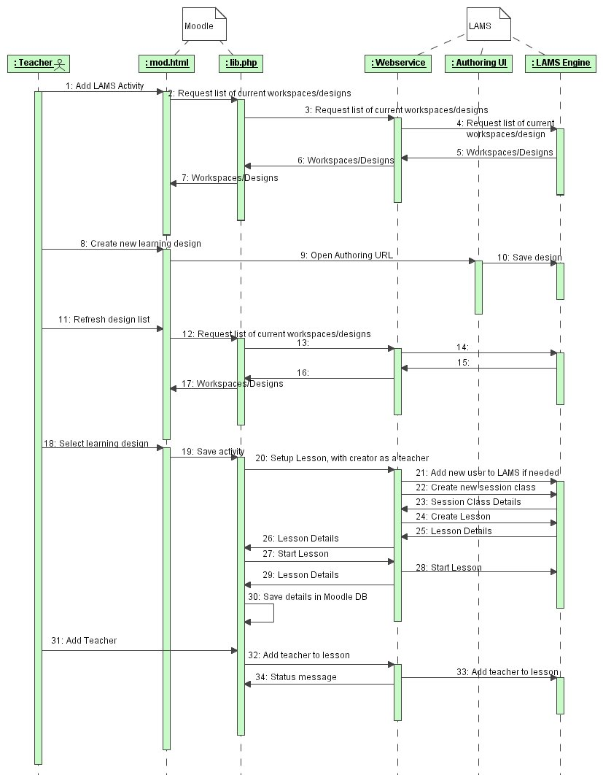
Figure 3: Creating A New Activity
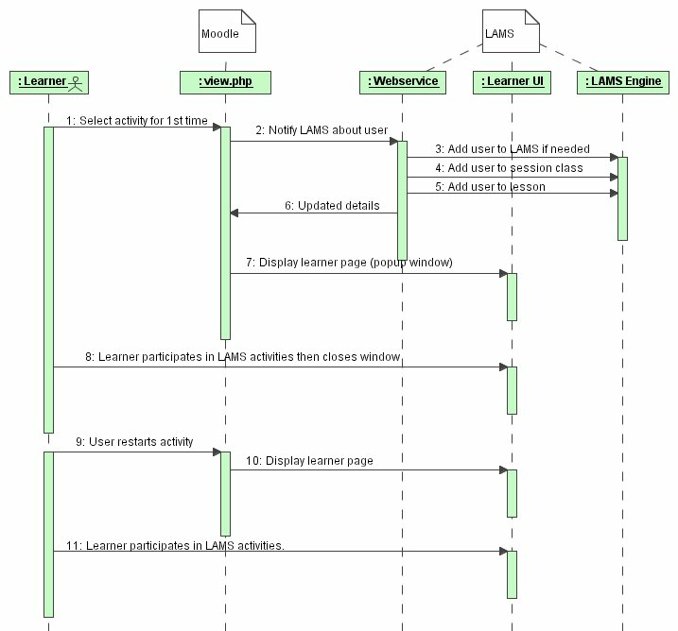
Figure 4: Learner Participates in Activity
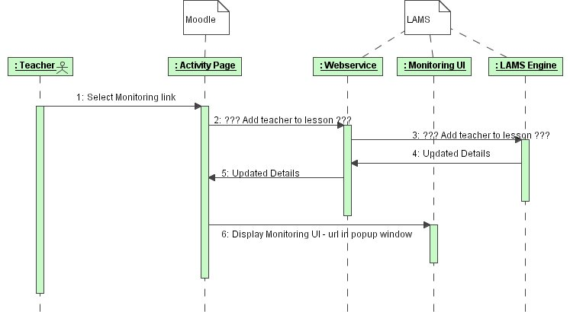
Figure 5: Teacher Participates in Activity

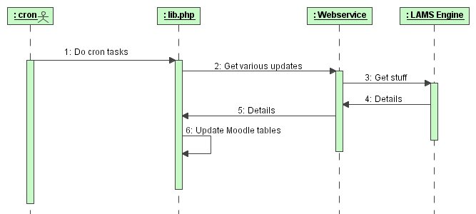
Figure 6: General Moodle / LAMS Interaction
As well as interactions triggered by user actions, there will be general system update interactions. These are likely to be triggered by the Moodle cron task, which will run lams_cron in lib.php (in the Moodle LAMS module).

User Authentication and Lesson Management
User Provisioning
LAMS and Moodle will share the same database for users.
Where we going to call the Moodle db or vice versa?
Authentication
LAMS and Moodle will implement their own version of single sign-on.
All URL calls from Moodle to LAMS will supply a ticket (long id number) on the URL call. LAMS will then call a Moodle webservice to check the ticket against the supplied username. Once authenticated, the session and user principal will need to be set up to allow the LAMS tools’ to function. This could probably be implemented using a JAAS module (or similar), except that this makes it difficult to access LAMS directly.
The web services themselves will also need to be authenticated, using either a Moodle account or IP filtering. Given that the integration will be between known boxes, IP filtering may be sufficient.
Just using IP filtering, rather than digital signing, etc could be a security hole if a hacker with rights on the Moodle server was determined to access our system. On the other hand, apart from the creation of users, there doesn’t seem to be a lot of sensitive data LAMS returns to Moodle, or destructive requests that Moodle can issue on LAMS.
Privilege Mappings
Moodle Privilege | LAMS Role
Admin | Admin
Non Editing Teacher | Staff
Editing Teacher | Author
Student | Learner

All Moodle users will be placed in a single LAMS home organization “Moodle”. (This should be a customizable parameter, in case we ever have one LAMS instance supporting two different Moodle systems.)
Session Classes and Users
There are two choices for creating a LAMS session class – create all the users at the start of the lesson or create them as they join a lesson. If we could guarantee that all users would have enrolled before a LAMS activity starts, then we could create the LAMS session class and LAMS lesson when the first user enters the activity (in Moodle), based on the course participants. However given Moodle’s open enrolment (and unenrolment), this isn’t possible.
So we will need to “trickle feed” users into a lesson.
- When the lesson is first created a session class will be created. The teacher who adds the lesson will be added to the session class.
- Any (ordinary) participants in the course at the time of the session class being created will be added to the session class as a learner.
- Any teachers in the course at the time of the session class being created will be added to the session class as staff.
- As students enrol, or new teachers are added, they can be added to the session class via the cron task.
- If a learner tries to access a lesson and doesn’t exist in the session class, they need to be added to the session class and then allowed into the lesson.
This may cause some problems with the grouping in LAMS, particularly with the chat/scribe tool. Teachers will need to use the chat/scribe and polling tools with some care, as they are designed to be used with learners participating over a fairly short period of time,
Moodle users can also unenrol during a course. LAMS will need to support “removing” a user from a lesson. The degree of support for this will be determined during implementation. Teachers will need to be warned about any potential problems in a sequence if a learner leaves (e.g. if the user is the chat in a chat and scribe).
In future versions of LAMS, this problem may be overcome by allowing the teacher to Force Complete a learner’s participation.
Groups
Moodle groups are more complex than LAMS groups and cannot be carried over to LAMS directory. In version 1.1, some propagation of groups may be possible.
LAMS Activity Cannot Support Guest Users
Moodle can support guest users within courses. LAMS cannot support this so the LAMS module would display a message indicating that this is not possible to use the LAMS activity unless logged in. Other Moodle activities, such as chat and forum have restrictions so this is not unreasonable – as a guest you can view forums but not post and you cannot chat at all.

Moodle Changes

LAMS Module
A LAMS Activity Module and a LAMS course format will need to be written for Moodle. They will have access to the Moodle tables, and will be responsible for meeting the requirements of a Moodle tool.
They will communicate with the LAMS server via web services. Nu-SOAP should be used for webservice (not PEAR::SOAP). Some work with webservices has been done previously for Moodle, although it is not part of the base. The LAMS integration should build on to top this earlier work.
A LAMS Activity Module may be based on the sample “module template” available from the Moodle.org website or by an existing module. It should be implemented as given in Section 2 Integration Look and Feel.
A LAMS course format will also need to be written. This should be done based on the topic course format, and should be implemented as given in Section 2 Integration Look and Feel, including the requirement for other activities to popup in a new window, with the breadcrumbs and any other navigation features modified to ensure that the main course window cannot be redisplayed in a popup window.
There will be a number of cron-based tasks that will be needed for both the activity and course module. These include
Adding new users to a lesson, based on recent enrolments (call to a LAMS webservice, updates LAMS).
Marking a user as left, based on recent unenrolments (call to a LAMS webservice, updates LAMS).
Get the user’s current progress in a LAMS lesson (call to a LAMS webservice). If it has changed since the last event, create a log entry for display in the recent events section.

Core Moodle Changes
Moodle will need to offer a webservice to support the authentication.
There will be others identified during the development process.

LAMS Modifications
The LAMS server will make LAMS functionality available to the Moodle Activity module via a mixture of direct URL calls and webservices.

Core Changes
LAMS will need to support the authentication method outlined previously.
LAMS will need to be able to group lessons (running designs) in a particular course. This will probably require a database change.

UI
The LAMS learning user interface must be modified to work in an IFRAME, as will be used in the course format interface. This may require changing some of the javascript and Flash that calls back to the LAMS server.

URLs
“Teacher” calls:
Open Authoring with no design.
Open Authoring with a particular design.
Open Monitoring. If possible, only show the lessons linked to current course.
“Learner” calls:
Open Learner, defaults to a particular design. If possible, only show the lessons linked to current course.

Web Services
A webservices framework will need to be used. As we run JBOSS 3.0.x for LAMS 1.0.1, we will need to use a third party framework, such as Axis. (Note: This may lead to a problem with XML parsers – Axis prefers Xerces2 but I think we use Crimson, as this is the standard JBOSS XML parser.)
In later versions of LAMS, we may be able to use inbuilt JBOSS webservice support, but it should be kept as standard as possible, to ensure we can move to another webserver if required.
Packet Format
All webservice packets from LAMS should follow this (rough) format:
<packet>
<error>
<error code/>
<error message/>
</error>
<data>
<key/><value/>
<data>
</packet>
If no error occurs, the error part will be null. Any error message should be something that may be shown to a user.
The data sections should be a mapping of values to a key. For example, the call to set up a session class will return a mapping containing one row, where the key is something like “SessionClassId” and the value is the session class id.
Currently Identified Calls:
- Get all workspaces and designs for a user. This is used to list the workspaces and designs for creating an activity.
- Get the current progress for a user or session class. (For the Moodle activity log).
- Set up session class. Includes a list of users for the session class and their privileges. Returns a session class id.
- Set up lesson class. Includes the learning design id. Returns a lesson id.
More will be identified during development. Many of the get calls can be based on the calls that already exist for the WDDX packet creation.

Export / Import LAMS Sequences

LAMS is able to export and package sequences when a Moodle course is being backup-ed up. LAMS will export the sequences and then pass those to the Moodle’s LAMS Module (PHP) that will take care of the packaging. For importing sequences, the Moodle’ LAMS Module, will call the appropriate web service (or XML-RPC) to add the sequence in LAMS.

LAMS Installation
We will not produce a customized installer for the integrated version of LAMS. The LAMS Moodle module will be made available in the custom download section on the Moodle website, and the user will download LAMS separately.
A how-to guide will be given for integrating the two systems.

Technology Alternatives
The initial challenge was to get a PHP system running under Apache, to talk to a Java based system running on JBOSS, in such a way that security is not compromised.
There are two parts to the integration:
- Direct URL calls to launch the authoring, monitoring and learner windows, as this cannot be done using anything else but a URL call. These calls require a single sign-on to be established for the user, so that they do not trigger a login screen in LAMS.
- Calls from the LAMS Moodle Activity module to the LAMS server to set up users, trigger the commencement of a lesson, get details needed for reporting back to Moodle, etc. The LAMS PHP module will need to authenticate itself to LAMS in some way.
This section documents technologies that were considered and why the chosen technology was selected. This is for historical purposes. It may be useful if we wish to change to another technology in the future.

Single Sign-On
Single Sign-On allows the user to sign on once and access multiple systems.
An implementation of single sign-on using Moodle has been done using CAS (used by Yale University) and UPortal. However the take up of CAS across universities is quite low, so it would add to complexity of integration will very little gain.
If we do wish to go with a third party single sign-on product in the future, CAS it worth investigating as it supports a wide variety of technologies, including PHP and Java.0
For more details on CAS
- http://www.developertutorials.com/tutorials/java/single-sign-on
- http://www.yale.edu/tp/auth/usingcasatyale.html
- http://www.yale.edu/tp/auth/cas20.html

Another alternative is to look at the use of Shibboleth.
http://www.josso.org/ Java Open Single Sign-On Project. This also has Java and PHP support, and bundles with JBOSS 3.2.7 are available. JOSSO supports Strong Authentication using client certificates.
http://www.jboss.org/wiki/Wiki.jsp?page=SingleSignOn JBOSS includes single sign-on support using the Tomcat module (JBoss-3.2.3 onwards). This would support the single sign-on requirements required for other LAMS projects, but it would not support the Moodle.

Moodle <-> LAMS Communications
There were three possible methods considered for direct Moodle to LAMS Communications.
- Use the “PHP / Java Integration” available from http://au.php.net/java. This is an extension to PHP which works under PHP 4. However it is marked as experimental and its reliability may be an issue and will not be supported in future versions of PHP.
- The JSR “JSR 223: Scripting for the JavaTM Platform” will support PHP running in a Java environment. A reference implementation (http://jcp.org/aboutJava/communityprocess/pr/jsr223/index.html) is available. However this is not feasible for three reasons (1) the reference implementation is design for PHP5, (2) is designed to have the PHP running on a Java application server, although it suggests that it will support PHP talking to a JVM and (3) it has only been recently accepted through the public review ballot.
- Communicating via web services will give LAMS the most flexible integration interface, in that it will be possible to change the version of PHP on the Moodle side, or upgrade LAMS, without the interface module having to be rewritten at both ends. As more functionality is made available in future versions of LAMS, then the webservice code on both sides will need to be modified, but this would have been required anyway.
Utilitising webservices also gives us an “open” interface in the future, to help with integration into other course management systems.
We have two choices if we look at using webservices. The most open method would be to use SOAP, as it is the mostly widely available protocol. Given that JBOSS doesn’t automatically support web services, straight XML-RPC may be an option. But SOAP is probably more flexible in the future, so we will use SOAP.

Appendix LAMS and Moodle Integration Walkthrough
by: Fiona Malikoff, Ernie Ghiglione, James Dalziel - MELCOE, Macquarie University with assistance from Martin Dougiamas, Moodle.org

Overview

Moodle is a Course Management System for managing flexible communities of learners through a dynamic website. LAMS is a Learning Design system for creating and running structured sequences of collaborative learning activities. Moodle and LAMS are complementary e-learning systems, as illustrated by the examples below.

The foundation for integration between Moodle and LAMS is Single-Sign-On, meaning that only one name and password is needed for each user across the two systems. There are three further points of integration:

- LAMS as a Moodle Activity: this means a LAMS sequence can be added as an individual activity within a Moodle course
- LAMS as a Moodle Course Format: this involves a new Moodle Course Format that is centred around one or more LAMS sequences
- Linking to a Moodle activity from within a LAMS sequence: the URL for an existing Moodle activity can be included in a LAMS sequence through Share Resources allowing LAMS to launch a Moodle activity at a specific point in a LAMS sequence.

Note: the screenshots below are taken from a live prototype implementation of LAMS and Moodle integration. Some minor aspects of this integration might change in the final version.

1. LAMS as a Moodle Activity
LAMS can be used within Moodle as one of its activities. Once LAMS is integrated within Moodle, it will allow the teacher (or course designer) to select LAMS as an activity. Figure 1 shows how a teacher using the Weekly Course Format can add a LAMS sequence as an activity for the Week 25 May - 31 May.

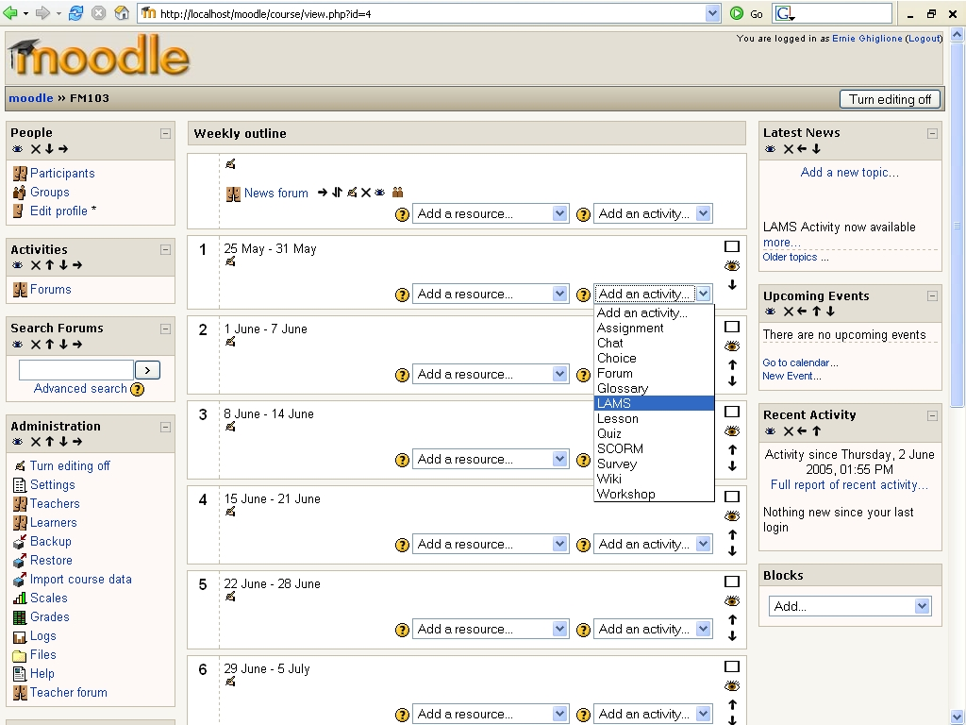
Figure 1: Adding a LAMS sequence as a Moodle Activity

Once the teacher selects LAMS from the drop-down activity menu, the following page presents the available sequences for that teacher (see Figure 2). The sequences are presented in the three LAMS Workspaces:

* Private: Teacher's private area (or folder)
* Public: Shared folder across all teachers on a given LAMS server
* Organisation/Department: Shared folder across the main organisation or department for that teacher.
Once a teacher selects a workspace, the "Select Sequence" drop-down menu is populated with the Learning Designs that are available to the teacher in that workspace. The teacher then selects the relevant sequence from the menu.
The teacher can also set the name and description he/she wants the students to see in Moodle for the chosen sequence.

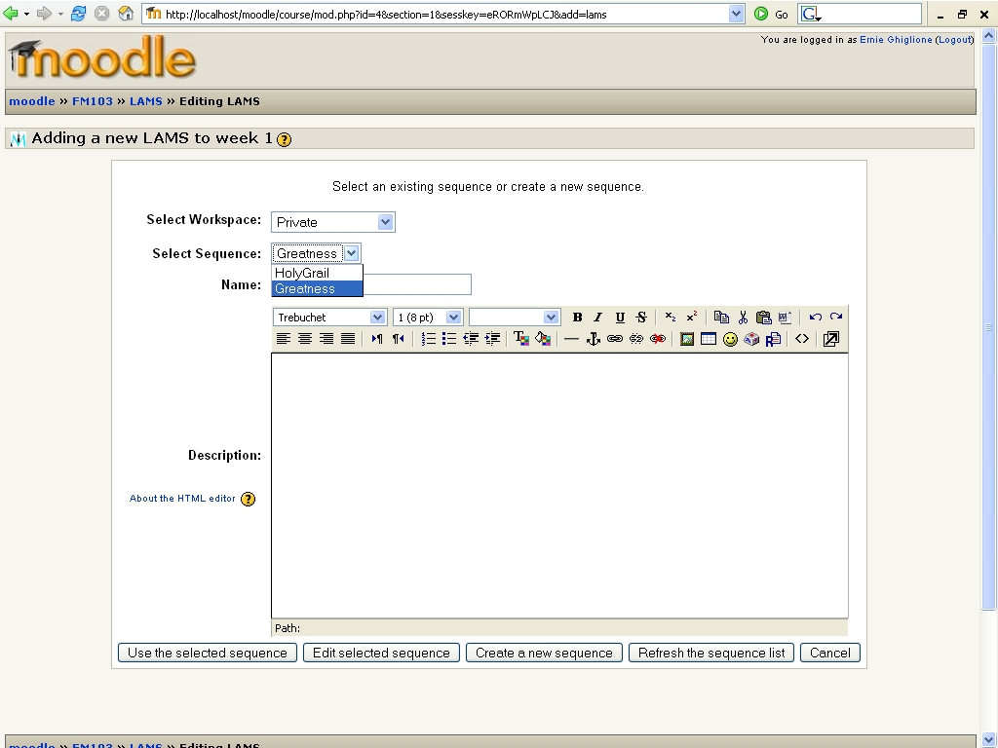
Figure 2: Adding/Editing a LAMS Sequence from Moodle.

Note that the buttons underneath the description textbox allow the teacher to edit that sequence or create a new sequence. If either of these options are chosen, a pop-up browser window will display the LAMS Authoring environment (see Figure 3). The teacher can then create or edit a design and once it is saved in LAMS, it can be chosen in Moodle by closing the LAMS window and clicking the "Refresh the design list" button to re-populate the "Select Sequence" drop-down menu.
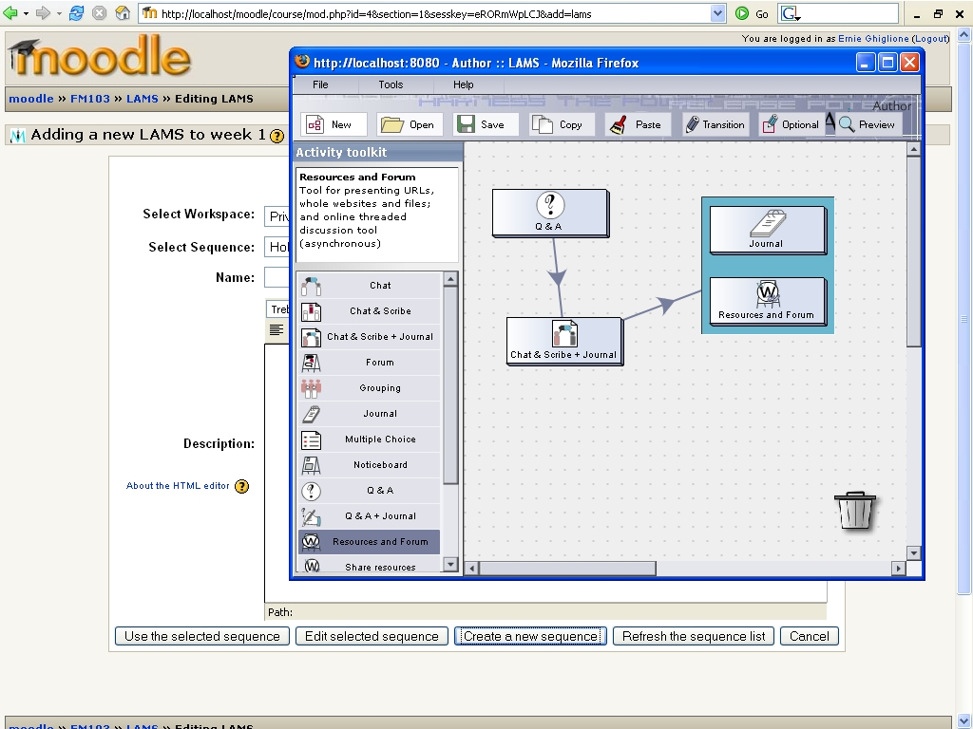
Figure 3: Creating a LAMS Sequence from Moodle.

Once a sequence is selected, the teacher enters the corresponding name and description (see Figure 4).

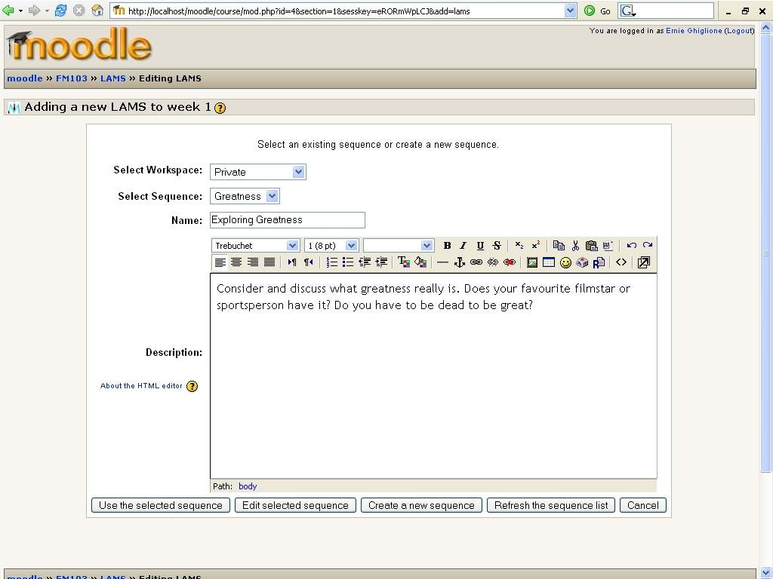
Figure 4: Selecting a LAMS Sequence as a Moodle activity.
After the teacher selects the sequence and clicks on "Use the selected sequence" button, the next page displays the Name and Description given to the sequence and links to the Leaner's and Monitor's interface in LAMS (see Figure 5).
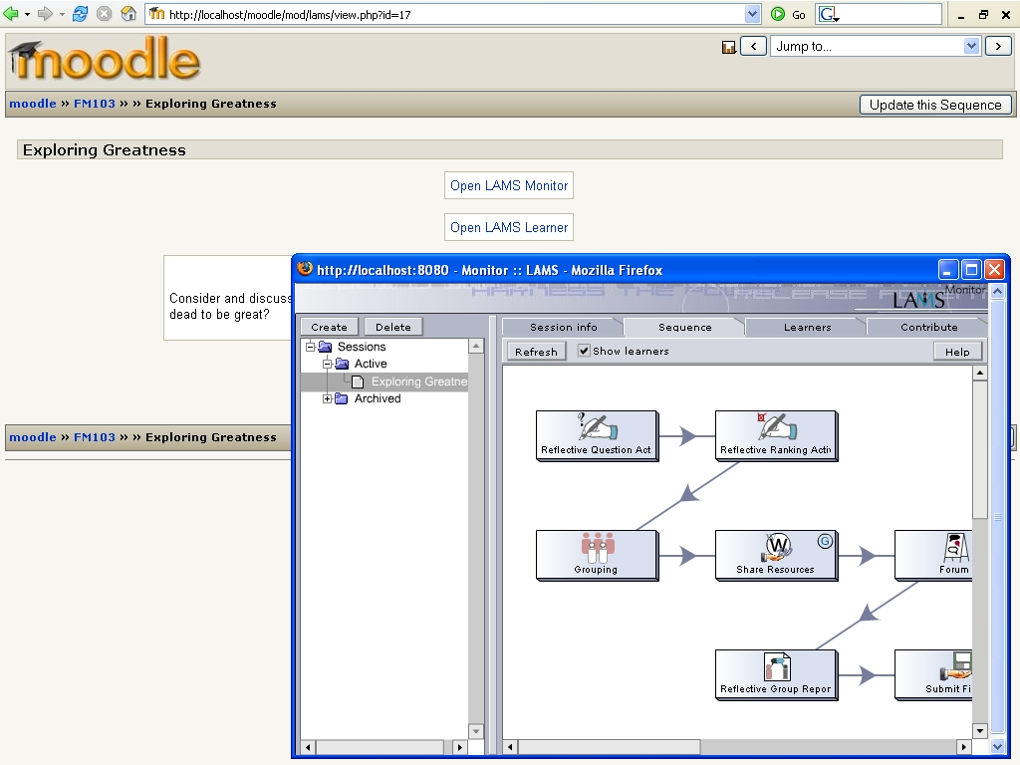
Figure 5: Teacher view of a LAMS activity in Moodle (includes LAMS Monitor view in pop-up window)

The Course page now will display the LAMS sequence as a Moodle activity (see Figure 6).
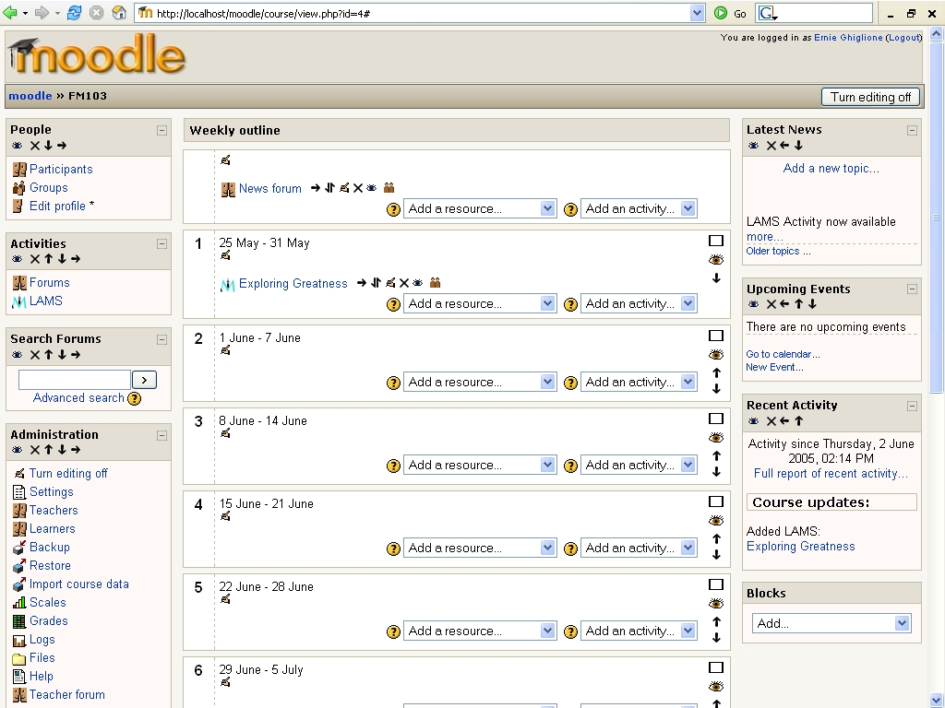
Figure 6: a LAMS Sequence added to a Moodle Course as an activity (see "Exploring Greatness" in Week 1).

When students click on the LAMS activity in the course page (see Figure 6), they will be presented with the description of the sequence and a button to access it (see Figure 7).
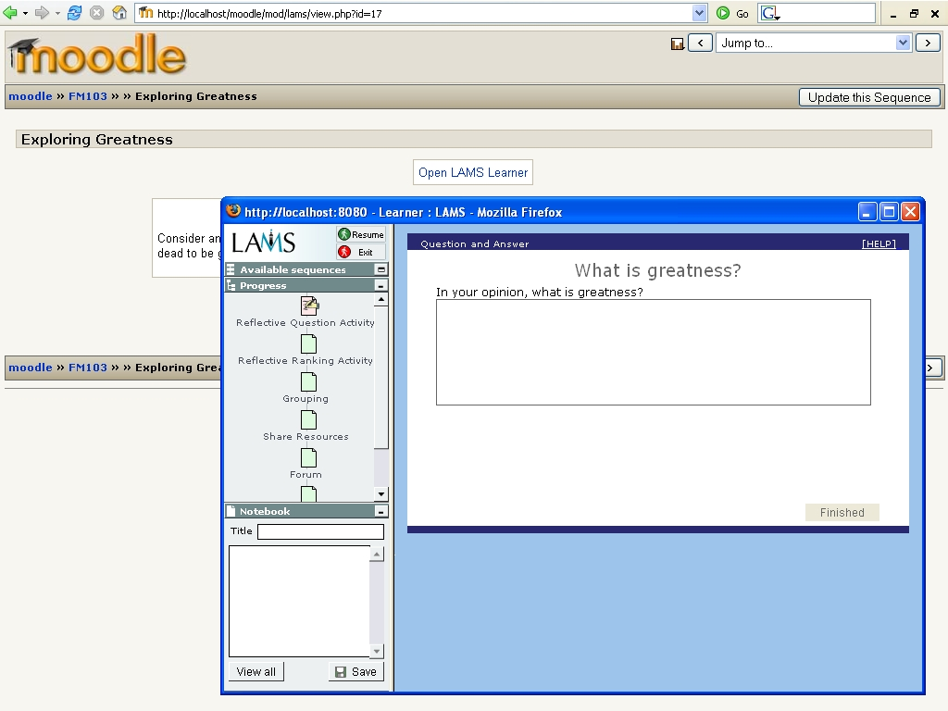
Figure 7: Student's view of the link to a LAMS Sequence in Moodle (includes LAMS Learner's view in pop-up window).

If the teacher clicks in the sequence, he will see links to the Leaner's and Monitor's interface (see Figure 5).

2. LAMS as a Course Format

Another way of integrating LAMS in Moodle will be by using the new LAMS Course Format. When creating a Moodle course, a teacher can select "LAMS Course" as the Course Format (see Figure 8).
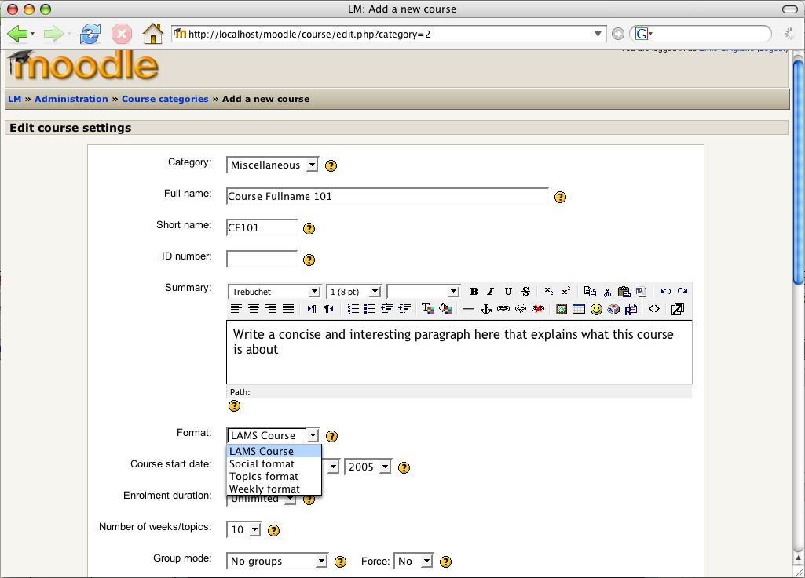
Figure 8: Using a LAMS Course Format.

The LAMS Course Format loads the LAMS Learner's interface as the center of the course (see Figure 9). Note that the teacher also can use other Moodle Activities in addition to LAMS (eg, see the Moodle Forum LAMS in Moodle at the bottom of Figure 9).

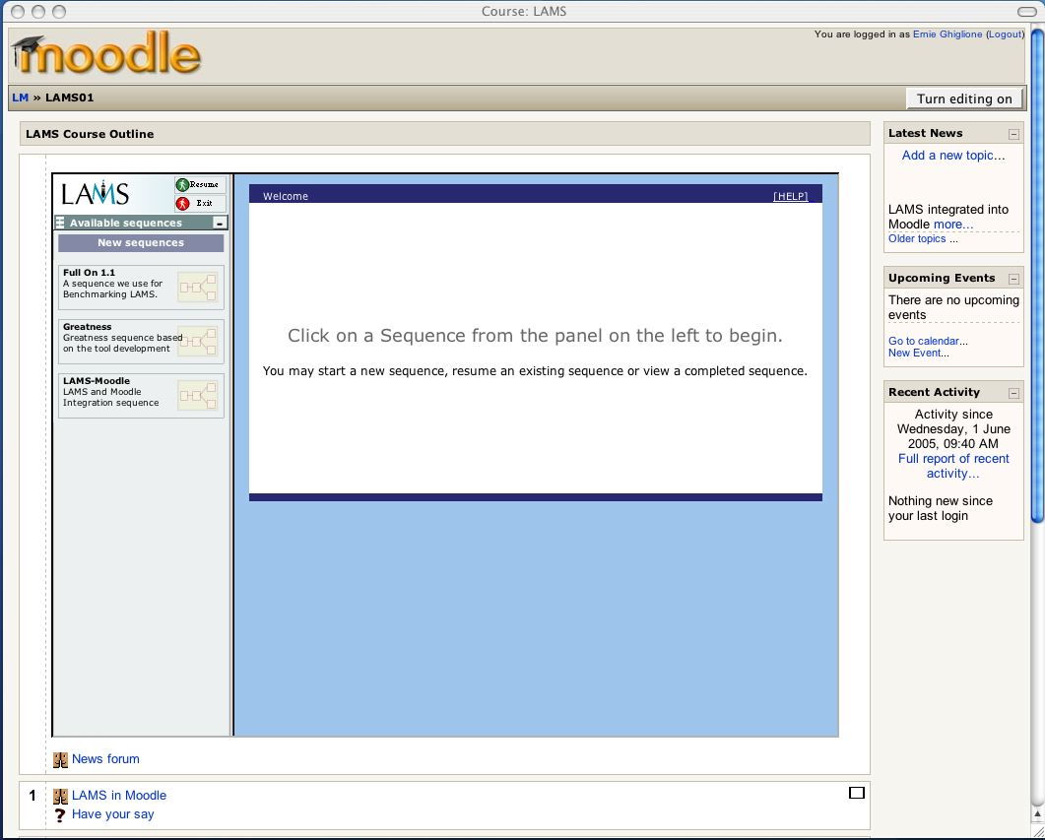
Figure 9: Using a LAMS Course Format.

Students can click on any of the sequences available for them in the LAMS Learner's interface (see top left of Figure 9), and once a sequence is selected, the student begins the first LAMS activity for this sequence (as shown on Figure 10).

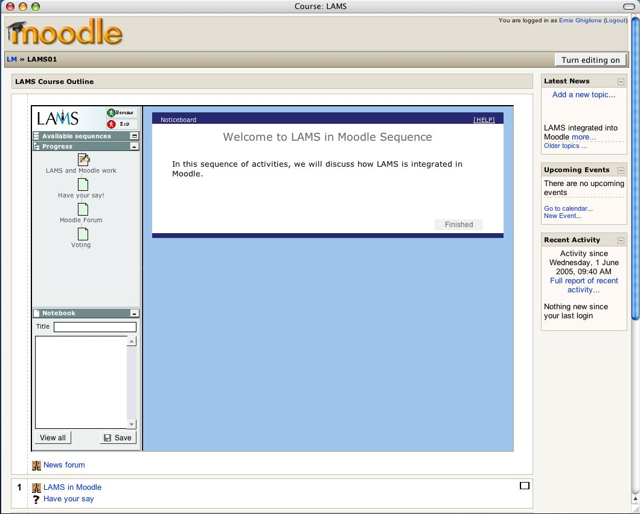
Figure 10: Running a Sequence.
Once a student begins a LAMS sequence, he/she can do the entire sequence from within the LAMS Course Format. Figure 11 shows the second step in this LAMS sequence, a Q&A activity.
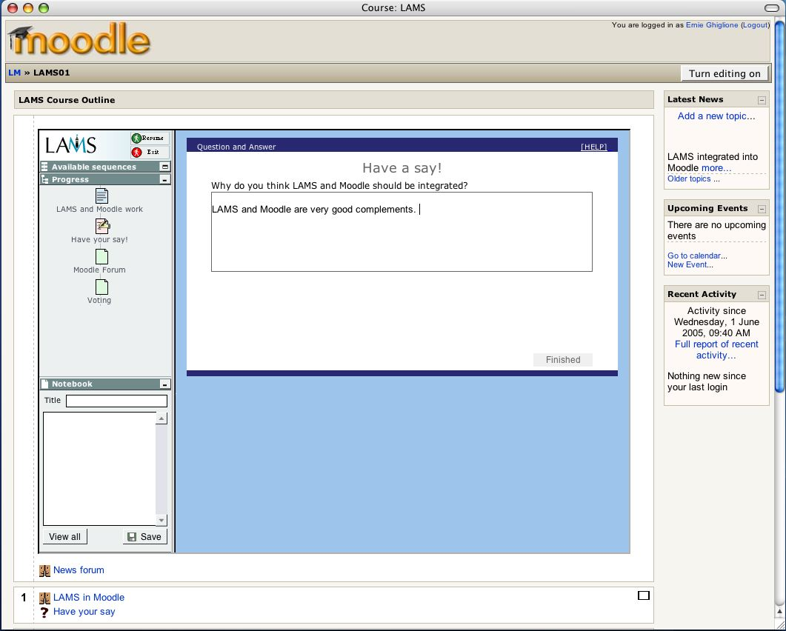
Figure 11: Using a LAMS Sequence within Moodle.

3. Linking to a Moodle activity from within a LAMS sequence

Once a LAMS sequence is running within Moodle (either as an individual activity, or via the new Course Format), it is possible to link from a LAMS sequence to an existing Moodle activity. For example, if a teacher that wants to use a Moodle Forum as the third activity in a LAMS sequence, he/she can use the LAMS Share Resources tool to insert a link from within LAMS to a Moodle Forum (see Figure 12 and 13). NB: The Moodle Forum needs to be set up in Moodle first, then the link to it inserted into LAMS. LAMS is not able to create a new Moodle forum directly.

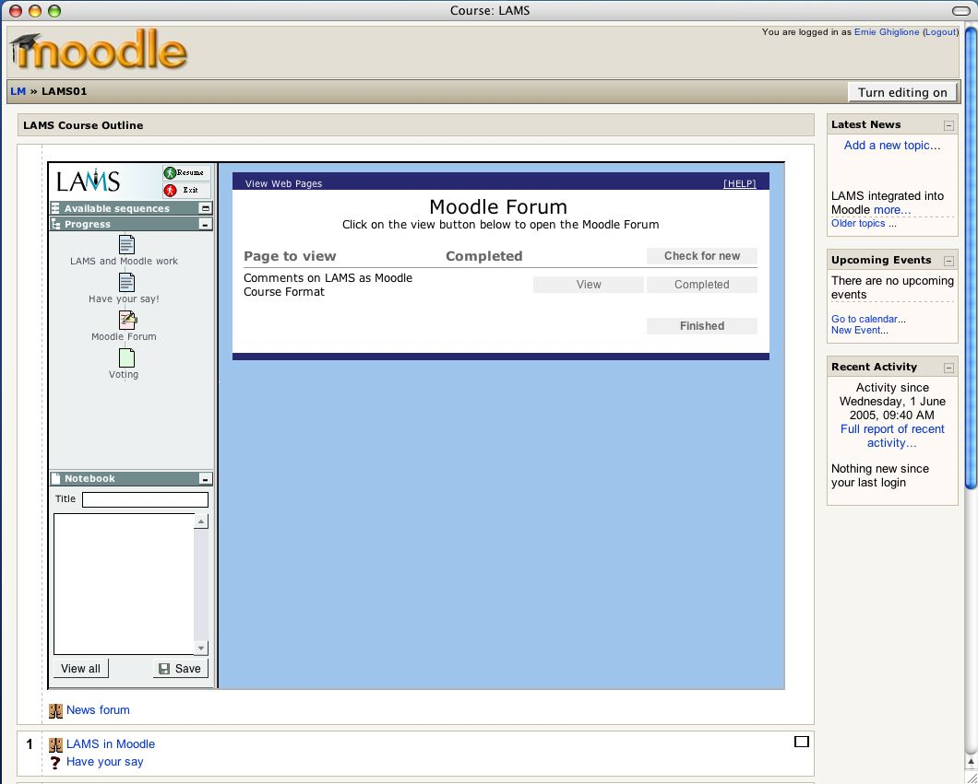
Figure 12: Using a Moodle Activity within a LAMS Design.
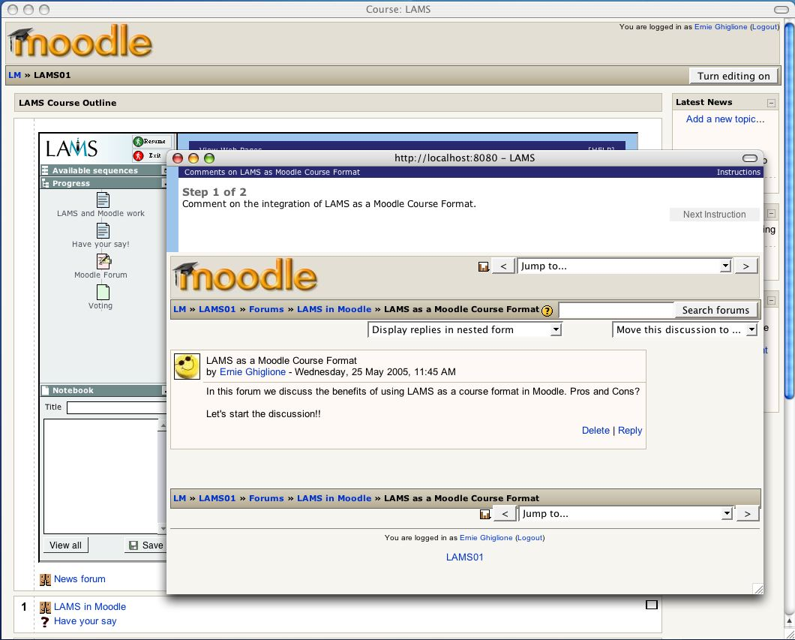
Figure 13: Using a Moodle Activity within a LAMS Design.

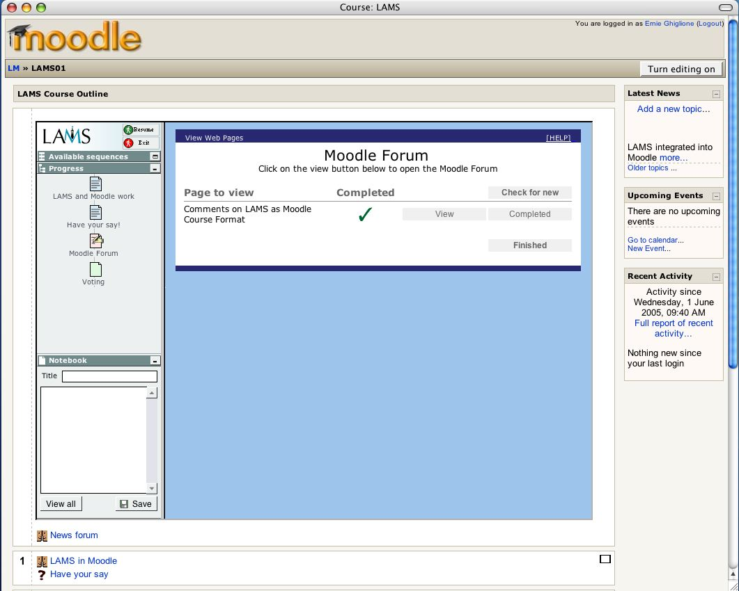
Figure 14: Using a Moodle Activity within a LAMS Design.

Once the Moodle activity is completed, students can then progress to the next LAMS activity in the sequence (see Figure 15). In this way, it is possible to create a sequence that is a mixture of LAMS and Moodle activities.
NB: This integration between Moodle and LAMS is simply a URL link. LAMS is not able to monitor or control student actions inside the Moodle activity this is only possible for LAMS own activities. Also, the Moodle activity needs to be created first in Moodle, and then linked to from LAMS LAMS cannot create activities in Moodle directly. However, in the future LAMS and Moodle plan to investigate advanced tool integration.

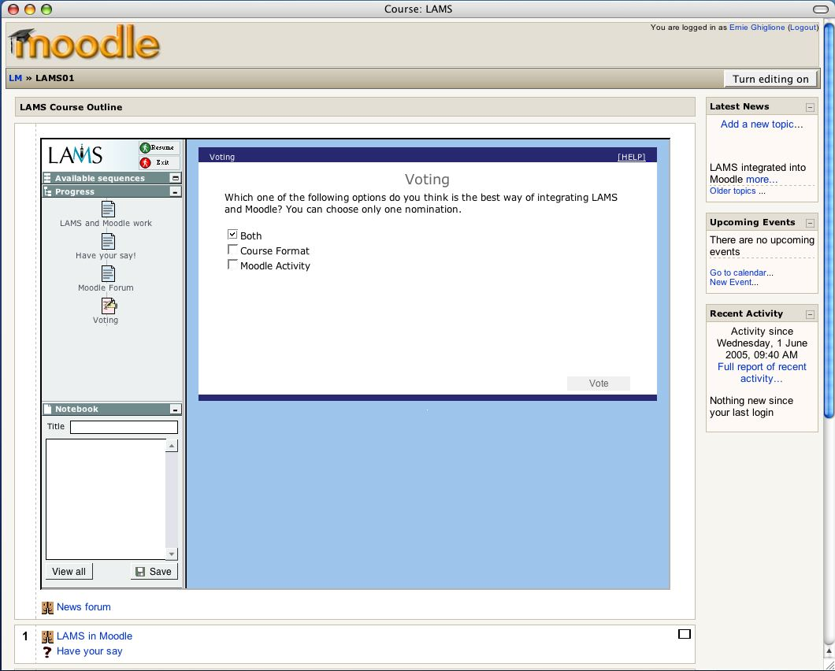
Figure 15: Using a LAMS Course Format.

