
Moodle Integration Report

Draft Version 1.1
Author: Fiona Malikoff
LAMS INTERNATIONAL
16 May 2005

Revision History
Name | Date | Reason For Changes | Version
Fiona Malikoff | May 2005 | Initial Draft | 1.1

Contents
1 Introduction 1
1.1 Scope 1
1.2 What need to be designed 1
1.3 Constraints 1
1.4 Issues 2
2 Moodle to LAMS Interactions 3
3 LAMS Moodle Activity Module 6
3.1 User Authentication and Lesson Management 6
4 LAMS Server Modifications 8
4.1 URLs 8
4.2 Web Services 8
5 Questions on Moodle 9
6 Technology Alternatives 10
6.1 Single Sign-On: CAS 10
6.2 Single Sign-on: Other Alternatives 11
6.3 Dual Login 11
6.4 Moodle <-> LAMS Communications 11

Figure 1: Creating A New Activity 3
Figure 2: Learner Participates in Activity 4
Figure 3: Teacher Participates in Activity 5
Figure 4: General Moodle / LAMS Interaction 5

Introduction

Scope
Moodle (http://moodle.org) is an open source course management system. LAMS is to be integrated with Moodle, with LAMS acting as an activity within Moodle.
This document describes the overall design of the integration.

What need to be designed
LAMS and Moodle integration is about Moodle being able to call LAMS. This is the opposite approach to wrapping a third party tool up for use with LAMS.
The following areas need to be addressed by the integration:
User Authentication
LAMS should not require users to log in – it should carry over the user and their privileges from Moodle. There are two aspects to this:
- setting up of users and session classes to support the Moodle users, and
- single sign-on.
Creation/Authoring of Sequences
The teacher must be able to create LAMS learning designs, or sequences from within Moodle. This will require the integration of the LAMS authoring module into Moodle.
A teacher must also be able to select an existing design for using in a Moodle course. This involves LAMS functionality which is currently made available via monitoring.
Lesson Management
The LAMS Moodle activity will need to trigger the automatic set up of a lesson, along with the appropriate session class, based on a design previously selected in Moodle.
The LAMS Moodle will also need to inform Moodle of certain basic information, such as what the user is doing. This will be kept as limited as possible.
Learner
Last but certainly not least, the integration must support a Moodle learner being able to participate in a LAMS sequence. This will involve the LAMS Moodle Activity calling the LAMS Learner module.
Note: The integration of LAMS and Moodle will not support LAMS accessing Moodle tools. For example, if a teacher wants to run a forum within a LAMS sequence, they must use the LAMS forum, not the Moodle forum. If the teacher wishes the students to use the Moodle forum, they should put in a Noticeboard activity which tells the students to go to the Moodle forum.

Constraints
Moodle is an existing system, written in PHP and runs on Apache. LAMS is written in Java and requires a J2EE engine to run, including (in the case of LAMS 1.0.1) EJB support.
Therefore the two systems cannot run on the same web server, requiring a method of communication not only across languages but across servers. This must be done with the minimum of disruption, rework or confusion to the user.

Issues
These are the issues which have been identified as difficult to solve.
Session Class Management: In Moodle users can join a course and leave a course on the fly. See “User Authentication and Lesson Management” for more details.
Multiple Teachers: LAMS doesn’t support more than one teacher monitoring a session very easily.
Look and Feel: The LAMS look and feel is very different to Moodle, and cannot be easily reskinned in 1.0.1. Even if we did reskin it to suit standard Moodle, Moodle itself can be skinned!

Moodle to LAMS Interactions

The following diagrams give a rough idea of how Moodle and LAMS may interact. They will be integrated by adding a LAMS activity into Moodle (i.e. a PHP module) and by adding one or more webservices into LAMS. The two systems will then interact via a combination of URLs and webservices.
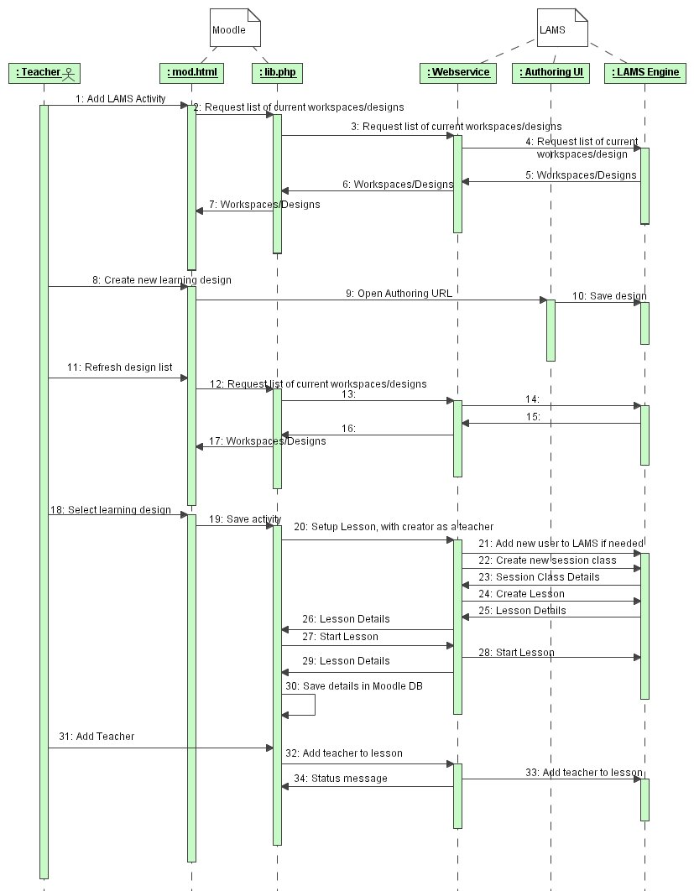
Figure 1: Creating A New Activity
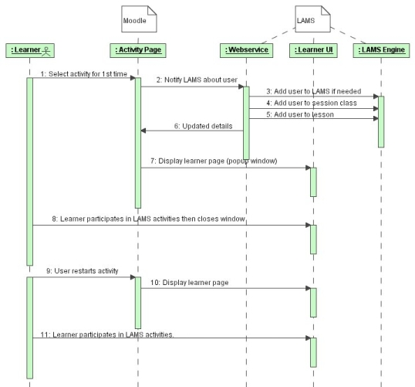
Figure 2: Learner Participates in Activity
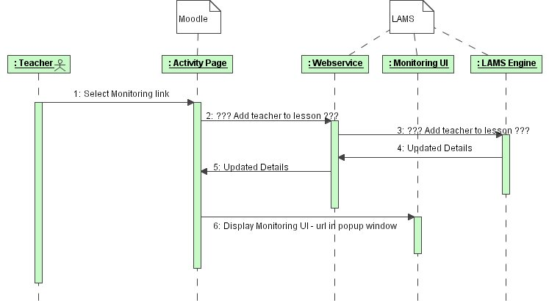
Figure 3: Teacher Participates in Activity

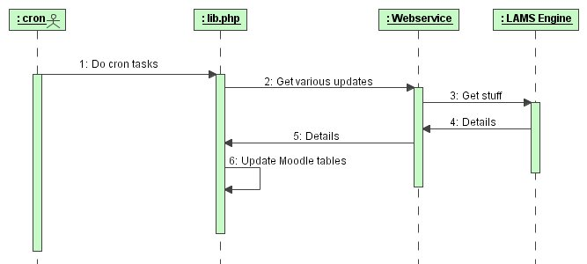
Figure 4: General Moodle / LAMS Interaction

LAMS Moodle Activity Module

The LAMS integration will be done as a Moodle Activity Module. The LAMS module will have access to the Moodle tables, and will be responsible for meeting the requirements of a Moodle tool. The activity module with communicate with the LAMS server via web services.
The activity module would display a simple screen in the activity page, similar to the base LAMS screen. It would open a popup window(s) for LAMS. This will allow the maximum amount of screen space for the LAMS interface. As with the standard LAMS, if the user has only one role (e.g. a learner) then the appropriate interface will pop up automatically. If the user has multiple roles (e.g. teacher) then the user will have to select which interface they want.

User Authentication and Lesson Management
Privilege Mappings:
Moodle Privilege | LAMS Role
Admin | Admin
Teacher | Staff
Creator | Author
Student | Learner

All Moodle users will be placed in a single LAMS home organization “Moodle”. (This should be a customizable parameter, in case we ever have one LAMS instance supporting two different Moodle systems.)
Creation Of Session Class – Users Enrolling and Unenrolling
We have two choices for creating a LAMS session class. If we could guarantee that all users would have enrolled before the LAMS activity starts, then we could create the LAMS session class and LAMS lesson when the first user enters the activity (in Moodle), based on the course participants.
However given Moodle’s open enrolment (and unenrolment), this isn’t possible.
Therefore we propose creating the session class and lesson when the activity is selected. Initially the creator of the activity will be created as a teacher in the lesson.
As students join the activity, they will be added to the lesson class.
This may cause some problems with the grouping in LAMS, particularly with the chat/scribe tool. Teachers will need to use the chat/scribe and polling tools with some care, as they are designed to be used with learners participating over a fairly short period of time,
Moodle users can also unenrol during a course. If a user unenrols half way through doing a LAMS lesson, we cannot remove learners from a lesson. The user would no longer participate in the sequence – which could cause problems if that user is the scribe in a chat/scribe activity.
In future versions of LAMS, this problem may be overcome by allowing the teacher to Force Complete a learner’s participation.
Groups
Need to find out what the Moodle groups are. Should we be running a LAMS lesson for each Moodle group? We cannot carry the Moodle groups directly into LAMS easily.
LAMS Activity Cannot Support Guest Users
Moodle can support guest users within courses. LAMS cannot support this so the LAMS module would display a message indicating that this is not possible to use the LAMS activity unless logged in. Other Moodle activities, such as chat and forum have restrictions so this is not unreasonable – as a guest you can view forums but not post and you cannot chat at all.

LAMS Server Modifications
The LAMS server will make LAMS functionality available to the Moodle Activity module via a mixture of direct URL calls and webservices.

URLs
“Teacher” calls:
Open Authoring with no design.
Open Authoring with a particular design.
Open Monitoring, defaulted to a particular design. (Does it matter if the others are available?)
“Learner” calls:
Open Learner, defaults to a particular design. (Does it matter if the others are available?)

Web Services
The “get” webservice calls will respond with a reply packet that includes either an error or the return data.
- Get all workspaces for a user.
- Get all available designs for selection (could be either to change the sequence or to select a sequence for running).
- Get recent activity for the user – this could be a difficult one to define. Need to look into what “recent activity” is in Moodle.
Many of the get calls can be based on the calls that already exist for the WDDX packet creation.

The “update” webservice calls will respond with a basic reply packet. This packet will contain and error string and a map containing a list of ids (e.g. key= “sessionClassId”, value = session class id).
Set up session class. Includes a list of users for the session class and their privileges. Returns a session class id.
Set up lesson class. Includes the learning design id. Returns a lesson id.

Questions on Moodle
Do you use any webservices yourself? Is there a preferred webservice implementation – PEAR::SOAP, NuSoap, PHP-Soap?
What does the take-up on CAS look like?
What are the groups? Why can’t I answer a survey unless I’m in a group?
How does the user status stuff work? Is there anywhere in Moodle that shows when users have completed an activity? What exactly is a “recent activity”?

Technology Alternatives
The initial challenge is to get a PHP system running under Apache, to talk to a Java based system running on JBOSS, in such a way that security is not compromised.
There are two parts to the integration:
- Direct URL calls to launch the authoring, monitoring and learner windows, as this cannot be done using anything else but a URL call. These calls require a single sign-on to be established for the user, so that they do not trigger a login screen in LAMS.
- Calls from the LAMS Moodle Activity module to the LAMS server to set up users, trigger the commencement of a lesson, get details needed for reporting back to Moodle, etc. The LAMS PHP module will need to authenticate itself to LAMS in some way.

Single Sign-On: CAS
Single Sign-On allows the user to sign on once and access multiple systems.
An implementation of single sign-on using Moodle has been done using CAS (used by Yale University) and UPortal. We should strongly consider using this as our base.
Advantages
We would be supporting a single sign-on solution that Moodle users are already using or are intending to use.
CAS Modules are available for PHP, Java servlets, ASP (without IIS filter), Perl and PL/SQL, while a Microsoft IIS filter is under development at Indiana University.
From one of the “how-to” articles available on CAS, it should probably be possible to implement CAS support in JBOSS 3.0.8 (or above) using a servlet filter. This requires Servlet 2.3 support, which is available in Tomcat 4.1.x.
Disadvantages
We would force anyone using Moodle and LAMS to use CAS (or come back to us for more integration work). This will be the case if we use any third party single sign-on product. At least CAS is a Java based server, so we may be able to run it within JBOSS, if we can support https.
If we were to just implement CAS support then LAMS would become unusable when the CAS server is unavailable. If we did combined CAS/LDAP support, then sites could set up LAMS to fall back to using the LDAP server if the CAS server failed.
The users still need to be created in LAMS, and using CAS requires the users to be in the CAS server, Moodle and LAMS. (This is a general single sign-on problem.)
No session is created by this login, so a separate session will need to be created by LAMS. We would also have to ensure that this will work with all our tools that currently access the UserPrincipal. This is likely to be applicable most, if not all, some other SSO solutions.
For more details on CAS
- http://www.developertutorials.com/tutorials/java/single-sign-on
- http://www.yale.edu/tp/auth/usingcasatyale.html
- http://www.yale.edu/tp/auth/cas20.html

If using CAS, may wish to consider which version. CAS 2.0, which supports proxiable credentials, appears to offer more security in that it allows a system requiring the user to confirm their login before proceeding to a system. This would be useful in a lab situation where the teacher may leave their PC unattended for a period of time – although this problem can be dealt with by the teacher locking their screen!

Single Sign-on: Other Alternatives
Could a cut down use of Shibboleth be used?
http://www.josso.org/ Java Open Single Sign-On Project. This also has Java and PHP support, and bundles with JBOSS 3.2.7 are available. JOSSO supports Strong Authentication using client certificates.
http://www.jboss.org/wiki/Wiki.jsp?page=SingleSignOn JBOSS includes single sign-on support using the Tomcat module (JBoss-3.2.3 onwards). This would support the single sign-on requirements required for other LAMS projects, but it would not support the Moodle.
We could also implement our own single sign-on solution, possibly using JAAS or using building on the Tomcat single sign-on support.
The simplest method would be an authentication string in the header – possibly a form of ticket supplied to the Moodle LAMS activity via an earlier webservice call.

Dual Login
Do we want to support dual login? That is, do we want users to be able to access LAMS directly, as well as accessing LAMS via Moodle. If we wish to support dual login, then there will need to be additional user management to set the passwords in LAMS.

Moodle <-> LAMS Communications
There were three possible methods considered for direct Moodle to LAMS Communications.
- Use the “PHP / Java Integration” available from http://au.php.net/java. This is an extension to PHP which works under PHP 4. However it is marked as experimental and its reliability may be an issue. I assume that it will not be supported in future versions of PHP, considering the next option.
- The JSR “JSR 223: Scripting for the JavaTM Platform” will support PHP running in a Java environment. A reference implementation (http://jcp.org/aboutJava/communityprocess/pr/jsr223/index.html) is available. However this is not feasible for three reasons (1) the reference implementation is design for PHP5, (2) is designed to have the PHP running on a Java application server, although it suggests that it will support PHP talking to a JVM and (3) it has only been recently accepted through the public review ballot.
- Communicating via web services will give LAMS the most flexible integration interface, in that it will be possible to change the version of PHP on the Moodle side, or upgrade LAMS, without the interface module having to be rewritten at both ends. As more functionality is made available in future versions of LAMS, then the webservice code on both sides will need to be modified, but this would have been required anyway.
Utilitising webservices also gives us an “open” interface in the future, to help with integration into other course management systems.
We have two choices if we look at using webservices. The most open method would be to use SOAP, as it is the mostly widely available protocol. Given that JBOSS doesn’t automatically support web services, XML-RPC may be an option. While XML-RPC isn’t as commonly used for webservices (and in Java land webservices is synonymous with SOAP), it may be simpler and more efficient that using SOAP.

If using webservices, we will probably use the Axis framework. This may lead to a problem with XML parsers – Axis prefers Xerces2 but I think we use Crimson, as this is the standard JBOSS XML parser.

