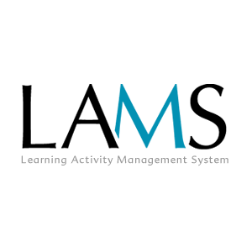
Development Process and Standards

Version 1.3
Author: Fiona Malikoff
LAMS INTERNATIONAL
7 MAR 2006

Revision History
Name | Date | Reason For Changes | Version
Chris Perfect | 13 Sept 2004 | Initial | 1.0
Fiona Malikoff | 15 Mar 2005 | Major Overhaul, added to CVS | 1.1
Fiona Malikoff | 13 Feb 2006 | Added sample class diagram | 1.2
Fiona Malikoff | 7 Mar 2006 | Updated the copyright statement | 1.3

Contents
1 Introduction 1
1.1 Scope 1
2 Development Cycle 2
2.1.1 Documentation 2
2.1.2 The Build 2
2.1.3 Continuous Integration 2
2.1.4 Tests & Testing 2
2.1.5 Build Server 3
2.1.6 QA 3
2.2 References for Agile Development 3
3 Coding Practices 4
3.1 Licence Statement 4
3.2 Java Coding Standards 4
3.2.1 Interfaces 4
3.2.2 Exceptions 5
3.2.3 Services (facades) 5
3.2.4 Utilities 5
3.2.5 Dates 6
3.3 Module Setup 6
3.4 Package Names 6
3.5 CVS Usage 6
4 Sample Class Hierachy 8
5 Database Standards 10

Introduction

Scope
The purpose of this document is to provide a developers’ reference for LAMS development.
These standards should be followed for LAMS 1.1 development. We will not try to retrofit changes into previous versions.
Note: Where possible, LAMS should always be written LAMS or lams, not Lams. It is an acronym Learning Activity Management System.

Development Cycle
The development philosophy for LAMS is based on “Agile” development. While some may seem to be adding complexity experience has shown that save effort and pain in the development process and end up improving the quality of the finished product. This document is not a complete reference for agile development - see the references at the end of this section.

Documentation
All Java code must be documented using Javadoc.
All tools must have their own design document. A template, DesignReport.doc, is given in the template directory (in cvs). As a minimum, the basic uses cases should be completed before coding commences. If the other sections are not completed before the tool is started, then they must be completed as the tool is developed.

The Build
The ultimate aim of the development cycle is to produce a working build from (a particular branch of the application). They key words in this statement are “produce” and “working”. Firstly “produce”: production of a build should be easy – we should be able to grab the master build script from CVS and run one task that will checkout/update all required assets, compile, generate, assemble, test and deploy the application. Secondly “working”: we should try and make sure we don't commit changes that break the build, which implies not just compile errors but run time errors as well. This in turn means that we should be able to automatically test the functionality of the build.
Of course in the early stages of a project the build may not be viable (because pieces are missing or not working) but the process should still be followed.

Continuous Integration
Continuous Integration is a development principle that says development work should be integrated every day (rather than developers going off on their own for days or weeks and then trying to reintegrate their changes). The reasoning behind this is that large, complex changes often break lots of things, whereas proceeding by smaller increments is much safer and ends up being more efficient. Basically the idea is that everyone gets the latest from CVS for the branch they are working on everyday and integrates their current changes. They should also as far as possible commit back their changes everyday.

Tests & Testing
All modules must have unit tests, implemented using JUnit.
Testing is integral to the development cycle, and just as importantly testing needs to be automated and repeatable. We are trying to avoid the “it worked on my machine/it worked last week/I built it but didn't get round to testing it” scenarios that happen so often and are so frustrating (and expensive). In order to “finish” a task a developer needs to prove that it works, so building the unit tests is also part of the task. This means that the developer should be building unit tests concurrently with the code additions/changes (some people say that you should build the unit tests first). When the code is checked in the unit tests should be checked in at the same time (and the build process should pick them up and use them).
After making any changes to lams_common please run ant task “test-report” – particularly after any changes regarding database. This will rebuild the database and insert test data. If you find anything is broken regarding sql script, please fix that. If the test case is broken, please notify the developer who created these test cases and tell the developer what has just been changed.
Cactus can be used to test EJBs and other container managed components. Integration and functional testing should also be automated where practical. For these purposes tools such as HttpUnit, Cactus, MaxQ, and JWebFIT are available.
Apart from just testing functionality performance is also vital. Any major component should be performance tested and if possible profiled. JUnitPerf is an extension to JUnit that allows creation of performance tests. Unfortunately profiling usually involves paying for a product. Performance testing should be done both at the unit and integration level.
All this testing is very important for bugs. The first thing to do when fixing a bug is to write a test case that replicates it. Once the bug is fixed this test case is checked in with the fix and becomes a permanent part of the automated testing. By doing this we ensure that if the bug ever re-appears it will be found and isolated quickly.

Build Server
The build server is an automated process that checks CVS regularly for changes. When it finds changes is does a clean build, runs various code checkers and metrics, runs unit and functional tests and sends out a report.
The two most common build servers in the Java world are Anthill and CruiseControl. Checkstyle has already be mentioned for checking coding standards, JDepends, Emma and Simian are all tools that analyze code and determine metrics (duplication, dependency etc.).
We do not have a build server currently. When we do set one up, a report is generated detailing problems, metrics etc will be produced. If the build fails then the person who committed the offending change should fix it ASAP.

QA
The first point to note of QA is that the person who develops the code should not be the one doing the QA on it (though they may well help in developing the QA tests). The developer is too close to the code and functionality to see it as a user does.
We do not have a separate QA team, so QA is done under Ernie’s guidance.
The second point to note of QA is that Unit Tests are not QA tests: they exist to make sure specific units of code work, not the entire system. While some QA testing can be automated

References for Agile Development
http://www.martinfowler.com/articles/continuousIntegration.html
http://www.extremeprogramming.org
http://www.fawcette.com/javapro/2004_06/magazine/features/pvarhol/
http://www.theserverside.com/articles/article.tss?l=TestDrivenDevelopmentPart1

Coding Practices

Licence Statement
The following license statement must appear in all of our code files. This includes .java, .jsp, .html, .xml and .properties files. This is not an exclusive list – if you add a new file type (eg .c) then this license statement must appear in the file if at all possible.
--
Copyright (C) 2005 LAMS Foundation (http://lamsfoundation.org)
License Information: http://lamsfoundation.org/licensing/lams/2.0/

This program is free software; you can redistribute it and/or modify
it under the terms of the GNU General Public License version 2 as
published by the Free Software Foundation.

This program is distributed in the hope that it will be useful,
but WITHOUT ANY WARRANTY; without even the implied warranty of
MERCHANTABILITY or FITNESS FOR A PARTICULAR PURPOSE. See the
GNU General Public License for more details.

You should have received a copy of the GNU General Public License
along with this program; if not, write to the Free Software
Foundation, Inc., 59 Temple Place, Suite 330, Boston, MA 02111-1307
USA

http://www.gnu.org/licenses/gpl.txt
--

Java Coding Standards
The general principles of Java Coding standards are related to coding style are already in place. Since these are covered extensively elsewhere so they will not be reproduced here. See http://java.sun.com/docs/codeconv/html/CodeConvTOC.doc.html and http://www.geosoft.no/development/javastyle.html for examples. The following sections define any differentiation from the Java coding standards.
Eventually the LAMS codebase will be checked using a code checker such as Checkstyle.

Interfaces
Name: I<whatever>.java
Implementors should include the basic name of the interface (without the I), addition of descriptive words recommended if package name does not provide enough differentiation.
e.g.
Differentiated by package name:
com.lamsinternational.lams.usermanagement.dao.IUserDAO
com.lamsinternational.lams.usermanagement.dao.hibernate.UserDAO

Differentiated by descriptive term in name:
com.lamsinternational.lams.authentication.IAuthenticator
com.lamsinternational.lams.authentication.LDAPAuthenticator
com.lamsinternational.lams.authentication.LamsAuthenticator

Following this convention the suffix Impl is not necessary for implementors.
No special names for default implementors: in many cases default does not mean anything anyway (or may change over time or across different deployments).

Exceptions
Name: <whatever>Exception.java
Exceptions should be defined in the package where they are thrown, unless they are truly system wide in which case they should be declared in the exception package (see below).
For each service/component there should be a base exception that more specific exceptions extend (which allows code to handle these exceptions generally or specifically as it chooses).
Unchecked exceptions: Consider using unchecked exceptions (i.e. extending RuntimeException) when there is no sensible way of handling the exception (i.e. all we can do is log an error and show an error page).
In general prefer creating and throwing your own exceptions rather than forcing users of your code to know about java and third party exceptions (especially where there is an interface or service/component boundary involved): e.g don't throw things like IOException, HibernateException, catch them and throw your own specific exceptions.
Note that Spring will automatically rollback a transaction that is a runtime exception. Check exceptions requiring a rollback need to be explicitly listed in the configuration file.
In general, exceptions should be defined in the package where they are thrown, as the exceptions are part of the interface to a class or component (since users of the class have to know about the exceptions).
Any system wide exceptions (or root exceptions) should go in com.lamsinternational.lams.exception.

Services (facades)
Name: <whatever>Service.java

Utilities
General utilities should be relatively low level and simple (e.g. string formatters, file readers etc.) and probably limited to one class. These should go in the util package (see below). Anything more complicated probably deserves it's own package.

Dates
Since users from one time zone could end up using a LAMS instance in another timezone we should be storing all date/times as UTC and converting to the local time zone of the user in the presentation tier (or in Flash as appropriate).

Module Setup
The code base is broken up into a series of modules. The core code is in lams_common and each tool has its own module. Each module is an Eclipse project.
Please follow the project layout of the tool_survey directory for structuring the tool modules. This gives a structure for db scripts, source and test code, installation scripts, etc.
Each module will have its own build script. This script must be callable by ANT and should not rely on Eclipse or any particular Eclipse plug ins. A developer should be able to take the ANT script and run it using ANT on the command line with minimal or no changes.

Package Names
General Package root is org.lamsfoundation.lams followed by the the functional area name (e.g. learningdesign, tools, lesson, etc.).
The domain model classes go in this area. Service elements (including interfaces) go in the subpackage service, dao elements (including interfaces) in the subpackage dao.
Under dao you will probably want to create subpackages for different implementations (e.g. hibernate).
For example:
org.lamsfoundation.lams.learningdesign | Learning design related
org.lamsfoundation.lams.lesson | Lesson related
org.lamsfoundation.lams.tool | General tool related files
org.lamsfoundation.lams.tool.survey.service | Survey tool service files
org.lamsfoundation.lams.tool.survey.dao | Survey tool DAO interfaces
org.lamsfoundation.lams.tool.survey.dao.hibernate | Hibernate implementations of interfaces in org.lamsfoundation.lams.tool.survey.dao
org.lamsfoundation.lams.tool.survey.web | Web interface related classes, such as Struts actions and forms.
org.lamsfoundation.lams.util | General utilities

CVS Usage
All code is stored in the CVS repositories on LAMSCVS.
Code should be checked in using your personal account. Please make comments that reflect the nature of the changes when committing work – don’t just leave the comments blank or put in text such as “My Friday updates”.
As development occurs, we will be tagging the head at discrete points.
All releases must be tagged with their release number. Not only does this allow us to pull out an old version easily, it makes branching easier.
The core part of lams is in the module “lams_common”.
All tools will be in their own module “lams_<toolcode>”.

Sample Class Hierachy
The following diagram is the overall pattern used in the LAMS code. We use a philosophy of programming to interfaces to make it easier (we hope) to “replace” parts of the system.
We layer our code to separate the web interface from the “business” logic in the service beans. The web layer knows about the interface definition of the service bean, and accesses the service bean via a proxy, rather than accessing the service bean directly.
The service beans call data access objects to load, update or delete data from the database. Again, the service bean knows about interface definitions to the DAO classes, rather than the concrete classes. For each database DAO object we have a Hibernate implementation. In a few rare cases such as the content repository, the DAO object writes to the filesystem rather than to a database.
Almost all database access in LAMS is done via the DAO classes and Hibernate. The only two exceptions are some security settings (in JAAS) and the tool deployment utility.
In addition to the POJO created by Hibernate, the service bean may create new DTOs (non-Hibernate objects) for passing back to the web layer and then onto Flash (for WDDX packets) or for JSP pages.
Please note the distinction between the Web and Service layers. The web layer does not access the DAO objects directly - all data access must be done via the service layer. If "munging" of data has to be done to suit a set of input or output data unique to a jsp page or Flash call, then it is normally best to do the "munging" in the web layer, and keep just the "business logic" in the Service layer. For example, if possible, create WDDX return packets in the Action/Servlet used for Flash access. In some cases this is very hard (given the work to extract the data from the WDDX packet and to build the new packet), in which case some of this functionality creeps into the Service layer. When this occurs, please document that it is a WDDX specific call.
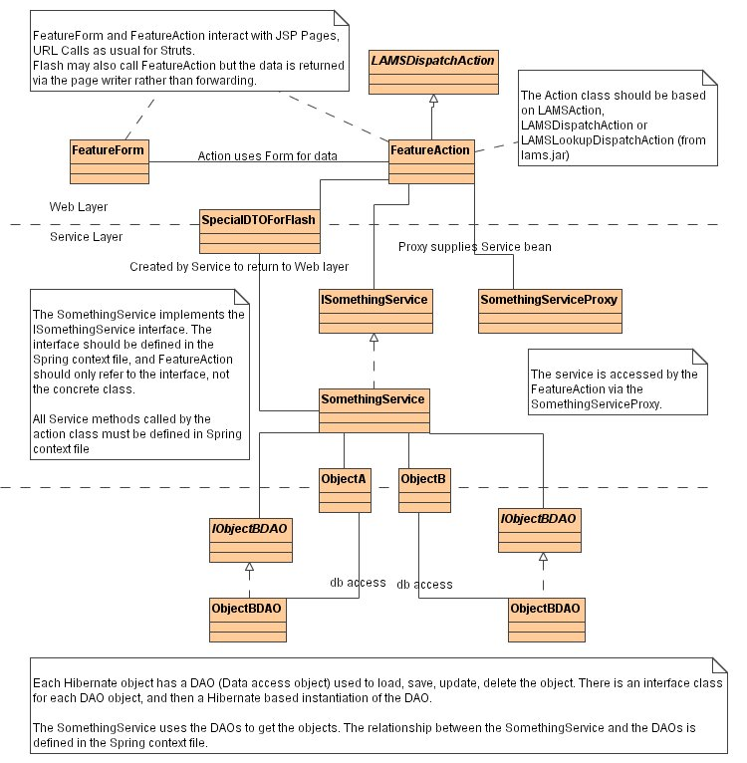
Figure 1: Sample Class Hierarchy

Database Standards
All database definitions should be generally SQL compliant, rather than taking advantage of MYSQL feature as much as possible. This will make it easier to port to another database in the future.
One MYSQL feature that you should use is the auto increment functionality
(see http://dev.mysql.com/doc/mysql/en/example-AUTO_INCREMENT.html & http://dev.mysql.com/doc/mysql/en/Getting_unique_ID.html )
This allows to use the "identity" method of identifier generation in our hibernate mappings (see http://www.hibernate.org/hib_docs/reference/en/html/mapping.html#mapping-declaration-id-sequences) as opposed to the "assigned" which requires us to generate our own. This is preferable as it should decrease the instances of problems due to badly assigned identifiers.

The LAMS database uses a UTF-8 connection and the transaction isolation level for InnoDB tables is READ-COMMITTED. The latter occurs out of the box for Win32 (which is good because there doesn't seem to be a way of altering it that works on 4.1 in Windows) but the linux version (and I am assumeing other UNIX-like OSs) defaults to REPEATABLE-READ. In order to change this for linux you need to create or edit the config file /etc/my.cnf like the following:
[mysqld]
transaction-isolation=READ-COMMITTED
Note: that according to the documentation you should be able to change the system variables to achieve these changes (or at least make changes that produce the same results) using the SET GLOBAL <variable>=<value> commands like we do in MySQL 4.0. Unfortunately the SET GLOBAL does not seem to work for many of the system variables 4.1 (though it doesn't produce an error).

All changes to the core tables should be should be made via the model (lams_common/db/model/lams_11.clay: you will need the Clay plugin for Eclipse to do this - see http://www.azzurri.jp/en/software/clay/). New create scripts can then be generated via the model. Tools should have their own models and their own database create scripts.

