
LAMS 1.1 Progress Engine

Draft Version 1.0
Author: Jacky Fang
LAMS INTERNATIONAL
1 February 2006

Revision History
Name | Date | Reason For Changes | Version
Jacky Fang | 20 April 2005 | Initial Draft | 1.0
Fiona Malikoff | 1 February 2006 | Added lesson states | 1.2

Contents
1 Introduction 2
1.1 Scope 2
1.2 Background 2
1.2.1 Learning Design 2
1.2.2 Activity 2
1.2.3 Lesson 2
1.2.4 Learner Progress 3
1.2.5 Learner Progress Bar 3
1.3 Progress Engine before 1.1 3
1.3.1 Polling Based Progress Engine 3
1.3.2 B6.1 Anti-Polling Progress Engine 3
2 Progress Engine from Teacher’s Perspective 4
2.1 Function Model 4
2.1.1 Use Case Diagram 4
2.1.2 Use Cases 4
2.2 Domain Object Model 8
2.3 Database Design Consideration 9
2.4 Business Class Model 10
2.5 Major Algorithm Explanation 10
2.5.1 Lesson States 11
2.5.2 Create a lesson without lesson class 13
2.5.3 Start a lesson 14
2.6 TODO List 14
2.6.1 Force Complete 14
3 Progress Engine from Learner’s Perspective 16
3.1 Function Diagram 16
3.1.1 Use Case Diagram 16
3.1.2 Use Cases 16
3.2 Domain Object Model 21
3.3 Database Design Consideration 21
3.4 Business Class Diagram 21
3.5 Major Algorithm Explanation 22
3.5.1 Move to next activity 22
3.5.2 Calculate the next activity at service layer 23
3.5.3 Mapping the Activity to the URL 25
3.5.4 LAMS 1.1 activity page loading Mechanism 26
3.5.5 Join a lesson with Retrieving Progress Data 27
3.5.6 Communication between Server progress engine and Flash Progress bar 28
3.6 TODO List 29
3.6.1 Learner Data Caching and Progress Data Caching 29
3.6.2 Learner Web UI 29
3.6.3 Others 29
4 Progress Engine Driven Activities 30
4.1 Grouping 30
4.1.1 Introduction 30
4.1.2 Functional model 30
4.1.2.1 Use case diagram 30
4.1.3 Object Model 31
4.1.4 Database design consideration 32
4.1.5 Major algorithm explanation 33
4.1.6 TODO List 33
4.1.6.1 Chosen grouping web layer 33
4.2 Gate 34
4.2.1 Introduction 34
4.2.2 Functional model 34
4.2.2.1 Use case diagram 34
4.2.3 Object Model 35
4.2.4 Database design consideration 36
4.2.5 Major algorithm explanation 36
4.2.5.1 Open Sync Gate 37
5 Reference 38

Figure 1 Progress Engine Use Case Diagram - Teacher 4
Figure 2 Lesson related domain object diagram 8
Figure 3 Lesson related database design 9
Figure 4 Business class diagram – Monitoring 10
Figure 5 Lesson States 12
Figure 6 create lesson sequence diagram 13
Figure 7 start a lesson sequence diagram 14
Figure 8 Force Complete Sequence Diagram 15
Figure 9 Progress Engine Use Case Diagram – Learner 16
Figure 10 Business Class Diagram – Learning 21
Figure 11 Move to Next Activity - Sequence Diagram 22
Figure 12 Calculate the Next Activity - Activity Diagram 23
Figure 13 Calculate the URL from Learner Progress- Activity Diagram 25
Figure 14 Join lesson with retrieving progress data - Sequence Diagram 27
Figure 15 Server and Flash Communication - Move to next activity 28
Figure 16 LAMS 1.1 Grouping Use Case Diagram 30
Figure 17 Grouping Domain Object Model 31
Figure 18 Database design Grouping 32
Figure 19 Gate use case diagram 34
Figure 20 Gate Domain Object Diagram 35
Figure 21 Gate database design 36
Figure 22 Open Synch Gate Activity Diagram 37

Introduction

Scope
This document explains the overall system design as well as the implementation algorithm regarding LAMS 1.1 progress engine. As we don’t have a separate use case document, this document will record the full development life cycle of progress engine, including use case illustration, database design, java class structure and all complex algorithm explanations. It is structured as three major sections against the functional module of LAMS 1.1
- Explain the design and implementation of progress engine that relates to the Monitor module.
- Explain the design and implementation of progress engine that relates to the learner module.
- Explain the design and implementation of progress engine that affects the LAMS controlled activities.

Background
To understand the new design of LAMS 1.1 progress engine, it is necessary to review some background concepts that related to LAMS progress engine. The main purpose of this section is to let new developers to understand the e-learning concept behind the design of progress engine and what progress engine is doing from user’s point of view. If you knows LAMS concept already, please feel free to skip this section:

Learning Design
The concept of learning design has been defined in the IMS specification. This is not a document to debate about the concept of learning Design. We are more interested in what does learning design mean for LAMS and progress engine. From progress engine’s perspective, learning design defines a sequence of collaborative learning activities and tools required to support these activities. It defines the basic navigation rule that progress engine should cope with.

Activity
Activity is the major element of a learning design. In another words, it is the learning object that sit inside the learning design. From progress engine’s point of view, activities are the nodes of the sequence that the engine needs to navigate through.

Lesson
While learning design is a reusable template, the lesson is one instance that using the learning design template. A lesson should have a number of participated learners, who are going to do the learning tasks that are defined in a learning design. Therefore, data that involved in the learning design instance of a particular lesson should not be shared across lessons. In terms of progress engine, the start of a lesson is the trigger of the progress engine. At this point, progress engine should initialize any resources of the learners.

Learner Progress
The learner progress is the data holder that records the progress status of runtime learning design instance. In other words, learner progress record where the learner is in a lesson. Therefore, learner progress has to be specific to a particular learner and a particular lesson.

Learner Progress Bar
The learner progress bar is a Flash component that sits on the LAMS learner GU interface. It gives learner a user friendly graphical representation of where they are in the learning design. It is a Flash reflection of learner progress data sitting on the server side.

Progress Engine before 1.1
Strictly speaking, LAMS 1.1 progress engine is the third version of the algorithm of progressing the learning design since the born of LAMS software. LAMS has gained lot of lessons from previous implementation in terms of scalability and maintainability. To understand the current design, it is necessary to review the experience and pitfalls from previous version.

Polling Based Progress Engine
The first version of LAMS progress engine is based on JMS asynchronous messaging. This approach is referred to Polling in the old documentation. Under the polling architecture, instead of LAMS itself to figure out what is the next activity for the learner, the client side (essentially the Flash component) drive the progress engine to keep moving by keep sending message to the server. This approach works fine if the number of concurrent learners is very small. However, once we moved onto the loading testing stage of LAMS application, the overhead generated by client messaging quickly becomes the major bottleneck that halted the whole system. The high concurrency nature of progress engine decides asynchronous messaging is not a suitable technology choice for LAMS.

B6.1 Anti-Polling Progress Engine
The algorithm for this version of progress engine has been explained in JP’s document “Anti-polling” [1]. If you are interested in knowing the details, please refer to his document. This approach completely removes the overhead result from polling architecture, which make it possible for LAMS to scale under hundreds of concurrent users. However, our profiling and stress testing tools quickly reveals new problems of this architecture. Due to the lack of proper data structure to hold the learner’s progress status, the Flash learner progress bar has to request the server to go through the entire learning design to calculate the exact position for display. Profiling shows this calculation consumes 65% of the system resources. And the bigger the learning design is, the more resources need to be consumed by this profiling. Even worse, this calculation needs to be done every time when each learner wants to progress to next activity. Consequently, designing a flexible data structure that holds necessary progress data becomes the major rationale we followed in 1.1 Progress engine.

Progress Engine from Teacher’s Perspective

Function Model

Use Case Diagram
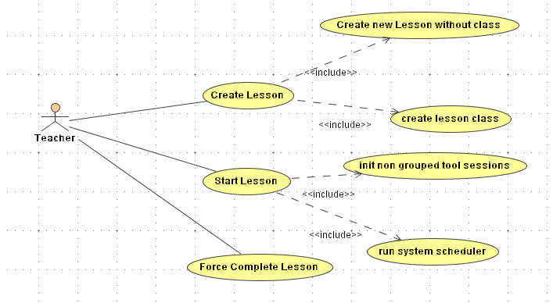
Figure 1 Progress Engine Use Case Diagram - Teacher

Use Cases
Primary Actor | Use Cases
Teacher | Create Lesson
Teacher | Start Lesson
Teacher | Force Complete Lesson

Use Case ID: | LAMS1.1 PG0001
Use Case Name: | Create Lesson
Created By: | Jacky Fang | Last Updated By: | 21/04/2005
Date Created: | 21/04/2005 | Date Last Updated: | 21/04/2005

Actors: | Teacher
Description: | The teacher creates a lesson for a learning session.
Preconditions: | - The teacher loads up the monitoring interface.
Postconditions: | - A lesson gets created.  - A copy of learning design for lesson gets created.  - A copy of tool content gets created.
Normal Flow: | - Teacher clicks on the create lesson button.  - Teacher selects the learning design he wants to run for the new lesson. And the teacher types in the title and description for the lesson.  - Teacher clicks on the button to tell LAMS to create lesson.  - LAMS creates a copy of the learning design.  - LAMS notifies all tools that involved in the learning design to create a copy of their content for lesson.  - LAMS creates a new lesson based on the copied the learning design.  - Teacher clicks on the create lesson class button.  - Teacher selects the list of learners and a list of staffs and the organization that forms the lesson class.  - Teacher clicks on the button to tell LAMS to create lesson.  - LAMS creates class grouping
Alternative Flows:
Exceptions:
Includes:
Priority:
Frequency of Use:
Business Rules:
Special Requirements:
Assumptions:
Notes and Issues:

Use Case ID: | LAMS1.1_ PG 0003
Use Case Name: | Start a lesson
Created By: | Jacky Fang | Last Updated By: | 21/04/2005
Date Created: | 21/04/2005 | Date Last Updated: | 21/04/2005

Actors: | Teacher
Description: | The teacher starts a lesson
Preconditions: | The lesson has been created and lesson class has been assigned.
Postconditions: | Non-grouped tool sessions are initialized and system schedulers are started if necessary.
Normal Flow: | - Teacher chooses a new lesson that has been started.  - Teacher clicks on the start lesson button to send a Flash message to the server to start lesson.  - LAMS goes through all the non-grouped tool activities and initialises the tool sessions if there is one.  - LAMS goes through all the scheduled based activities and start scheduler of each task if necessary.  - LAMS responds a message to indicate the status of starting a lesson.
Alternative Flows:
Exceptions:
Includes:
Priority:
Frequency of Use:
Business Rules:
Special Requirements:
Assumptions:
Notes and Issues:

Use Case ID: | LAMS1.1_ PG 0002
Use Case Name: | Force Complete a lesson
Created By: | Jacky Fang | Last Updated By: | 21/04/2005
Date Created: | 21/04/2005 | Date Last Updated: | 21/04/2005

Actors: | Teacher
Description: | The teacher forces a student to complete his lesson.
Preconditions: | The learner has joined lesson and a learner progress has been shown in the monitoring interface.
Postconditions: | - The selected student’s learner progress data should be marked as lesson completed.
Normal Flow: | - Teacher chooses a learner progress appears under monitoring tab.  - Teacher clicks on the force complete button to send a message to learner to force complete a learner.  - LAMS set the lesson complete to true inside learner progress.  - LAMS set the status of all the tool session created for this learner to ENDED.  - LAMS notifies all tools’ to set its session status to completed
Alternative Flows:
Exceptions:
Includes:
Priority:
Frequency of Use:
Business Rules:
Special Requirements:
Assumptions:
Notes and Issues:

Domain Object Model
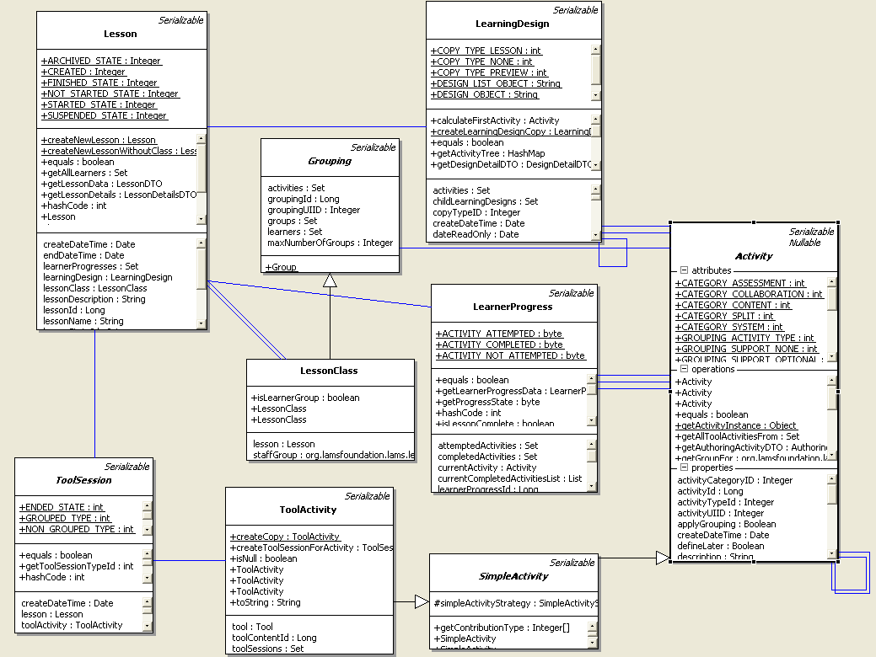
Figure 2 Lesson related domain object diagram
The above diagram is a fragment of the entire domain object diagram to illustrate the object model design to handle lesson related learner progression. As you can see, there are four major aggregated components for a lesson:
- LearningDesign – It defines the major learning sequence that students in a lesson should complete.
- LessonClass – It holds all the students information who are participating a lesson. It is also a special grouping type in LAMS to perform class based learning tasks.
- LearnerProgress – It records the progress data for each learner. One lesson should have 0 or many learner progression. Every student should only have one learner progress record. This makes it possible for a teacher to monitor all students progression status.
- ToolSession – As you already know, learning design is a static aggregation of learning activities. Each activity refers to a tool session record that holds the runtime data for the activity. To understand more about tool session, please read tool contract document [2] from Chris Perfect.

Database Design Consideration
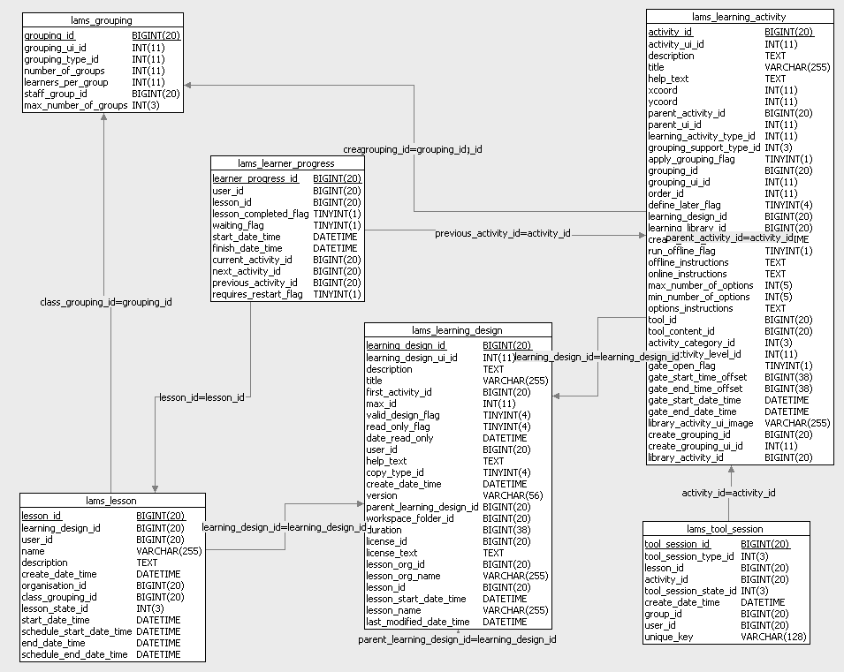
Figure 3 Lesson related database design
Figure 3 is a fragment of database model that illustrate the database structure mapping to the object model we discussed in the last section. As the major inheritance mapping we adopted is “Table per class hierarchy”, the above diagram appears to simpler than the object model we shown in the last section.

Business Class Model
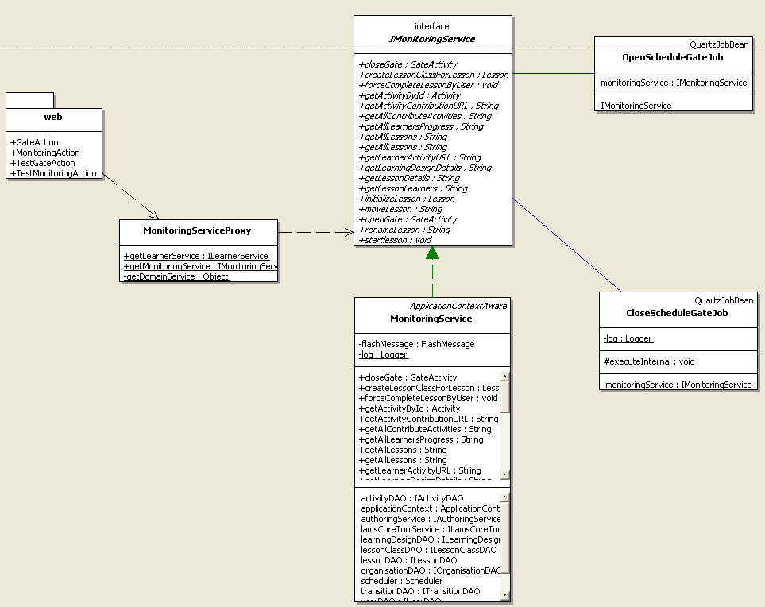
Figure 4 Business class diagram – Monitoring
Above diagram shows the design of monitoring web layer and service. The web Struts action servlet handle the http request from Flash client and delegate the calculation to monitoring service. The monitor service is configured as transactional and each method represents a unit of work. Authoring service, tool service, system scheduler and other resources are injected into monitoring service using method injection.

Major Algorithm Explanation
In section 2.1, we review the functional model of teacher specific progress engine. In this section, we are going to explain the algorithm implemented underneath to achieve the functionalities described in the above section. To explain algorithm, sequence diagram, state diagram and code snippets will be provided wherever necessary.

Lesson States
The lesson passes through a number of states. The states are defined in the Lesson class.

Lesson State | Description
CREATED | A newly created lesson. The learning design has been copied. The lesson class may or may not have been configured. The lesson is shown on the staff interface but not on the learning interface.
NOT_STARTED_STATE | A CREATED lesson may be scheduled to start at a particular date. When it is schedule, state is set to NOT_STARTED_STATE for lessons that have been scheduled. The lesson is shown on the staff interface but not on the learning interface.
STARTED_STATE | The lesson has been started. The lesson is shown both the staff interface and learner interface. Whilst in this state, the learners can participate in the lesson.
SUSPENDED_STATE | A lesson that is in STARTED_STATE may be suspended. While suspended, the lesson can be seen on the staff interface but not on the learning interface. When the lesson is no longer suspended, it returns to STARTED_STATE.
FINISHED_STATE | The state for lessons that have been finished. A finished lesson is shown as inactive on the staff interface, and is shown on the learner interface but the learner is to only see the overall progress and be able to export data - they should not be able to interact with the tools.
ARCHIVED_STATE | The state for lessons which are shown as inactive on the staff interface but no longer visible to the learners.
DISABLED_STATE | The state for lessons that are removed and never can be accessed again

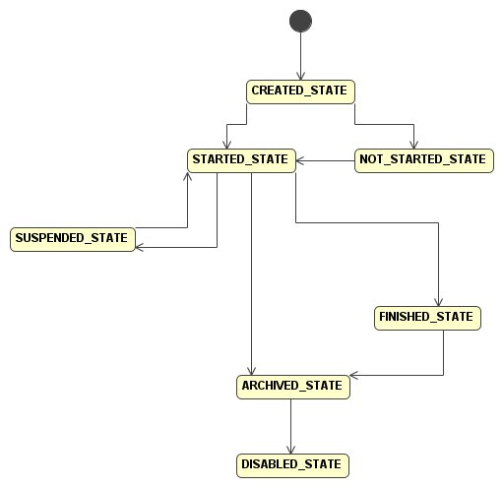
Figure 5 Lesson States

Create a lesson without lesson class
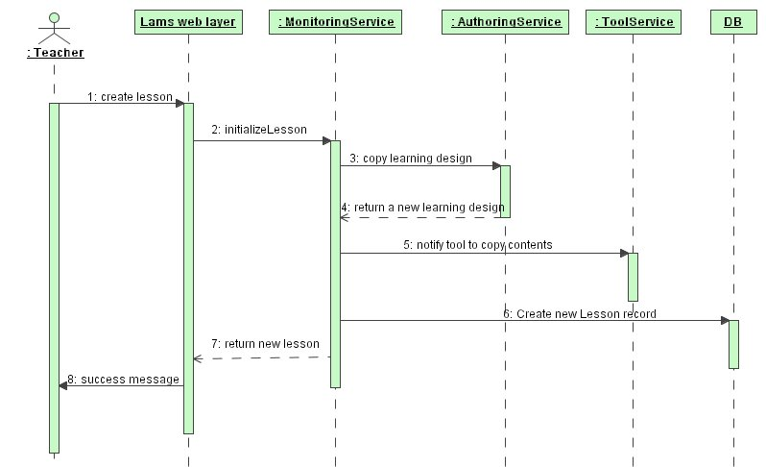
Figure 6 create lesson sequence diagram
The algorithm of create a lesson without class is pretty much illustrated in the above diagram. There is one step we want to get into a bit more detail explanation. Notice that we are notifying all the tool activity involved in the learning design to create a copy of their contents. Our way of establishing association between LAMS core and tool component is using container context. In terms of Spring, the ToolService object implements ApplicationContextAware to allow the Spring services beans to be loaded dynamically according to the tool activities that sit inside the learning design. If we have a tool that is using EJB as its business object technology, tool service should be configured to handle JNDI look up apart from Spring application context look up. Please refer to the Java doc that lives with the code to understand the detail mechanism of loading up service bean.

Start a lesson
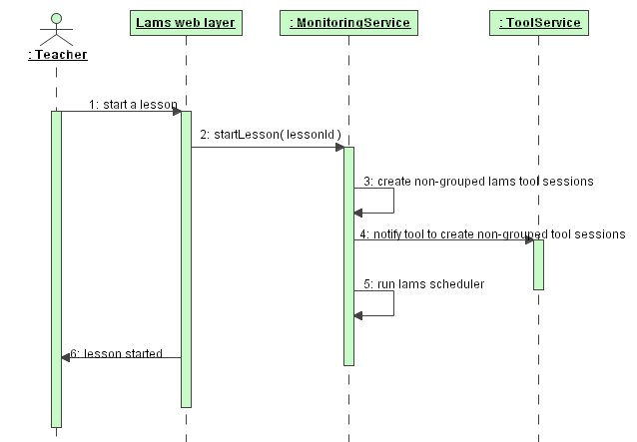
Figure 7 start a lesson sequence diagram
Figure 5 illustrates the algorithm of starting a lesson. Load testing of progress engine before 1.1 reveals that creating run time instance for tools become one of the major bottleneck of LAMS. This is due to the huge number of concurrent database insertion when lot of learners try to progress to the next activity at the same time. Therefore, LAMS 1.1 progress engine tries to release the burden of database insertion at runtime as much as possible. In the above diagram, step 3 and 4 create all non-grouped tool sessions to remove the insertion bottleneck as much as possible. We are not able to initialize grouped tool session at this point because of random nature of grouping algorithm.

TODO List

Force Complete
Although we have defined basic algorithm, this hasn’t been implemented so far. Further, apart from the force complete the learner, we might also need to force complete all learners in the lesson. To implement For complete, following sequence diagram might give the ideas of the algorithm you need in your code.
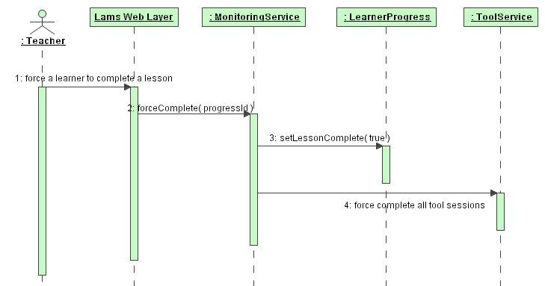
Figure 8 Force Complete Sequence Diagram

Progress Engine from Learner’s Perspective

Function Diagram

Use Case Diagram
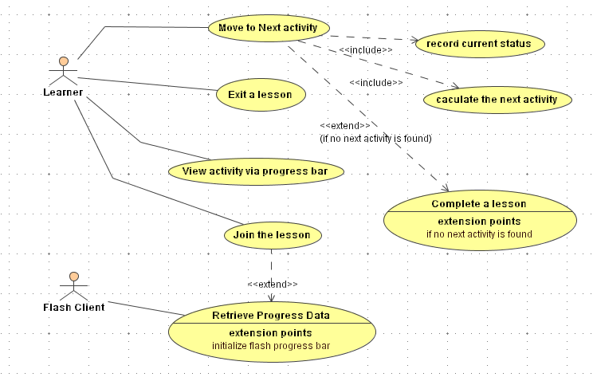
Figure 9 Progress Engine Use Case Diagram – Learner

Use Cases
Primary Actor | Use Cases
Learner | Join a lesson
Learner | Move to next activity
Learner | Exit a lesson
Flash Client | Retrieve active lessons
Learner | View Activity via Progress Bar

Use Case ID: | LAMS1.1 PG0004
Use Case Name: | Join a Lesson
Created By: | Jacky Fang | Last Updated By: | 21/04/2005
Date Created: | 21/04/2005 | Date Last Updated: | 21/04/2005

Actors: | Learner
Description: | The learner joins a lesson to start or resume the learning session that is available to him.
Preconditions: | The learner loads up the learning interface.
Postconditions: | The current activity shown in the activity frame of learning GUI.
Normal Flow: | - The learner selects the active lesson and clicks on the Flash active lesson button.  - The Flash client calls URL to trigger join lesson at LAMS server.  - LAMS calculates the learner progress for the requested learner and lesson and sends an acknowledgement message back to Flash.  - LAMS calls the URL of the first activity and displays its content in the activity frame.
Alternative Flows: | - If the learner has run the lesson before, LAMS calls the URL of the last activity that has been visited by the learner.
Exceptions:
Includes:
Priority:
Frequency of Use:
Business Rules:
Special Requirements:
Assumptions:
Notes and Issues:

Use Case ID: | LAMS1.1 PG0005
Use Case Name: | Move to next activity
Created By: | Jacky Fang | Last Updated By: | 21/04/2005
Date Created: | 21/04/2005 | Date Last Updated: | 21/04/2005

Actors: | Learner
Description: | The learner completes one activity and moves to the next activity defined in the learning design.
Preconditions: | The learner has joined lesson.
Postconditions: | The LAMS shows the content of the next activity.
Normal Flow: | - The learner clicks on the finish button of the current running activity.  - LAMS calculates the next activity in the learning design.  - LAMS calls the URL of the next activity.
Alternative Flows: | 2.1 If there is no more activity in the learning design, LAMS sets the learner progress to “lessonComplete” State.  3.1 LAMS shows the completion page if lesson is completed.
Exceptions:
Includes:
Priority:
Frequency of Use:
Business Rules:
Special Requirements:
Assumptions:
Notes and Issues:

Use Case ID: | LAMS1.1 PG0006
Use Case Name: | Exit a Lesson
Created By: | Jacky Fang | Last Updated By: | 21/04/2005
Date Created: | 21/04/2005 | Date Last Updated: | 21/04/2005

Actors: | Learner
Description: | The learner exits the lesson without completing it.
Preconditions: | The learner has joined lesson.
Postconditions: | The LAMS shows the welcome page..
Normal Flow: | - The learner clicks on the exit lesson Flash button on a running lesson.  - The Flash client calls the exit lesson URL to trigger the “exit lesson” procedure at server side.  - The LAMS sets the current learner progress to “restarting” and sends an acknowledgement message back to Flash.  - The LAMS shows welcome page in the activity frame.
Alternative Flows:
Exceptions:
Includes:
Priority:
Frequency of Use:
Business Rules:
Special Requirements:
Assumptions:
Notes and Issues:

Use Case ID: | LAMS1.1 PG0007
Use Case Name: | Retrieve Progress Data
Created By: | Jacky Fang | Last Updated By: | 21/04/2005
Date Created: | 21/04/2005 | Date Last Updated: | 21/04/2005

Actors: | Flash Client
Description: | The Flash client sends a request to server to retrieve the learner progress data.
Preconditions: | - The learner has joined lesson and Flash client received lesson joined Flash acknowledgement message.  - Some unexpected exception occurred at Flash side.
Postconditions: | The Flash progress bar shows the proper position of the learner.
Normal Flow: | - The Flash client calls the server URL with the lesson id and the user id.  - The LAMS server retrieves the requested learner progress and translates it into the expected format by the Flash client.  - The LAMS sends the message back to Flash client.
Alternative Flows:
Exceptions:
Includes:
Priority:
Frequency of Use:
Business Rules:
Special Requirements:
Assumptions:
Notes and Issues:

Use Case ID: | LAMS1.1 PG0008
Use Case Name: | View Activity via Progress Bar
Created By: | Jacky Fang | Last Updated By: | 21/04/2005
Date Created: | 21/04/2005 | Date Last Updated: | 21/04/2005

Actors: | The learner
Description: | The leaner views the content of the activity via progress bar.
Preconditions: | - The learner has joined the lesson.  - The learner has visited the activity he intended to view.
Postconditions: | The LAMS shows the content of the progress bar.
Normal Flow: | - The learner clicks on the Flash object inside the learner progress bar.  - The Flash client sends the request to server to ask for the URL according the activity that the user clicked on.  - The LAMS calculates the URL and loads it into the activity frame.
Alternative Flows:
Exceptions:
Includes:
Priority:
Frequency of Use:
Business Rules:
Special Requirements:
Assumptions:
Notes and Issues:

Domain Object Model
The learning part progress engine is based on the same domain object design as teacher part progress engine. Please refer to section 2.2 for diagramming and explanation.

Database Design Consideration
The learning part progress engine is based on the same database design as the teacher part progress engine. Please refer to section 2.3 for diagramming and explanation.

Business Class Diagram
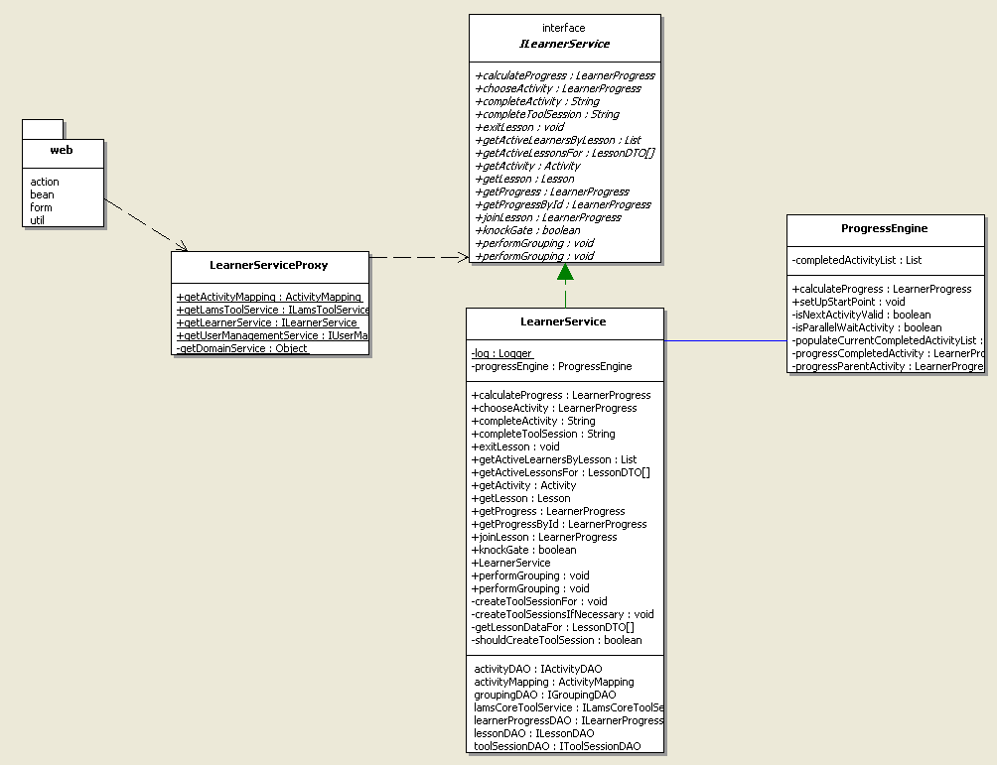
Figure 10 Business Class Diagram – Learning
Figure 9 shows the service layer class diagram for lams_learning module. Apart from standard service façade pattern we followed like the other modules. We have factored out the progress engine related calculation into the class “ProgressEngine”. The algorithm that implemented in this class will be explained in detail with sequence diagram and activity diagram in the later sections.

Major Algorithm Explanation
This section explains the algorithms implemented underneath to achieve the functionalities described in the above sections. To explain the algorithms, sequence diagrams, activity diagrams and code snippets will be provided wherever necessary.

Move to next activity
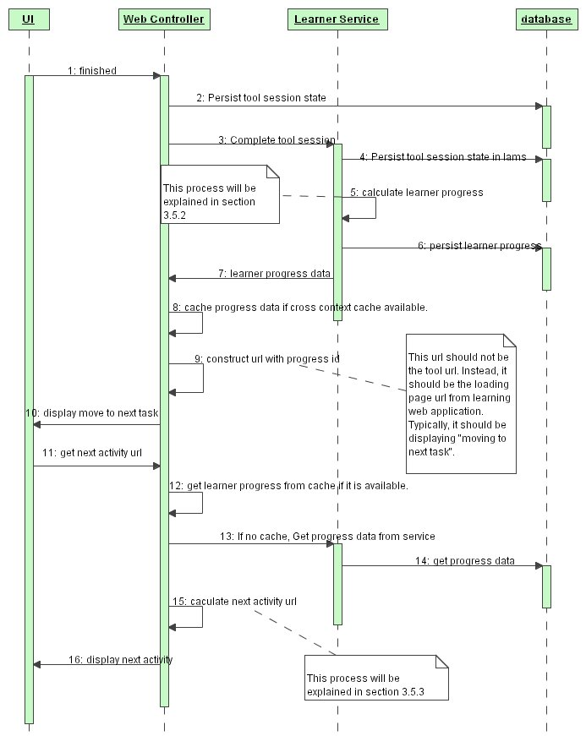
Figure 11 Move to Next Activity - Sequence Diagram
Above diagram shows the overall algorithm used to complete the moving from one activity to the other. This process usually triggered by clicking on the “Finished” button of a particular tool page. Step 2 to Step 6 has to be done in one transaction so as to ensure there is no inconsistent state between tool and LAMS server. After that, LAMS travel from tool web application to lams_learning web application by http URL redirecting. The lams_learning is responsible for calculating the URL for next activity and forward to it. Two major algorithms, Calculate the next activity at service layer and Mapping the Activity to the URL, are hidden in above diagram, which will be explained in following sections.

Calculate the next activity at service layer
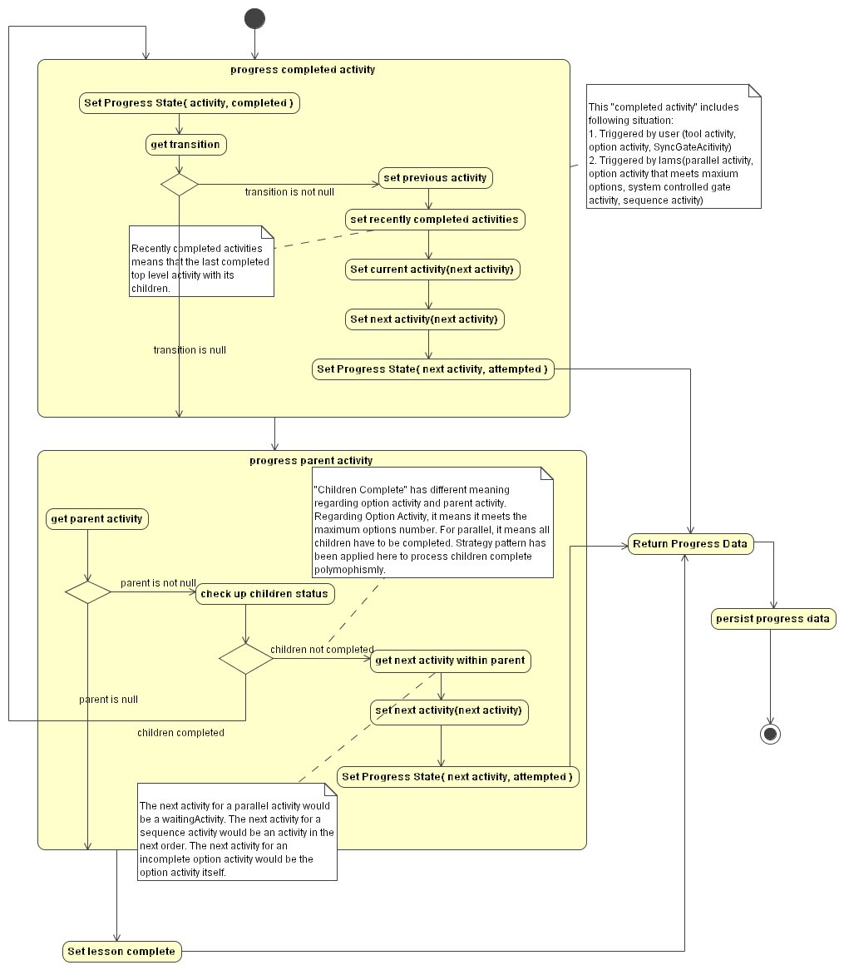
Figure 12 Calculate the Next Activity - Activity Diagram
The first major functionality of progress engine is to be able to figure out what is the next activity in the learning design when one activity is completed. Figure 12 shows the detail logic of calculating next activity at service layer. The trigger of this procedure is the completed activity that is fed either by the web layer or the calculation procedure itself.
According to the learning design structure we defined for LAMS 1.1, the transition has only been used to identify the sequence of top level activities. All children activities within a top level activity are structured using order id. In this context, transition has been used as the major condition to identify the completion of a top level node. In other words, we assume we’ve found the next activity if there is transition following the completed activity. Furthermore, a completed activity without transition also indicates it might have a parent activity or it is the last activity in a learning design.
Whenever a parent activity is identified, the algorithm looks through all children activities belong to that parent. If all children are completed, it recursively feed this parent activity into “process completed activity” logic to figure out the proper next activity. The algorithm is meant to be able to walk through the whole activities tree until a transition is identified. If incomplete children exist, the algorithm should pick up the right next child activity according to the type of this parent and return the learner progress back to the client. To understand how the algorithm figure out the right next child activity within the parent, please read the comments in activity diagram and the java doc for class “ProgressEngine”.

Mapping the Activity to the URL
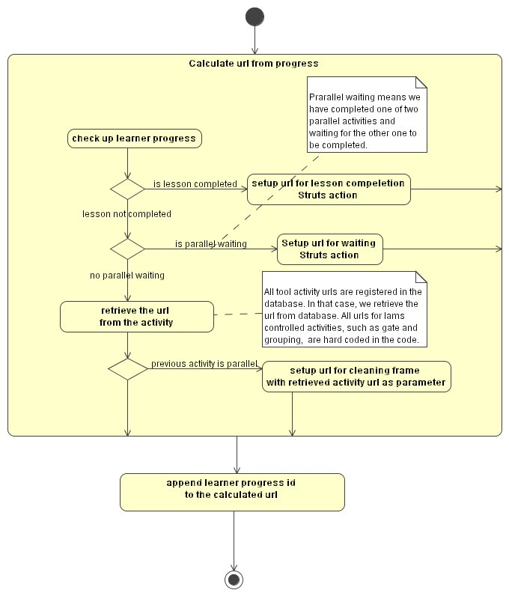
Figure 13 Calculate the URL from Learner Progress- Activity Diagram
Once the service layer progress engine calculated the next activity to move on to and returned the learner progress, the web layer progress engine needs to figure out what is the proper URL for the next activity. Figure 13 illustrates the algorithm to fulfill this functionality.

LAMS 1.1 activity page loading Mechanism
To fully understand how progress engine display the JSP of the next activity, we have to explain the activity page loading mechanism first. As you might know, the LAMS activities are classified into two big categories – complex activity and simple activity. (If you are uncertain about LAMS activity hierarchy, please study relevant java class and UML modeling that is designed by Chris perfect) From the perspective of displaying these activities using JSP, we would like re-classify these activities into three major categories – Single frame JSP activity, multi-frame JSP activity and LAMS system JSP activity. These three categories and corresponding page loading strategy are explained as follows:
- Single framed JSP activity – A single frame loading JSP is used to display the content of this type of activity. Referring back to the activity hierarchy designed in the object model, all simple activities as well as sequence activity falls into this category.
- Multi-framed JSP activity – When we are dealing with parallel activity, single frame is no longer enough to display two or more activities on the same screen. It is therefore multi-frame needs to be initialized before the actual activity contents can be loaded into the JSP.
- LAMS system JSP activity – A single framed JSP is also used for system activities. The difference between this category and single framed JSP activity is that the actually activity content won’t be displayed directly. Instead, a LAMS page will be loaded to represent activity’s content. Options activity is a good example - LAMS option page will be shown with all the sub-activities outlines and instructions rather than the contents of all optional activities.
Why did we make this classification? We want all activities contents are loaded by LAMS loading page rather than shown directly from Struts action forward. Why LAMS loading page is important? LAMS loading page has to exist because of two major reasons. Firstly, the loading page is a clean solution to add extra frame and clean unnecessary frame whenever required. Without using an intermediate loading JSP, we could not find a solution to achieve the same functionality. Secondly, the loading page is a good place to send update progress bar message to the Flash client. If you are familiar with LAMS before 1.1, you will notice that the entry JSP page of each tool is doing updates of the Flash progress bar. This results in a tight dependency between tool and the Flash progress bar. Furthermore, update code on all tools’ JSP generates duplicate code and consequently a maintainability nightmare.
Isn’t the loading page is extra overhead? Well, it might be! But considering the benefit it brought us, we decide to live with the overhead it generates. Further, the bottleneck of most J2EE application sits at poorly programmed business layer and persistent layer. We decide to let loading tests and profiling tell us what the bottleneck of LAMS 1.1 is.

Join a lesson with Retrieving Progress Data
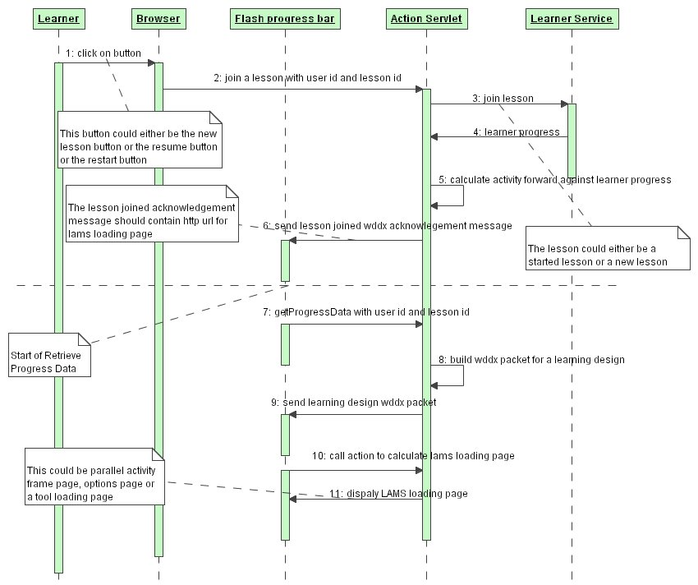
Figure 14 Join lesson with retrieving progress data - Sequence Diagram
Based on the understanding of major progress engine algorithm and page loading mechanism, we can further the explanation of the joining lesson algorithm. The explanations of join lesson and retrieving progress data are combined because these two use cases usually happen consecutively. Once LAMS finishes joining the learner to the lesson and send the wddx acknowledgement message with the URL of loading page calculation struts action back to Flash, Flash sends the request to the LAMS server to grab entire learner progress structure to build up learner progress bar. The progress data request from Flash has to be sent after the Flash client receives the “Joined Lesson” message from LAMS because it needs to load the latest progress data.

Communication between Server progress engine and Flash Progress bar
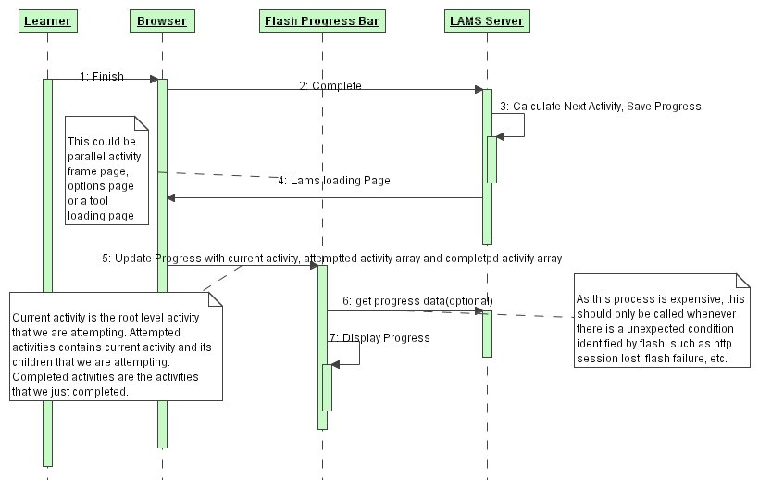
Figure 15 Server and Flash Communication - Move to next activity
We have already explained the algorithm of moving to next task on the LAMS server side. How do we achieve the visual indication of the movement on the Flash progress bar? Figure 15 explains the detail logic behind the scene. A Flash movie update script like following will be placed on the LAMS loading page:
<object classid="clsid:D27CDB6E-AE6D-11cf-96B8-444553540000" codebase="http://download.macromedia.com/pub/shockwave/cabs/flash/swflash.cab#version=6,0,29,0" width="1" height="1">
<param name="movie" value="../../learnerProgress_lc.swf?currentTaskId=xx">
<param name="quality" value="high">
<embed src="../../learnerProgress_lc.swf?currentTaskId=xx"
quality="high"
pluginspage="http://www.macromedia.com/go/getflashplayer"
type="application/x-shockwave-flash"
width="1"
height="1">
</object>
This script should update progress bar with current activity, attempted activity array and completed activity. Please refer to the notes on Figure 15 for the meaning of these variables. As these data has been calculated along with the server side “move to next task”, we save all the extra calculation we did in LAMS 1.0. Furthermore, the data sent back to Flash is only a couple of bytes, which minimize the Flash – Java communication cost. As a safe guard, Flash can send the request to server to restore the whole progress bar structure if there is an exception has been identified at Flash side. But we believe this won’t happen very often.

TODO List

Learner Data Caching and Progress Data Caching
Caching is one of the most important techniques to improve the scalability of high concurrency applications. In terms of progress engine, there are two major pieces of data need to be cached.
Firstly, the learner information is used very frequently by progress engine as well as LAMS. In most cases, we are reading the data rather than updating it. Therefore, it becomes a good candidate to be cached. Furthermore, learner cache is also used to calculate total online learners for a lesson. At this stage, we couldn’t think of a perfect solution to achieve this due to complexity of http session and browser oriented web application. Fiona suggested using socket as well as client JavaScript to ensure the cache got cleaned when the leaner exit the lesson in an abnormal way. But this approach is yet to be tested. This is only the best solution we found out so far.
Secondly, retrieving learner progress is a heavy procedure due to its complex object structure. As the progress engine travels from one web application to the other quite frequently, normal http session cache no longer helps here because of the switch between web application contexts.(The travelling mechanism has been explain in fairly detail manner in section 3.5.1.) Re-loading learner progress again and again from database could be painful and heavy. Therefore, one of the tasks in the TODO list is to find out a good cross context caching technology to cache the learner progress properly.
As proper caching implementation needs to be seriously tested by loading tests, we leave this job in the TODO list at this stage.

Learner Web UI
The learner web UI is still in prototype stage. We are waiting for U.K. developer to build up the Flash client to test learner progress engine completely in a real browser environment.

Others
Regarding code, there are TODO tags marked whenever there is improvement requirement for current implementation. Comments are usually supplied wherever a TODO tag is marked. Please generate TODO report from code for details.

Progress Engine Driven Activities

Grouping

Introduction
Grouping before LAMS 1.1 has been implemented as a system tool embedded inside LAMS core engine. It is one of the most important components of the LAMS learning model. By applying grouping, the teacher gains the ability to split students into groups and assigns different tasks for different groups. Functionality wise, the teacher doesn’t have the option to decide how to group learners. The LAMS will group learners in the class randomly. Lacking of the power to decide who goes to which group makes the LAMS 1.0 grouping functionality less attractive in the practical use.
In LAMS 1.1, we take a couple of steps further on grouping functionality. In the new version of grouping activity, the teacher can not only decide the number of groups, the number of learners in a group but also choose the learners for a particular group.
Let’s look at the functional model first.

Functional model

Use case diagram
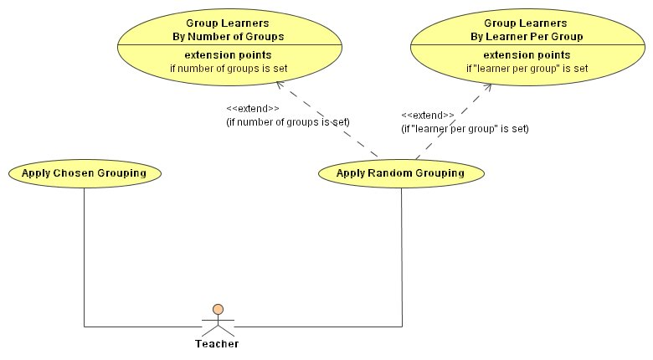
Figure 16 LAMS 1.1 Grouping Use Case Diagram
The above diagram illustrates the basic functionality provided in LAMS 1.1 grouping. Note that both “Group Learners by Number of Groups” and “Group Learners By Learner Per Group” are marked as extension rather than inclusion because only one of these two conditions can be applied when the teacher tries to create a random grouping activity. Applying both conditions will implicitly set the limit of the number of total learners in a class, which might make it difficult for a teacher to assign learners into the class when the lesson gets started.

Object Model
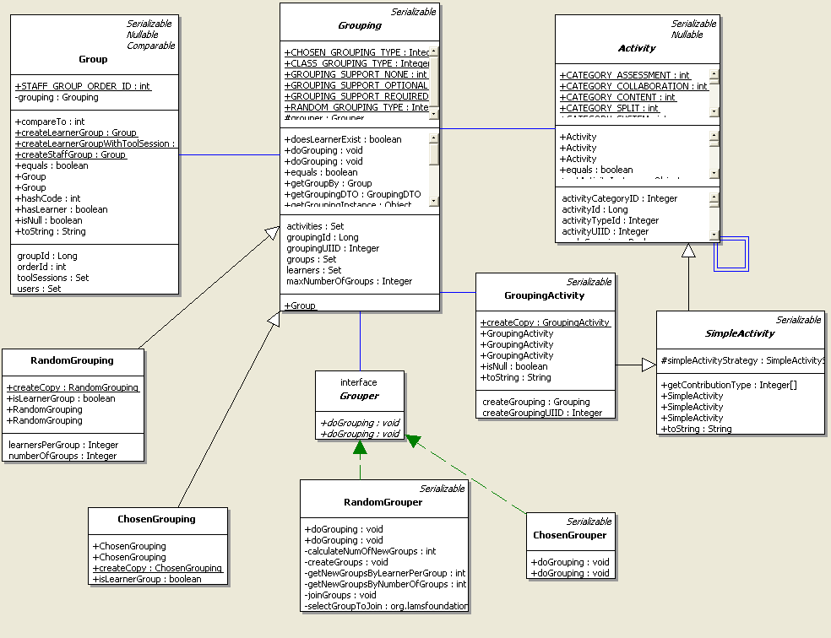
Figure 17 Grouping Domain Object Model
The above diagram shows the object model fragment for grouping implementation. Instead of having two different grouping activities, we delegate the grouping specific operations to the class “Grouping”, which is extended by two sub-classes – RandomGrouping and ChosenGrouping. These two classes act as the data holder for two types of groupings. Furthermore, the strategy interface “Grouper” is created purely for calculation purpose. doGrouping method within grouper performs the grouping algorithm in a polymorphic way. The end result of this algorithm is to create a number of groups inside the grouping object.

Database design consideration
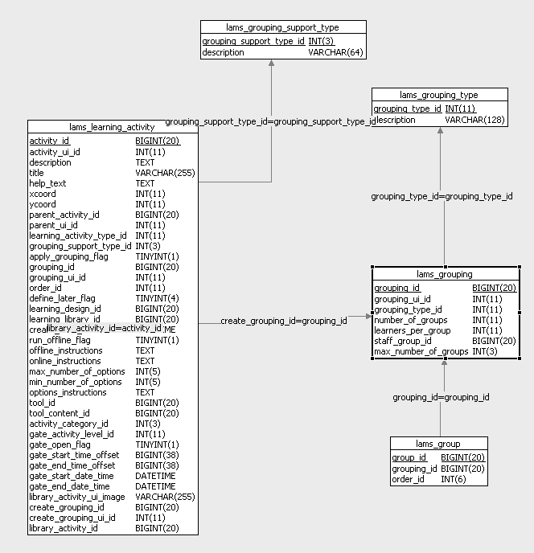
Figure 18 Database design Grouping
Compared to the domain object model, the database design is much simpler. Most of the inheritance relationships you have seen are mapped using “Table per class hierarchy” to improve efficiency. In Figure 18, it is probably worth explaining the meaning of lams_grouping_support_type. In LAMS 1.1 and before, whether an activity supports grouping or not is predefined in the activity’s design. In other words, author can’t configure a tool to support grouping or not. As we can see, ultimately, LAMS should be able to cope with multi levels of grouping support and make it configurable in the database. This table is designed under this context. Although most LAMS 1.1 tools are still not able to freely switch between grouped and non-grouped mode, this database design setup the groundwork to make this feature possible in the LAMS version beyond 1.1. It has three basic support types, which are explained as follows:
- NONE – It means that the activity that doesn’t support grouping.
- OPTIONAL – It means that the grouping capability is available but not compulsory. When the author applies a grouping to an activity, it becomes a grouped activity. Otherwise it is a non-grouped activity.
- REQUIRED – It means that the grouping capability is compulsory for a particular activity. If the author doesn’t apply grouping on an activity, LAMS will apply class level grouping on this tool automatically.

Major algorithm explanation
Both grouping algorithm has been explained in fairly detailed manner in the Java doc and comments with the class. Please refer to it to understand the details.

TODO List

Chosen grouping web layer
Most part of the chosen grouping will be the Flash component sits on the Monitoring UI. Therefore, we need to have a thorough discussion with Flash developer before we can start the implementation of action servlets and any web layer of chosen grouping. As excessive Flash development work load needs to be by the U.K. Flash fellows, we are still waiting for Flash developer to be free to work on this.

Gate

Introduction
Gate is a new concept introduced by Chris into LAMS 1.1. It is adapted from Sync Point within LAMS 1.0 and doing much more. From LAMS learning model point of view, the teacher may want to stop the class or individual learner at some point of the lesson. This is useful for teacher to control the pace of the lesson and review what students have done. Consequently, the concept of learning gate was born to fulfil this functionality in LAMS.
LAMS 1.0 Sync Point is useful to stop all learners after the students have completed certain activity. What if the teacher wants to schedule this behaviour? Or what if the teacher wants to fully control the release of this sync point rather than release it automatically after the whole class has reached the point? Furthermore, what if the teacher only wants to stop a learner or a group of learners rather than the whole class? Obviously, the design of LAMS 1.0 Sync point is no longer adequate. Moreover, it is clear that the naming of gate brought us more intuitive literature meaning than sync point. LAMS 1.1 Gate is designed to deal with all questions that we have just raised.

Functional model

Use case diagram
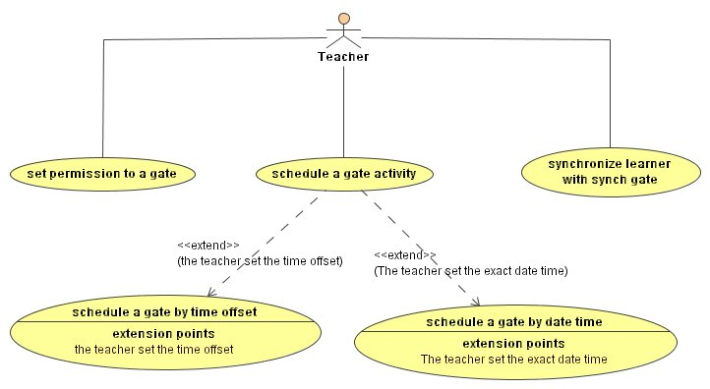
Figure 19 Gate use case diagram
The above diagram shows the functionality overview of LAMS 1.1 gate implementation. In general, the teacher can set three types of gates in a lesson. They are:
- Permission Gate – This gate won’t be open until the teacher permits the students to go through. The teacher can open the gate any time he wants to at the monitoring UI.
- Schedule Gate – The teacher needs to setup the way of scheduling when he sets the gate into the learning design. It can either be scheduled using the time offset against the lesson start time or the exact time stamp. If the teacher chooses the second way, he needs to ensure lesson startes before pre-defined gate time stamp. Once the lesson started, the system scheduler will run gate scheduler to open and close the gate automatically according to the predefined condition.
- Synch Gate – This is very similar to the LAMS 1.0 implementation. It stops the learners in front of the gate until all the learners have reached the gate.
Careful read will possibly note that we haven’t mentioned the functionalities of setting gate for individual learner or group. The reason is that it is not supported in current implementation of LAMS 1.1 although the database model is designed to cope with these functionalities. Furthermore, the lack of runtime instance support of activity object model stops us implement gate for learner and group in LAMS 1.1. These model constraints will be explained in detail in the following sections.

Object Model
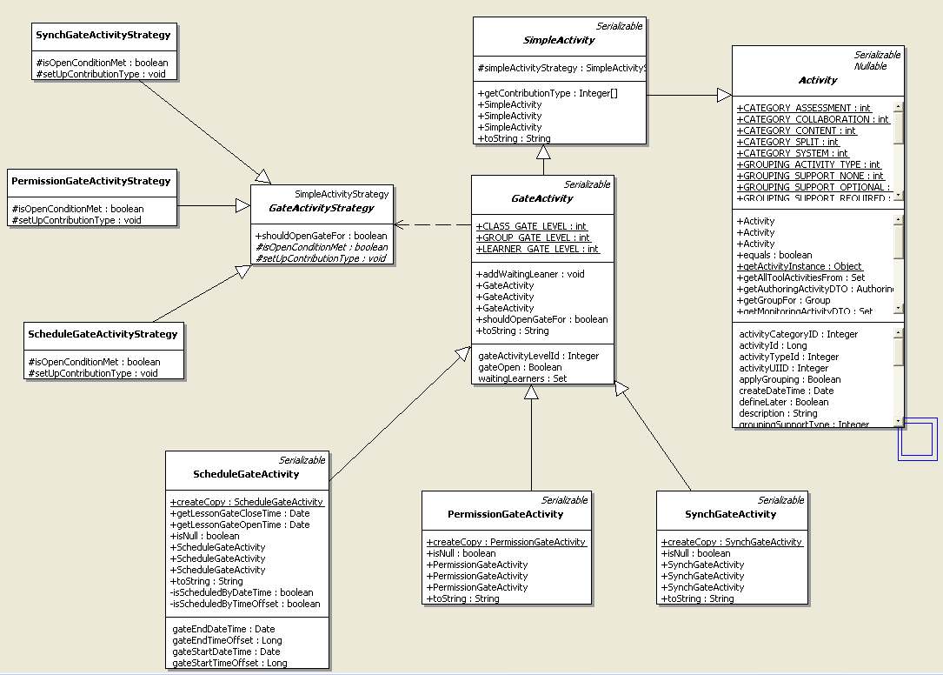
Figure 20 Gate Domain Object Diagram
Gate activity is part of entire activity hierarchy. It defines the data holder for different types of gates in LAMS 1.1 Strategy pattern has been applied here to check up the condition of opening gate in a polymorphic manner.
Why we mentioned that activity model lacks of runtime instance support in the previous section? If you have read Chris’ document, “LAMS 1.1 Tool Contract” [2], you should know that every tool activity will be associated with a set of tool sessions to hold its learning time data for different learner or different group. However, gate activity is LAMS system activity and there is no equivalent like tool session. In the current activity model, there is one and only one gate activity instance for a gate could exist in a lesson. This constraint makes it impossible for a teacher to set gate for individual group and learner.

Database design consideration
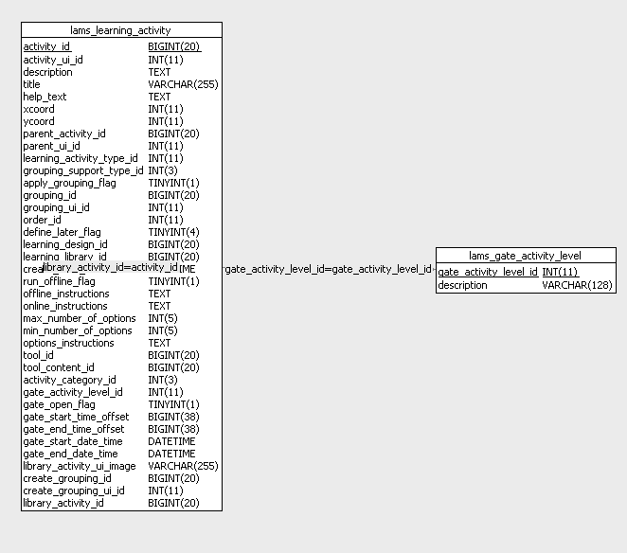
Figure 21 Gate database design
Gate activity is one child of activity. So it is mapped into activity table. The gate activity level is designed to cope with gate for individual learner, group or an entire lesson class. Once we have proper activity model implemented, we can start to implement gate for different levels to make it more powerful.

Major algorithm explanation
Most of the Permission Gate and Schedule Gate algorithms are quite simple and intuitive. The way we run system schedule is also explained in detail in section 2.5.3 . All relevant code are well documented and self explanative. In this section, we only want to go through the algorithm of sync gate implementation to make it clearer.

Open Sync Gate
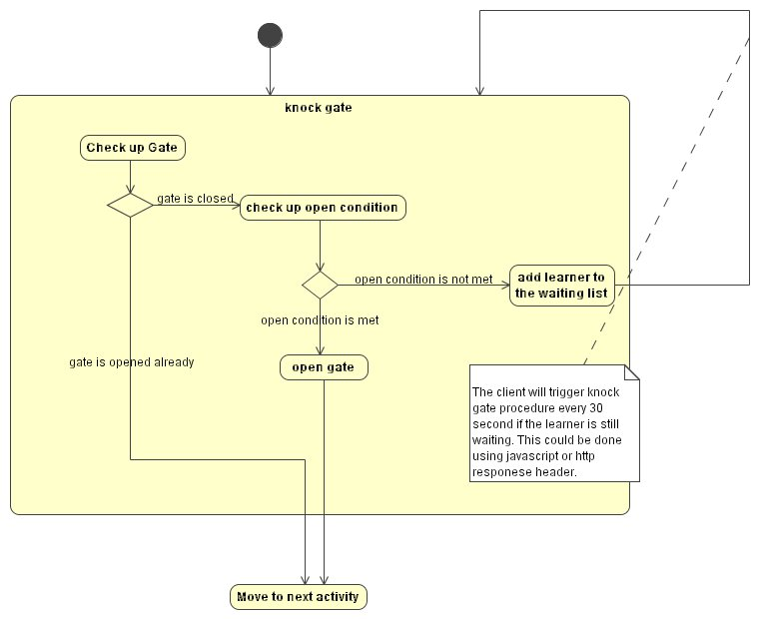
Figure 22 Open Synch Gate Activity Diagram
The knock gate procedure will firstly triggered by the completion of the activity before the gate activity in a learning design. As we have shown in the note, waiting learner will knock gate every 30 seconds. As far as I know, there are two ways to achieve this functionality. Personally, I would prefer the way of using http response header because it works across different browsers and we don’t need to worry about scripting blocking program installed on the client machine.

Reference
- Jean-Philippe Brianchon, “ANTI_POLLING”, lamscvs/lams_documents/lams1.0/ANTI_POLLING.doc
- Chris Perfect, “LAMS 1.1 Tool Contract”, lamscvs/lams_documents/LAMSToolContract.doc

