
IMS Content Package Reader Tool Design Report

Draft Version 1.0
Author: Fiona Malikoff
LAMS INTERNATIONAL
25/02/2005

Contents
1 Introduction 3
1.1 Scope 3
1.2 Constraints 3
1.3 References 3
2 Functional model 4
2.1 Use Cases 4
3 Content Object data model 8
3.1 Content Class Diagram 8
3.2 XML Library 8
4 Presentation Tier Design 9
4.1 Author Side Page Flow 9
4.2 Learner Side Page Flow 9
4.3 Monitor Side Page Flow 10
4.4 Struts Work Flow diagram 10
4.5 Screen Prototypes 10
4.5.1 Authoring: Author uploads a new content package. 10
4.5.2 Authoring: Author uses an existing content package. 12
4.5.3 Authoring: Author defers selecting the content package until runtime. 13
4.5.4 Learner 14
5 Business Model of IM Tool 15
5.1 Class Diagram 15
5.2 Implementation Details 16
5.2.1 Uploading An IMS Content Package 16
5.2.2 Runtime Functionality 16
6 Run time data model 18
6.1 Database schema 18
6.2 Data Definition 18
6.3 Hibernate Value Object Model 19
6.4 LAMS Tool Interface 1.1 20
7 IM Tool Sequence Diagram 23
8 Technology Options 23
8.1 IMS Content Package Interpretation: RELOAD 23

Figure 1 Content Package Object Model Diagram 8
Figure 2 Author Side Page Flow Diagram 9
Figure 3 IMS Content Package tool business class diagram 15
Figure 4 IMS Content Package tool Hibernate diagram 19

Revision History
Name | Date | Reason For Changes | Version
Fiona Malikoff | 25 FEB 2004 | Initial Draft | 1.0

Introduction

Scope
This document is design to illustrate the system design of an IMS Content Packaging reader tool, as well as functionality and technology choices that will be adopted for the development.
This tool will allow:
- an author to upload an existing package into the content repository and use the package in a learning design.
- a learner to access the content of the content package as part of a lesson.
Content packages will not be shared across sequences. Sharing of packages requires security to manage the package access, and should include support for searching the metadata for appropriate packages. This may be done in a future tool but it will not be implemented in the current content package tool.

Constraints
- The tool will support content packages built in accordance with versions 1.1.2 thru 1.1.4 IMS Content Packaging specification.
- The tool will not create content packages, aggregate or disaggregate existing content packages.
- The tool will only support the accessing of content. It will not support the searching of any of the metadata information from the package.

References
IMS Content Packaging Specification:
http://www.imsglobal.org/content/packaging/
RELOAD Project: http://www.reload.ac.uk/.
Source code available from http://sourceforge.net/projects/x4l-reload/
LAMS SRS: Software Requirements Specification for Learning Activity Management System (LAMS) 1.1

Functional model

Use Cases
Use Cases List
Primary Actor | Use Cases
Teacher | Create a learning design with a content package.
Teacher | Create a learning design deferring the content package selection until runtime.
Learner | Participate in a learning design containing content from a content package.

Use Case ID: | LAMS1.1_IMS0001
Use Case Name: | Create a learning design with a new content package.
Created By: | FionaMalikoff | Last Updated By:
Date Created: | 09/02/2005 | Date Last Updated:

Actors: | Teacher
Description:
Preconditions: | - Teacher is logged in, is in the authoring environment and is editing a learning design.
Postconditions:
Normal Flow: | - Teacher selects the IMS Content Packaging tool.  - Teacher selects the IMS content package that she wishes to use.  - The IMS content package is uploaded, expanded and stored.  - The learning design is saved with a link to the desired package content.
Alternative Flows: | - Teacher selects the IMS Content Packaging tool.  - Teacher selects the IMS content package that she wishes to use.  - The IMS content package is uploaded, expanded and stored.  - Teacher decides this was not the correct package and deletes the content package details.  - The learning design is saved without a link to the uploaded package content.
Exceptions:
Includes:
Priority:
Frequency of Use:
Business Rules:
Special Requirements:
Assumptions:
Notes and Issues: | The IMS Content Package could either be a zip file or an expanded package such as a package on a CD.  If the teacher uploads an IMS Content Package but realizes that it is not the correct package, the teacher should be able to delete the package immediately. Once the content is part of a saved learning design, it should not be removed. If we were to remove it, we need to determine if the content is “used” in any learning design and implementing this would probably tie the tool to closely to the learning design architecture. If it is possible to implement a delete than can be done anytime, it would be a nice feature.

Use Case ID: | LAMS1.1_IMS0002
Use Case Name: | Create a learning design deferring the content package selection until runtime.
Created By: | FionaMalikoff | Last Updated By:
Date Created: | 09/02/2005 | Date Last Updated:

Actors: | Teacher
Description:
Preconditions: | - Teacher is logged in, is in the authoring environment and is editing a learning design.
Postconditions:
Normal Flow: | - Teacher selects the IMS Content Packaging tool.  - Teacher indicates that she wishes use defer selection of the content package.  - The learning design is saved with out the contact package.
Alternative Flows:
Exceptions:
Includes:
Priority:
Frequency of Use:
Business Rules:
Special Requirements:
Assumptions:
Notes and Issues: | Note: Will need another use case for selecting the content package at runtime.

Use Case ID: | LAMS1.1_IMS0003
Use Case Name: | Participate in a learning design containing content from a content package.
Created By: | FionaMalikoff | Last Updated By:
Date Created: | 09/02/2005 | Date Last Updated:

Actors: | Learner
Description:
Preconditions: | - User is logged-in and in the Learner’s environment  - User is doing a sequence that contains the content package item.
Postconditions:
Normal Flow: | - User moves onto the content package activity while working through the sequence.  - The content is displayed in two parts (1) a hierarchical display structure gives the overall structure of the content from which the user can select and item and (2) a display area in which the currently selected item is displayed.  - The initial content (as defined by the package) is displayed.  - The learner can navigate through the content using the links I the hierarchical display or embedded in the content.  - When the learner has finished looking through the content, they can finish the activity via a GUI widget indicating finish.
Alternative Flows: | If the user exits LAMS without finishing the package, they would be returned to the package next time they enter the lesson. The content would start at the initial content as defined by the package – not the list item looked at by the learner.
Exceptions:
Includes:
Priority:
Frequency of Use:
Business Rules:
Special Requirements:
Assumptions:
Notes and Issues:

Presentation Tier Design

The user interface is implemented in JSP pages, using Struts and Tiles.

Author Side Page Flow
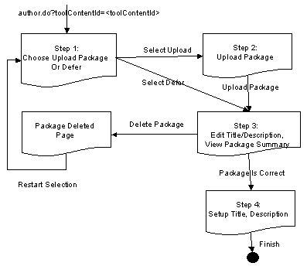
Figure 1 Author Side Page Flow Diagram

This pageflow supports the author either uploading a new content package at authoring, or creating the step in the sequence but not uploading the package until runtime. The author will be able to delete a freshly uploaded package, but she will not be able to delete a previously uploaded package that is assigned a content id.

Learner Side Page Flow
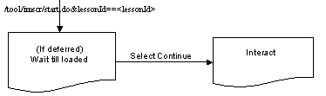
Figure 2 Learner Side Page Flow Diagram

The learner side page flow is primarily driven by the content itself.
If the author opted to defer the upload of the content package, then the learner will start on the “Wait till loaded” screen. The user may press “Continue” to start using the content (Interact), once the teacher has uploaded the package.
If the author uploaded the content at authoring time, or if they have already loaded it by the time the learner reaches the tool, the learner will go straight to the Interact screen.
The Interact screen will display (1) the hierarchy of the organization of the content and (2) the content of the initial item. The user may then navigate using the hierarchy or any internal links.
If the user selects another item in the hierarchy, then the content area will display the newly selected item.
If the currently displayed content has its own navigation links (e.g. flash movie buttons, url links) then the user may navigate to other items either within the content or to other resources such as publicly accessible websites.

Monitor Side Page Flow
To be done.

Struts Work Flow diagram
The following input paths are used to start particular sections of the tool:
Authoring: /tool/imscr/author.do?toolContentId=<toolContentId>
Monitoring: /tool/imscr/monitor.do?lessonId=<lessonId>
Learner: create session: /tool/imscr/start.do&lessonId==<lessonId>
complete session: /tool/imscr/finish.do&lessonId=<lessionId>
learner: /tool/imscr/????

Screen Prototypes

Authoring: Author uploads a content package.
Note: the prototypes are shown with the navigation hierarchy given as a complete list. This may be changed to a Javascript interactive tree when the screens are implemented.
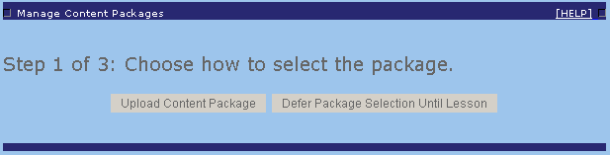

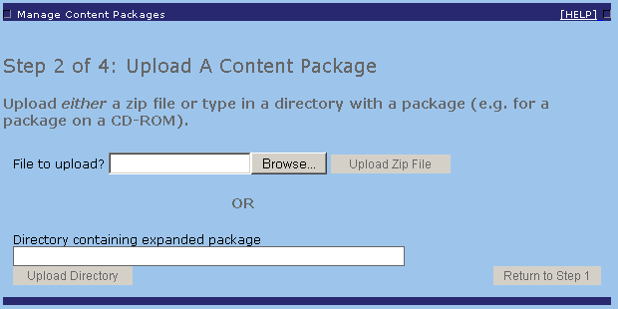
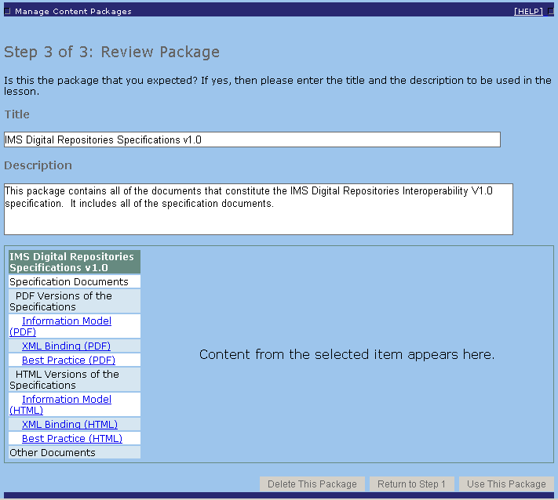

Authoring: Author defers selecting the content package until runtime.
If deferring the selection of the content package, then Step 1 is then same, step 2 is skipped and the author completes step 3.
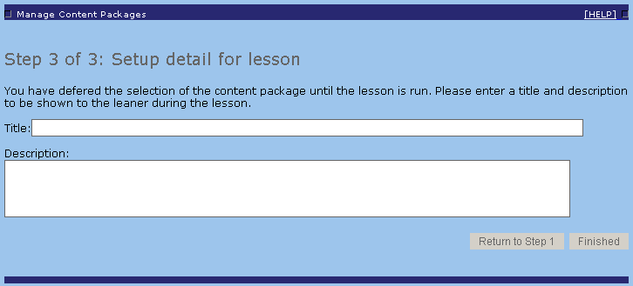

Learner]
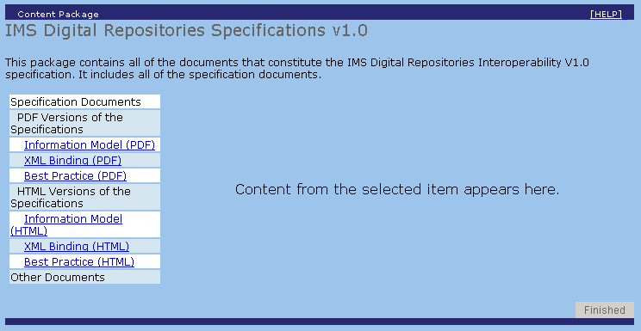

Business Model of IM Tool

Class Diagram
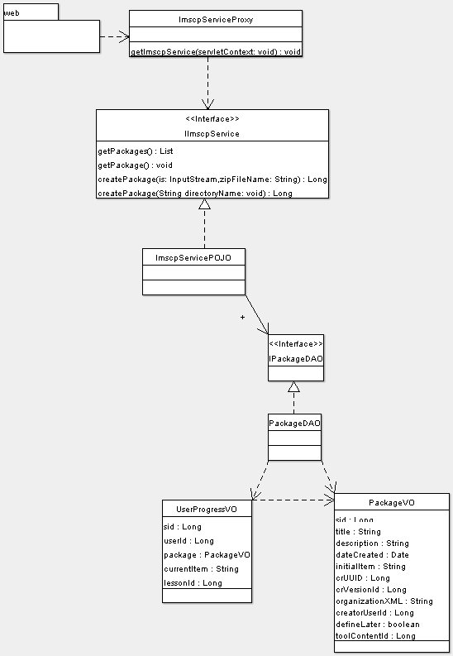
Figure 3 IMS Content Package tool business class diagram
This diagram gives us a picture of the business logic layer architecture of IMS content package tool. ImscpServiceProxy acts as an known location for the tool and all access to the tool should be via this manager. The proxy will select the implementation of the IImscpService service. This allows the selected implementation of the IImscpService to be changed without changes to the ActionForms or other calling code.
The IImscpService interface defines the functionality offered by the tool to the tool’s own screens. A separate interface for authoring and runtime calls will be created if required. All of the service interfaces will be implemented by ImscpServicePOJO, which is a singleton managed by the Spring framework.
IPackageDAO is the database service façade for the tool. It is used by business layer to achieve standard CRUD database operations for the Package object. The implementation is currently Hibernate
PackageVO and UserProgressVO are Hibernate objects. They are disconnected from the session automatically and used to return package details to the Struts Action classes and to JSP pages if required.

Implementation Details
The tool will be implemented using the Spring framework.
Storage of the content will be done using the Content Repository service. The Spring application context will need to be sorted out for this tool. Just reusing the Content Repository jar as it is at the moment will create two application contexts – one for the tool and one for the content repository. This may cause problems with transactions as the hibernate will be using two different sessions managers. This is to be explored further during implementation.

Uploading An IMS Content Package
When a package is uploaded the contents converted as follows.
- The resource files are stored as a package node in the content repository, with the default resource as the initial path.
- The title and description fields from the metadata (in the imsmanifest.xml file) are stored in the package object. All other metadata is ignored.
- The organization and resource entries from the imsmanifest.xml file are converted to a simpler XML format which is also stored in the package object (and hence into the database). The new format contains just enough information to list the entry points and to select the content.
Content Package can have titles and descriptions in different languages. As the teacher can override the title and description, the selection of the correct version is not crucial. Therefore, where more than one title/description exists, the first entry encoded for “en” or “en*
will be used.
The new XML is generated, rather than storing the imsmanifest.xml file itself as it allows quicker processing at runtime. The uploading and hence parsing of the full imsmanifest is done once and the simpler XML will be parsed many more times at runtime. It has the disadvantage of “losing” the extra information in the imsmanifest file so if a later version of the tool wants to access more information from a package, the package will have to be re-uploaded.
The organization/resource structure could also be stored in the database and passed to the presentation layer as a POJO. Storing it as XML reduces the number of rows required in the database and allows us flexibility to use XSLT or JSTL XML tags for converting the data to a hierarchy on-screen. The XML/separate rows in database is much of a muchness and could be switched in a future implementation.
Issues: Will the newly generated XML be too big to go in a blob field in the database? I assume not. If it is, we will need to go the separate rows or put it in a file and store it as a separate item in the content repository.
The interpretation of the imsmanifest.xml will be done using the schema processing code from the RELOAD project. In particular, the moonunit classes will be used. This will require the inclusion of the diva (uk.ac.reload.diva), jdom (uk.ac.reload.jdom and org.jdom), moonunit (uk.ac.reload.moonunit) and Castor (org.exolab.castor) packages. The licences for moonunit, jdom and Castor will need to be included in the tool package.

Runtime Functionality
At runtime, the learner will have a two part screen, with a navigation section on the left and the content on the right. The navigation will be built using the XML generated at upload time.
To access the content, a special servlet “download” will be used. This servlet takes the uuid and version id of the content package converted to a directory path, along the relative path of a file, to find the entries in the content repository. For example, file images/fred.jpg in the package node uuid=10, version 1 becomes the call:
/tools/imscr/download/10/1/images/fred.jpg
Issue: now that I have seen the IMS content package pathing, this may not be as simple as my little demo servlet. Will need to rethink the servlet once I have the resource side of the XML file sorted out. I may need to add an extra layer of pathing.

Run time data model

Database schema

Data Definition
imscp_package
FIELD | Type | Length | Description
sid | long | n/a | id (primary key)
tool_content_id | long | n/a | ToolContentId as supplied by the authoring call. This value is generated by the core LAMS system and will be used to access this package at runtime.
define_later | boolean | n/a | Should the content be assigned at runtime?
title | varchar | 255 | Title from the imsmanifest.xml file
description | text | n/a | Description from the imsmanifest.xml file
date_created | date | n/a | UTC Date/time that the package was uploaded into LAMS (mandatory)
creator_user_id | long | n/a | User id of the user who uploaded the package. (mandatory)
cr_uuid | long | n/a | UUID of the package as stored in the content repository (mandatory)
cr_version_id | long | n/a | version if of the package as stored in the content repository (mandatory)
initial_item | varchar | 255 | initial path for the package
organisationXML | text | n/a | XML defining the organizational structure for this package. Used to generate the hierarchical display of the content. (mandatory)

imscp_userprogress
FIELD | Type | Length | Description
sid | long | n/a | id (primary key)
learner_id | long | n/a | User id of a learner. (mandatory)
lesson_id | long | n/a | id of the lesson. (mandatory)
package_id | long | n/a | foreign key to the imscp_package. (mandatory)
current_item | varchar | 255 | The path of the last item selected

The combination of <user_id, lesson_id, package_id> must be unique. It denotes a single “usage” of a content package. Note: The same package may be used in multiple lessons. So, once this record is created, only the current_item will be updated.

Hibernate Value Object Model
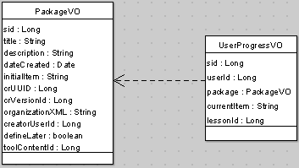
Figure 4 IMS Content Package tool Hibernate diagram

LAMS Tool Interface 1.1
This section is yet to be completed. It is here to be filled out as I work out what I need to do!
The namespace for the tool will be “imscp”.
The references to tables outside of the tool will be user ids for the uploader of the content and for tracking where learners currently are in the content, and uuid and version numbers required for accessing the content in the content repository.
The following sets out the compatibility of the tool with the interfaces.

Deployment interface

Initial configuration | Not sure about this yet.
Ear file | The deployment packages will be in the form of ear file The ear file will contain a web application, built using the Struts and Spring frameworks. The deployment package will include the necessary jar files for the RELOAD code.
Dynamic deployment | ?? Not sure yet – depends how we handle context, etc.
Multiple Tool versions residing with LAMS | Again, not sure what I need here yet.
DB tables | A script will create the two tables required for deployment. No initial values are required.
Authoring: Standard
Standard
Exports | Yet to work out what extras are required for content.
Flash Interface | /tool/imscr/author.do?toolContentId=<toolContentId>
New Tools | This tool will not be made up of other activities. It will be a basic activity.
Tools data exchange | This tool will not exchange data with other tools.
Image/Icon | The tool will provide an icon (how will this be done – url or during import).
Lesson Printout | What do we want here – do we really want to print out every item in the content? Do we just print the organization?
Preview Mode | The preview mode will show the author the split screen with the organization hierarchy and the content.
LAMS Xpress | Not sure what is needed here.
Doc/PDF | Not sure what is needed here.

Administrative
Basic Tool Information | The tool will provide information regarding the input, outputs, metadata, version, signature and licensing as an MBean.
Tool Configuration | There are no runtime configuration parameters.
Tool Statistics | Not sure if there are any meaningful statistics. Should the tool be recording start and stop times? Very little information is being kept on each user’s interaction with the content.
Tool Deployment | A Procedure for tool to be self installed will be supplied.
Export tool | No exporting of the tool will be supported.
Monitor
Learner Progress Monitor | The tool will provide a url, which links to a page displaying a list of learners and their most recently accessed item.
Contribute | There are not contributions from learners for this tool.  Should I include a dummy page or make this value blank?
Define in Monitor | The monitor teacher cannot defined any content during the activity.  (We could offer this if it is felt to be important – just more work to do).
Hide entries | There are not contributions from learners for this tool so there is nothing to hide.  Should I include a dummy page or make this value blank?
Statistics | What statistics would be useful.?
Monitor URL | To be determined.
Portfolio Export | There are not contributions from learners for this tool so there is nothing to export. The only information we have per user is the last entry that they looked at. Should we be keeping a list of all entries looked at, and would that be meaningful.
Archive/Delete | Tool will provide and interface to Archive, Delete, Portfolio and Print requests. There is very little to archive, something to delete and portfolio and print request meaning is yet to be decided.
Monitor mode (previously "check-up" mode"). | ????

Learner
Create Session | Instantiates an activity.  Triggered by Implements $TOOL_URL/start.do ?
Complete Session | Completes the instantiated activity.  The $TOOL_URL/finish.do will call a completeSession() method of the service interface of the Tool and returns ActionForward to $CONTROLLER_URL/do.next Action.  The do.next Action returns the proper JSP page for what to display next. ????? Surely next is the next tool?
Tool URL | URL where the tool is launched.  $TOOL_URL is the Tools web application URL, stored in the MBean of the Tool.
Data access interface | Interface to access data from an instantiated activity. What should this do?
Activity entry points | This activity only has one entry point.  The tool will keep track of the last item viewed, and the user will be returned to that item if the user resumes the tool.
Activity Tracking | There is little difference to the content display depending on whether the activity is "not attempted", "attempted", "completed". If it is not attempted, then there will not be a current item and the user will be taken to the initial item. If it has been attempted, then there will be a current item and the user will be taken to that item. If the action is completed, then the user will be returned to the last item reviewed.
Run Mode | The Learner interface is normally run as "run" mode.
Return to Completed Activities | Do we want to stop updating the current item when the learner has completed an activity? There isn’t any point stopping navigating around the content.
Lock when Finish option | Tool should implement this feature when isReusable=true. See previous point.
Define Later | Do we want to have the staff upload at runtime?
Double submission protection | All Form submission must implement the double-submission protection code.

IM Tool Sequence Diagram
TOBE DONE

Technology Options
TOBE DONE
The tool will be implemented using the Spring framework. The user interface is implemented in JSP pages, using Struts and Tiles.
Storage of the content will be done using the Content Repository service. The Spring application context will need to be sorted out for this tool. Just reusing the Content Repository jar as it is at the moment will create two application contexts – one for the tool and one for the content repository. This may cause problems with transactions as the hibernate will be using two different sessions managers. This is to be explored further during implementation.

IMS Content Package Interpretation: RELOAD
The interpretation of the imxmanifest.xml will be done using the schema processing code from the RELOAD project. In particular, the moonunit classes will be used. This will require the inclusion of the diva (uk.ac.reload.diva), jdom (uk.ac.reload.jdom and org.jdom), moonunit (uk.ac.reload.moonunit) and Castor (org.exolab.castor) packages. The licences for moonunit, jdom and Castor will need to be included in the tool package.

