Monitoring UI ToDOs.

Refer also to the UML Class diagram as references are made to Class Names
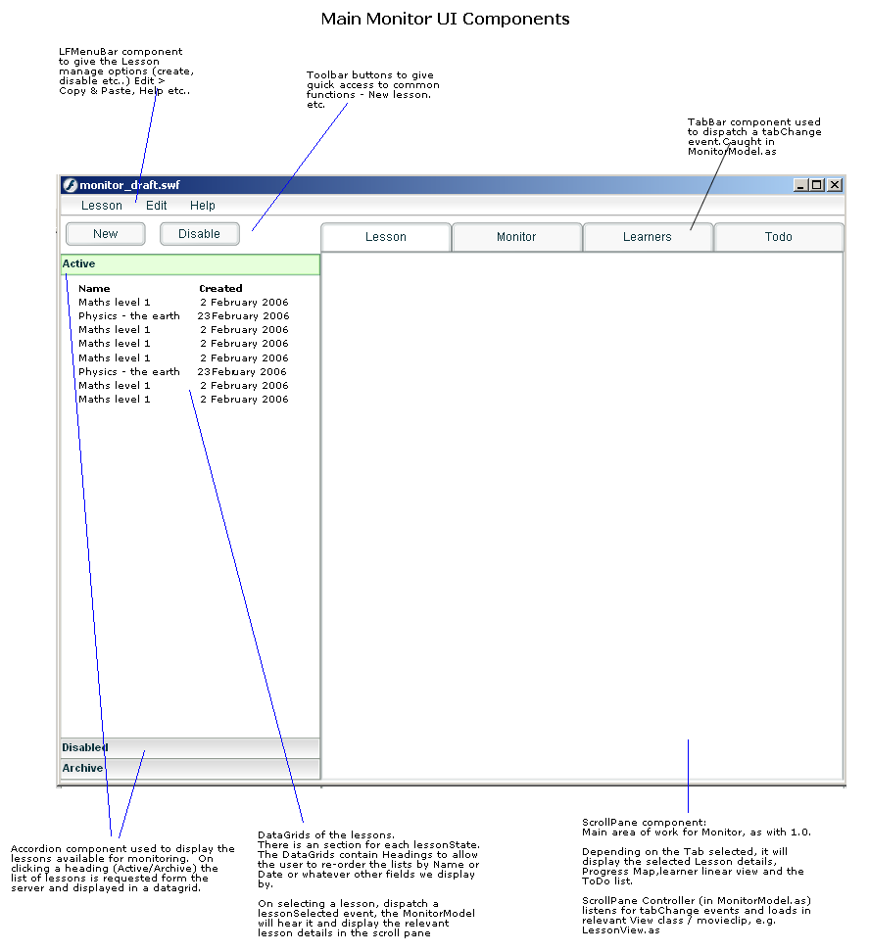
(monitor_layout.png)

Build Frame work
Build frame work of monitoring to re-use codebase as in authoring. May need some moving about of items from org.lamsfoundation.lams.authoring tp org.lamsfoundation.lams.common for easier re-use.

Simpler structure than authoring. Only one main MVC for whole app. Smaller components to have MVC structure build into single class.

See class diagram in UML for outline strucutre of classes

Application.as
Build a new Application.as for monitor. This class forms the core of the module, initialising the monitor app and loading in all the other classes and resources as needed. Depending on complexity, it may make sense to set up an inheritance chain.. So Application.as loads core services needed for all the modules (Learner, Monitor and Auth) such as Config, Cursors, Dictionary etc... and then it is extended to AuthorApplication.as, MonitorApplication.as

Manage lessons

List lessons
Left hand side consists of the LessonBrowser which shows list of Active and Archived lessons. Use Accordion component, with each section containing a datagrid of lessons.

Active Lessons
Maths 101 12-02-06 Runnning
Psych 10112-02-06 Runnning
Physics 20212-02-06 Disabled
Archive Lessons
Maths 101 12-02-06 Disabled
Psych 10112-02-06 Disabled
Physics 20212-02-06 Disabled

Each lesson in the datagrid should show
The datagrid list of lessons should include header rows an allow sorting by the headers – I.e. Name, Date Created, Status

Monitoring Tabs:

1) [ Lesson] - Shows lesson details, allows management of the selected lesson
When a lesson is selected in the list the details of that lesson should show in the this tab. This is similar to the [Session Info] tab in the LAMS 1.0. On selecting the lesson in the LessonBrowser, the LessonBrowserController will tell the LessonManager to request getLessonDetails from the server. The data in the return packet should be displayed by the LessonView

Key tasks/Use cases on this tab:

1) Create Lesson

** add info on server side calls from Fiona **

Step 1 - User clicks ‘New’ in tool bar or in MenuBar. (Note this may happen at anypoint, i.e. in any tab, with any lesson opened)

Step 2 – UI displays a dialog to select a lesson from the list of Valid Designs . We can re-use much of the code in Workspace.as to do this. Possibly via import, inheritance or copy/paste. User selects a design to use to create a lesson, the dialog returns this data to the MonitorController (See how the data is returned to CanvasController from Workspace dialog in Authoring using a DTO)

Step 3 – MonitorModel requests initialiseLesson passing the design ID, a lessonID is returned.

Step 4 – User assigns a class of learners and at least one staff/teacher to the lesson. User clicks [Select Lesson Class] button. .LessonManager will request a list of Organisations (in this case they are classes of users) available to the staff emember who is logged in using <<<??? WHAT is sever call >>>. The LessonClassDialog lists all these classes, the user selects the class to use, this data is returned to the LessonManagerController.

The selected class should be displayed in the LessonView. There should be [Change Class] and [Edit Class] buttons next to the class name Change class will repeat this step to re-set the class.

Step 5 (Optional) – [Edit class] will allow the to select a subset of users from this class, for example, if one or more pupils are off sick today.

editClass_btn.onClick() shows the SelectUsersDialog with all of the users in that class listed, they shold be listed according to role in that Organisation, i.e. Staff users, followed by Learner users. Each user should have a check box next to them, if the check box is unchecked they should be removed from the list.

The list is returned to LessonManager. The lesson manager requests <<<??? to set this new lesson class to the lesson.>>>

/*
LessonManager requests getUsersFromOrgByRole() first for the learners, then for the staff
*/

2) Start Lesson
The lesson can be started immediately, or by scheduling a date and time:
/monitoring.do?method=startLesson&lessonID=22 returns true or error message

Or later:

/monitoring.do?method=startOnScheduleLesson&lessonStartDate=24%2F01%2F2006+14%3A51%3A00&lessonID=12 returns true or error message

There should b a dateTime field on the [Lesson Tab] which shows the time the lesson is scheduled to start, if no time is set it should display ‘immediately’ To select a date, use the caledndar component, and then some NumericSteppers or Combo boxes to select the time.

3) Manage Lesson

When a lesson has been started there are various options available to a user:

Archive Lesson
Use case:
User clicks [Archive Lesson] button in the Lesson tab, MonitorModel requests archiveLesson().. If response is successful, update the status info in the Lesson tab and also refreshes the Lesson List

Suspend Lesson
Use case:
User clicks [Suspend Lesson] button in the Lesson tab, MonitorModel requests suspendLesson().. If response is successful, update the status info in the Lesson tab and also refreshes the Lesson List

Unsuspend Lesson
Use case:
User clicks [Suspend Lesson] button in the Lesson tab, MonitorModel requests unsuspendLesson().. If response is successful, update the status info in the Lesson tab and also refreshes the Lesson List

Remove Lesson\
Use Case:
User clicks [RemoveLesson] button in the Lesson tab, MonitorModel requests removeLesson().. If response is successful, update the status info in the Lesson tab and also refreshes the Lesson List

Finish on Schedule
It is possible to set a time when the lesson should end.
Use Case:
User clicks the [Set Finsh Time] button in the Lesson tab. MonitorModel requests finishOnScheduleLesson and passes the lessonFinishDate. If the request is successful, then update the LessonTab finish date field.

