LAMS 1.1 - Monitoring UI
Author: David Caygill
03-03-06
dave@lastfish.co.uk

Refer also to the UML Class diagram as references are made to Class Names and also to the Monitoring.doc for the server call details.

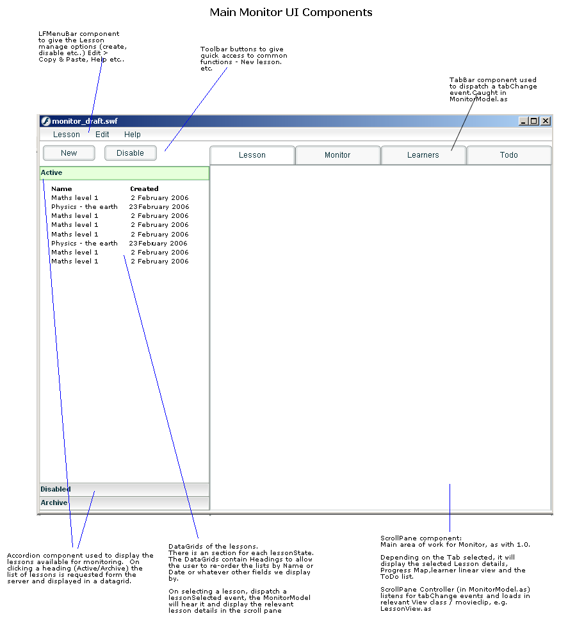
(monitor_layout.png)

Build Frame work
Build frame work of monitoring to re-use code base as in authoring. May need some moving about of items from org.lamsfoundation.lams.authoring to org.lamsfoundation.lams.common for easier re-use.

Simpler structure than authoring. Only one main MVC for whole app. Smaller components to have MVC structure build into single class.

See class diagram in UML for outline structure of classes

Application.as
Build a new Application.as for monitor. This class forms the core of the module, initialising the monitor app and loading in all the other classes and resources as needed. Depending on complexity, it may make sense to set up an inheritance chain.. So Application.as loads core services needed for all the modules (Learner, Monitor and Auth) such as Config, Cursors, Dictionary etc... and then it is extended to AuthorApplication.as, MonitorApplication.as

Manage lessons

List lessons
Left hand side consists of the LessonBrowser which shows list of Active and Archived lessons. Use Accordion component, with each section containing a datagrid of lessons.

Active Lessons
Maths 101 12-02-06 Runnning
Psych 10112-02-06 Runnning
Physics 20212-02-06 Disabled
Archive Lessons
Maths 101 12-02-06 Disabled
Psych 10112-02-06 Disabled
Physics 20212-02-06 Disabled

Each lesson in the datagrid should show
The datagrid list of lessons should include header rows an allow sorting by the headers – I.e. Name, Date Created, Status

Monitoring Tabs:

Tab 1 [ Lesson] - Shows lesson details, allows management of the selected lesson
When a lesson is selected in the list the details of that lesson should show in the this tab. This is similar to the [Session Info] tab in the LAMS 1.0. On selecting the lesson in the LessonBrowser, the LessonBrowserController will tell the LessonManager to request getLessonDetails from the server. The data in the return packet should be displayed by the LessonView

Key tasks/Use cases on this tab:

1) Create Lesson

** add info on server side calls from Fiona **

Step 1 - User clicks ‘New’ in tool bar or in MenuBar. (Note this may happen at any point, i.e. in any tab, with any lesson opened)

Step 2 – UI displays a dialog to select a lesson from the list of Valid Designs . We can re-use much of the code in Workspace.as to do this. Possibly via import, inheritance or copy/paste. User selects a design to use to create a lesson, the dialog returns this data to the MonitorController (See how the data is returned to CanvasController from Workspace dialog in Authoring using a DTO)

Step 3 – MonitorModel requests initialiseLesson passing the design ID, a lessonID is returned.

Step 4 – User assigns a class of learners and at least one staff/teacher to the lesson. User clicks [Select Lesson Class] button. .LessonManager will request a list of Organisations (in this case they are classes of users) available to the staff member who is logged in using <<< getOrganisationsForClass() >>>. The LessonClassDialog lists all these classes, the user selects the class to use, on selecting a class, the list of users in that class should be displayed – as in the current Monitor 1.0 interface. Then the class is selected by clicking [Done] and this data is returned to the LessonManagerController.

The selected class should be displayed in the LessonView. There should be [Change Class] and [Edit Class] buttons next to the class name Change class will repeat this step to re-set the class.

Step 5 (Optional) – [Edit class] will allow the to select a subset of users from this class, for example, if one or more pupils are off sick today.

editClass_btn.onClick() shows the SelectUsersDialog with all of the users in that class listed, they should be listed according to role in that Organisation, i.e. Staff users, followed by Learner users. Each user should have a check box next to them, if the check box is unchecked they should be removed from the list.

The list is returned to LessonManager. The lesson manager requests <<<??? to set this new lesson class to the lesson.>>>

After the design has been set, there should be a View Lesson Class button which requests a list of learners form the server using getLessonLearners

2) Start Lesson
The lesson can be started immediately, or by scheduling a date and time:
/monitoring.do?method=startLesson&lessonID=22 returns true or error message

Or later:

/monitoring.do?method=startOnScheduleLesson&lessonStartDate=24%2F01%2F2006+14%3A51%3A00&lessonID=12 returns true or error message

There should b a dateTime field on the [Lesson Tab] which shows the time the lesson is scheduled to start, if no time is set it should display ‘immediately’ To select a date, use the calendar component, and then some NumericSteppers or Combo boxes to select the time.

3) Manage Lesson

When a lesson has been started there are various options available to a user:

Archive Lesson
Use case:
User clicks [Archive Lesson] button in the Lesson tab, MonitorModel requests archiveLesson().. If response is successful, update the status info in the Lesson tab and also refreshes the Lesson List

Suspend Lesson
Use case:
User clicks [Suspend Lesson] button in the Lesson tab, MonitorModel requests suspendLesson().. If response is successful, update the status info in the Lesson tab and also refreshes the Lesson List

Unsuspend Lesson
Use case:
User clicks [Suspend Lesson] button in the Lesson tab, MonitorModel requests unsuspendLesson().. If response is successful, update the status info in the Lesson tab and also refreshes the Lesson List

Remove Lesson\
Use Case:
User clicks [RemoveLesson] button in the Lesson tab, MonitorModel requests removeLesson().. If response is successful, update the status info in the Lesson tab and also refreshes the Lesson List

Finish on Schedule
It is possible to set a time when the lesson should end.
Use Case:
User clicks the [Set Finish Time] button in the Lesson tab. MonitorModel requests finishOnScheduleLesson and passes the lessonFinishDate. If the request is successful, then update the LessonTab finish date field.

4) Display critical To-Do tasks.
On this LessonDetails there should be a list of the critical Todo tasks. I.e. all the tasks that will stop the lesson from progressing if they are not completed: Permission Gate, Chosen Grouping and Define Later activities will all stop the lesson completing. This list can either be build from the design, or from the getAllContributeTasks server call (the tasks with isRequired = true. Fiona is investigating now.

Tab 2 [ Monitor] – Shows Lesson Design and position of Learners as dots.
When a lesson is selected in the lesson browser, or the Monitor tab is selected the design should be displayed, and the learners positions in the design be displayed in each activity.

Get Design Details
The MonitorModel will check to see if we have a populated DesignDataModel in the instance of the Canvas for this design. If we don’t then the design must be requested from the server with getLearningDesignDetails(lessonID). The design should then be rendered to the Canvas view. You should be able to use all the same code from Canvas, CanvasModel, Canvas View and CanvasController. n You may wish to make a different view and controller (as in the UML diagram) to support the different tasks that Monitor has to perform.

Get the learner progress
Once the design is loaded, then we need to get the positions of the learners to draw the dots onto the activity.
Call getAllLearnerProgress(lessonID) to receive an array of Learner’s progress data. The data packet will contain the IDs of the activities the learners are in, the most important one at this stage is ‘current’, which is the ID of activity the learners is in right now.

The learner progress data should be stored in the MonitorModel and when set should dispatch a ‘LearnerProgressUpdate’ event so that all the views can update their display.

Viewing an Activity’s monitor screen from the tool
Use case:
User double clicks an activity to see the Tool’s monitor page. DesignController receives the Double click and MonitorModel will launch a pop up window using the toolActivity.monitorURL property. Similar to how authoring works now.

Viewing an Activities’ details in the property inspector
Use case:
The user clicks on an Activity in the canvas to view information. The Property Inspector will change its appearance based on the type of Activity clicked on. When an activity is clicked on,. we should refresh the getLearnerProgress data so that we are sure the most up to date info is being displayed in the Property Inspector. This may however have performance impacts (too much time waiting on hourglass cursor, or server side performance hit) so try it out, and if the Java guys complain, or it feels to clunky, then try a refresh button.

Tool Activity
For a tool activity a List Box should display the list of Learners currently in that activity using the data from the MonitorModel. Under the list, show a [View Learner] button. To the right show [Open Tool Monitor] and [Open Tool Content] buttons.

[View Learner] Will request getLearnerActivityURL from the server, this will return a URL specific for that Learner in that Activity at that time. When the URL returns from the Comms class, launch a browser pop up with the URL.

[Open Tool Monitor] Launch a pop up with the ToolActivity.monitorURL property. This should have been provided in the Design, and set in the DesignDataModel in the same way as authorURL in monitoring.

[Open Tool Contribute] Will be identical to Open Tool Monitor

Grouping Activity
Grouping activities should display the same kind of List Box of learners as Tool Activity. No View Learner button will be required.

Depending on the type of gate this display will be different.

Chosen Grouping gate - display a [Choose Groups] button. On clicking launch a LFWindow with a 2 step wizard to select the users for the groups.

Step one – User enters the number of groups to create.
Step two – Show a list of all the Learners in this lesson (should be in MonitorModel, if not, request getLessonLearners from the server.) Next to each learners show a column of radio buttons for each group. At the heading of each column show the group name in an Editable text box. Default names would be Group 1, Group 2 etc...

Step 3 – Users clicks Done once all the users have been assigned to groups. Monitor Model calls performChosenGrouping and passes the list of user IDs for each group and group names.

Step 4 – Return to Property Inspector and display a [Show Groups] button. If the user clicks Show Groups, the pop up the LFWindow dialog again and list all the users and the groups they are in. Under heading by group name. List each group alphabetically.

Random grouping will just display a [Show Groups] button

Gate Activity
Gate activities will also display the same kind of ListBox containing all the users currently in that activity.

Depending on the type of gate the display will change.

Permission Gate – show an icon indicating is the gate is closed or open.
Schedule Gate – show the time the gate will open.

For both gates - on the right, show [Check Status] and [Release Gate] buttons. Check Status will request checkGateStatus(actID,lessonID) from the server. The result will update the display, either the time to open of the closed/open icon depending on the gate type. Release Gate will call releaseGate(gateActivityID) to the server, if true is returned, change the status (time or closed/open icon) if the result is false, display an error.

Force Complete a user through an Activity
Use Case:
A user wants to hurry along a learner through one or more activities. The user can drag the learner icon (green dot) to another activity (in the future) and the learner will progress to that activity, ‘force completing’ all the activities encountered on the way.

The green dots should be draggable. When it is released, the DesignController should check for a hitTest with an Activity. If an activity is found then MonitorModel should request forceComplete(lessonID, learnerID, targetActivityID) to the server

When a successful result is returned, then clear the learner Progress data and refresh it to re-draw the positions of the learners. The learner that was force completed should now appear in the target activity.

Tab 3 [ Learner] – Shows a Learner Centric view of the Lesson.
Each learner is listed individually and their progress mapped in a line from left to right. this will be built using the data from DesignDataModel and getLearnerProgress info stored in the MonitorModel. The code library developed for this task will be re-used for the LearnerUI’s progress display

Use the icons in the LAMS 1.0 learner UI for Completed, Current and Not done activity status as they don’t rely on colour alone. It may help to look at the 1.0 code on how this is built, and the way it works. It is possible to click on the Activity and launch the learner’s screen. This is the same URL as the View Learner button in the Property Inspector in the Monitor tab.

At the start of each learners list there should be two buttons, [Export Portfolio] and [Show Journal] Both of these will launch a Popup browser window with a LAMS URL with the Learner ID appended. Ask Fiona for these URLs, most likely they will be hardcoded into the UI.

Export Portfolio will produce a .zip archive of HTML files that show the learners work in that sequence.

View Journal will produce a web page with all the Notepad/Journal entries for that learner for that lesson.

Tab 4 [ Todo] – Shows a list of all the tasks the teacher has to perform for the lesson.
This is similar to the Contribute tab in LAMS 1.0

Clicking this tab, or selecting a lesson in the LessonBrowser with this selected will trigger a request to getAllContributeActivities(lessonID). The return packet will contain a list of Activity IDs and thier URLs. They will also have an isRequired=boolean field, this should be repersentedd on the UI, perhaps in Red for the important ones.

Each todo activity should be entered in the order they have to be done, probably in the order they appear in the design, next to each entry should be a [Do Now] button which launches the popup window in the case of Tool Activities, or go to the relevant dialog or screen for system ones such as Grouping, Permission gates etc..

Good luck :-)

