
AUTHORING Design Report

Version 1.8
Author: FIONA Malikoff
LAMS INTERNATIONAL
27 January 2006

Revision History
Name | Date | Reason For Changes | Version
Fiona Malikoff | 19 Aug 2005 | Replaces authoring notes document | 1.1
Fiona Malikoff | 14 Sept 2005 | Updated paths for lams_central move, and modified store paths for the new servlets | 1.2
Fiona Malikoff | 17 Nov 2005 | Clarified grouping | 1.3
Fiona Malikoff | 17 Jan 2006 | Added validation, client updates, meta-data and licenses, based on discussions with Ernie Ghiglione and Dave Caygill | 1.4
Mai Ling Truong | 24 Jan 2006 | Updated validation documentation | 1.5
Mai Ling Truong | 25 Jan 2006 | Updated the sample wddx packet for Store Learning Design | 1.6
Fiona Malikoff | 25 Jan 2006 | Updated license details based on actual implementation. | 1.7
Mai Ling Truong | 27 Jan 2006 | Included a sample configuration snippet for Client Updates. | 1.8

Contents

Introduction 4
Scope 4
Learning Design and Related Notes 5
Grouping Examples 9
Store Learning Design Servlet 12
Authoring Action: getToolContentID(Long toolID) 12
Learning Design Validation Rules 14
Client Updates 17
Metadata & Licenses 18
Authoring Action: getLicenses() 18

Introduction

Scope
The authoring module supports the Flash authoring client. It primarily stores and retrieves learning designs and activity libraries.
For the moment, it also supports the definition of styles. This functionality may move to the central area.
For detailed explanation on each of the following methods listed below please refer to lams_central\src\java\org\lamsfoundation\lams\authoring\service\ IAuthoringService.java

Learning Design and Related Notes

Here is a list of entities in authoring and their properties.
Please note that it may be that not of all of these need to be sent to the UI (i.e. flash via WDDX) indicated by [f]
Note on ID’s: In general there is an id (previously ‘id’) for flash and also an equivalent pk id (previously ‘sid’). Flash will always use the internal id except for the learning_design_id which will be sent to flash on the initial save. We should introduce a standard way of identifying the flash id, perhaps ****_ui_id? As sometimes it is ambiguous – E.G. grouping_id is a a pk, so I have named it grouping_ui_id
Key:
+ = property added
- = property removed
# = property altered
??? = property that doesn't exist right now but probably should
//<blah> = a comment or question by me
pk = primary key = db identifier
[f] = needed by flash
Learning Design
learning_design_id (integer, 20 figures, DB PK - supplied at save time) [f]
id (int, nullable - used by flash?) [d.c: shoulc not be needed anymore]
description (text, nullable) [f]
title (255 characters, nullable)[f]
first_activity_id (int, PK of first activity, nullable)
first_id(flash generated id to indicate which is first activity, as above but not pk version)[f]
max_id (int, nullable - used by flash) [f]
valid_design_flag( 1 = true or 0 = false - indicates if this LD can be run as a lesson)[f]
read_only_flag(1 = true or 0 = false) [f][d.c: depends on how workspace/folder stuff works out]
date_read_only (date time nullable) [f?]
user_id (int, pk of creating user) [f?]
help_text (text, nullable) [f]
lesson_copy_flag ( 1 = true, 0 = false - indicates if this LD is a copy created for a lesson) [d.c:should not appear to authoring, lesson/monitor only]
create_date_time (datetime) [f]
# version (56 characters, nullable) //changed to nullable [f?]
parent_learning_design_id (int, nullable: pk of parent LD - could be the LD this is a copy of, or the previous version of the LD) [f?]
- open_date_time (datetime, nullable - first datetime when learners can begin the LD) //in lesson now
- close_date_time (datetime, nullable - last datetime when learners can being LD) //in lesson now
duration (int, nullable: milleseconds indicating how long the LD should run for)
workspace_folder_id (int, pk of folder where this LD resides) //replace by a join table instead?
??? some more metadata fields (ernie?)[f??]
Transition
learning_transition_id (int pk supplied at save time)
id (int nullable, used by flash) [f]
description (text nullable) [f]
title (255 characters nullable)[f]
to_acitivity_id (int nullable, pk of the activity this transition leads to) //why is this nullable?
from_activity_id (int nullable, pk of the activity this transition leads to) //why is this nullable?
learning_design_id (int, pk of LD this transition belongs to)
create_date_time (datetime)
+ to_id (int nullable used by flash)[f]
+from_id (int nullalbe used by flash)[f]

Activity
activity_id (int pk supplied at save time)
id (int, nullable, used by flash) [f]
description (text, nullable) [f]
title (255 characters, nullable)[f]
xcoord (int, nullable) [f]
ycoord (int, nullable) [f]
parent_activity_id (pk of parent activity, nullable - this will be set if this activity is inside a complex
activity which will be the parent activity)
parent_id (int, nullable used by flash ti indicate parent relationship)[f]
learning_activity_type_id (int enumeration: values indicate type of activity:(1='TOOL', 2='GROUPING_RANDOM', 3= 'GROUPING_CHOSEN', 4= 'GATE_SYNCH', 5='GATE_SCHEDULE', 6='GATE_PERMISSION', 7='PARALLEL', 8='OPTIONS', 9='SEQUENCE') [f]
grouping_id (int nullable: the pk of the grouping to be applied to this activity)
grouping_ui_id(?new name? Need some consistent way to identify the flash generated id system)[f]
order_id (int nullable, activities within a complex activity use this field to show order) [f]
define_later_flag (1 = true, 0 = false, default false) //not currently used [f: will need some way of flagging this to flash if this is not used]
learning_design_id (int nullable ,pk of learning design this activity is part of, activity must have either this or the learning_design_id set) <<?chris should this be library?
learning_libary_id (int nullable, pk of learning library this is part of, see above) [f]
create_date_time (datetime)
offline_instructions (text, nullable, instructions for use offline) [f]
GroupingActivity
createGroupingID (int, pk of grouping to be created by this activity)
createGroupingUIID (int) [f]
PermissionGateActivity
as Activity plus
gate_activity_level_id (int enumeration: 1 = learner, 2 = group, 3 =
class) [f]
ScheduleGateActivity
as Activity plus
- gate_start_date_time (datetime nullable, either this, the next one
or both should be set) //removed: replace with gate_start_time_offset [f]
- gate_end_date_time (datetime nullable, see above) ///removed: replace with gate_end_time_offset[f]
gate_activity_level_id (int enumeration: 1 = learner,2 = group, 3 =
class) //leave as 1 right now [f]
- gate_start_time_offset (long int, nullable, number of milliseconds from start of lesson to open gate, either this or the following or both should be set)[f]
- gate_end_time_offset (long int, nullable, number of milliseconds from start of lesson to close gate, either this or the one above or both should be set)[f]
SynchGateActivity
as Activity plus
gate_activity_level_id (int enumeration: 1 = learner, 2 = group, 3 =
class) //only 2 and 3 make sense for this one [f]
ToolActivity
as Activity plus
tool_id (int, pk of tool this activity uses)
tool_content_id (int, key used to identify content to tool)
tool_ui_id[f]
tool_content_ui_id[f]
ComplexActivity
<complext activities include an ordered set of other activities - in the db this is indicated by parent_activity_id and order_id>
ParallelActivity
as ComplexActivity
SequenceActivity (not used in 1.1)
as ComplexActivity
OptionsActivity
as ComplexActivity plus
max_number_of_options (int 5 figures, default 0) [f]
max_number_of_options (int 5 figures, nullable) [f]
+ option instructions (text, nullable)[f]
Grouping
groupingID (integer pk supplied at save time)
groupingUIID [f]
groupingTypeId (int enum: 1 = RandomGrouping, 2 = ChosenGrouping [f]
+ id (int nullable used by flash)[f]
ChosenGrouping
as Grouping
RandomGrouping
as Grouping plus
numberOfGroups (int, number of groups to create, one of either
this one or the following) [f]
learnersPerGroup (int, number of learners in each created group,
see above) [f]
LearningLibrary //not needed right now by UI
[f:each library activity is contained within one LearningLibrary. Should this be represented in the flash WDDX??]
learning_library_id (integer pk)
description (text)
title (255 characters)
create_date_time (datetime)
[f: To be decided]
Workspace
workspace_id (integer pk supplied at save time)
root_folder_id (pk of root folder: should be created when workspace is created)
+ name field (255 characters)
WorkspaceFolder
workspace_folder_id (integer pk supplied at save time)
parent_folder_id (pk of parent folder, nullable)
name (64 characters)

Grouping Examples
The grouping is a bit hard to understand, so a couple of examples are given below to illustrate the structure.
Each grouping activity creates a grouping. An activity that is grouped is related to a grouping – and not to the grouping activity.
Example 1: Q&A activity done with a Random Grouping. This is would be like splitting a high school class into groups to answer the question. Initial data on client. The UIID fields are used to link the objects.
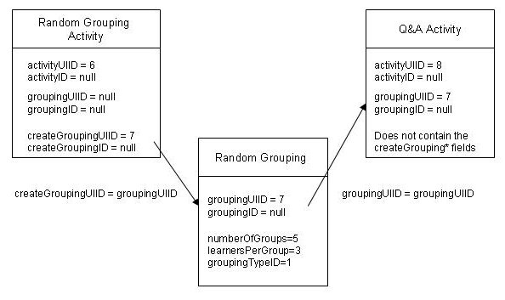
When the data is sent from the client to the server, only the grouping activities should include the createGroupingUIID, createGroupingID fields.
When the data is sent back from the server to the client, only the grouping activities should include the createGroupingUIID, createGroupingID fields. In the current example packet learning_design.xml, it shows all activities with the createGrouping* fields – this is not correct. While these fields exist in our flattened AuthoringActivityDTO, the fields should be null and hence should not be included in the wddx packet (null fields not sent from server to client).
The details required to make up the groups (numberOfGroups, leanersPerGroup) are in the grouping, not in the grouping activity. The grouping activities are in an array of their own – the groupings are not stored as part of the activity structure.
Example 2: Noticeboard, done with a Random Grouping. After saving onto server (which sets the ID fields).
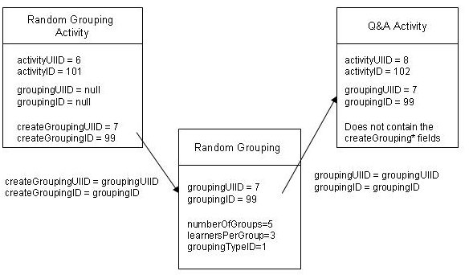
Example 3: Two levels of grouping. The entire lesson is split into groups using a chosen grouping, and then the chosen groups are further split using random grouping. The Q&A activity is done with the Random Grouping. This is would be like splitting an entire course (e.g. 600 people) into 6 streams, and then randomly grouping student from a stream into a tutorial size group. The diagram below shows the initial data on client. The UIID fields are used to link the objects.
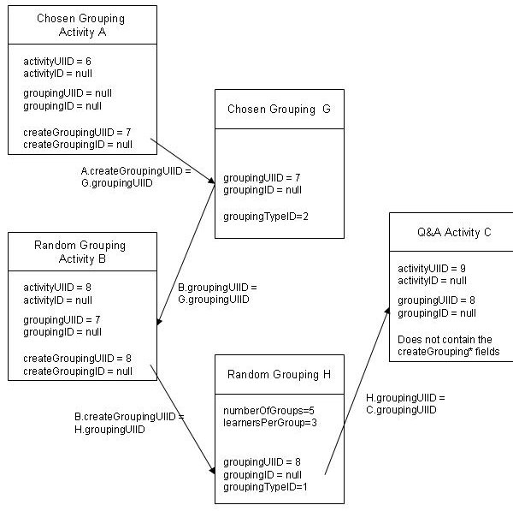

Store Learning Design Servlet
POST Body: Learning Design packet
URL: http://<server>/lams/authoring/ authoring/storeLD
Returns:
A WDDX packet containing the
design id Unique id for this design.
Sample Input Packet:
See storeLearningDesignDetails.xml for a sample packet.

Sample Output Packet:
<wddxPacket version='1.0'><header/><data>
<struct type='Lorg.lamsfoundation.lams.util.wddx.FlashMessage;'>
<var name='messageKey'><string>storeLearningDesignDetails</string></var>
<var name='messageType'><number>3.0</number></var>
<var name='messageValue'>
<struct type='Lorg.lamsfoundation.lams.authoring.dto.StoreLearningDesignResultsDTO;'>
<var name='learningDesignID'><number>22.0</number></var>
<var name='valid'><boolean value='true'/></var>
</struct></var></struct></data></wddxPacket>

Authoring Action: getToolContentID(Long toolID)
This method generates a new tool content id for an activity. It uses the ToolContentIDGenerator to get the next tool content id.
Parameters: toolID
URL: http://<server> /lams/authoring/author.do?method=getToolContentID&toolID=<value>
Returns:
A WDDX packet containing the
toolContentID the new tool content id required

Sample Output Packet:
<wddxPacket version='1.0'><header/><data>
<struct type='Lorg.lamsfoundation.lams.util.wddx.FlashMessage;'>
<var name='messageKey'><string>getToolContentID</string></var>
<var name='messageType'><number>3.0</number></var>
<var name='messageValue'><number>6.0</number></var></struct></data></wddxPacket>

Learning Design Validation Rules

All learning designs are to be validated, and only if they are valid will the “isValid” field be set. If a design is not valid, then it cannot be previewed.
The design may be checked on the server and on the client but for the moment it will primarily be checked on the server. When a design is saved, the server will validate the design and set the isValid field. The isValid value will be passed back to the client. If it is invalid then the “saved” message will indicate that the design is incomplete and it will have a button to expose a list of why the design it incomplete. If the user requests “why?” then the client will need to revalidate the design and display a list of problems.
Originally we were going to have the validation in two places, but it will probably be better just to have it on the server. Given that the client validation would only be done after the design has been saved, client validation doesn’t offer an “earlier” validation than the server validation and hence the normal advantage of client validation is eliminated.
So the server will also return any validation “messages” in the response packet. The “messages” will be a list of ValidationErrorDTO objects.
ValidationErrorDTO {
Long UIID;
String message;
}

The Rules and the values for the ValidationErrorDTO will be as follows. More messages can be added as more rules are determined.

Rule: Other (Used to cover any cases that are not covered by another code)
UUID: n/a
Message: Error text (in English) describing problem will be put into the message field

Rule: Each transition must have an activity before and after the transition
UUID: Transition that is missing a leading/trailing activity
Message: A Transition must have an activity before or after the transition

Rule: For any learning design that has more than one activity then each activity should have at least one input or one output transition.
UUID: The activity that is missing the transition
Message: An activity must have an input or output transition

Rule: Exactly one “top level” activity will have no input transition
Only check the activities directly in the design, do not check activities inside complex activities.
If more than one activity is missing the input transition, one ValidationErrorDTO will be created for each activity that has no input transition. One of these activities will legitimately not have an input transition but we can’t tell which one!

UUID: Activity which is missing the input transition.
Message: There is more than one activity with no input transition
If no activities are missing their input transitions (i.e. all activities have an input transition) then return a different code. Cannot determine which activity is at fault therefore no activity UI ID will be returned.
UUID: n/a
Message: No activities are missing their input transition.
Rule: Exactly one “top level” activity will have no output transition
Only check the activities directly in the design, do not check activities inside complex activities.
If more than one activity is missing the output transition, one ValidationErrorDTO will be created for each activity that has no output transition. One of these activities will legitimately not have an output transition but we can’t tell which one!
UUID: Activity which is missing the output transition.
Message: There is more than one activity with no output transition
If no activities are missing their output transitions (i.e. all activities have an output transition) then return a different code. Cannot determine which activity is at fault therefore no activity UI ID will be returned.
UUID: n/a
Message: No activities are missing their output transition.

The above three rules will ensure that the design is not circular.

Rule: If grouping is required (i.e. activity has GROUPING _SUPPORT_REQUIRED) then a grouping must have been applied to the activity.
UUID: Activity that has not been assigned a grouping.
Message: Grouping is required

Rule: If grouping is not supported required (i.e. activity has GROUPING_SUPPORT_NONE) then a grouping has not been applied to the activity.
UUID: Activity that has been erroneously assigned a grouping.
Message: Grouping is not supported

Rule: If a grouping is selected, then the grouping exists (this will be a server only check).
UUID: Activity that has a missing grouping.
Message: Grouping is selected but does not exist

Rule: An optional activity must contain one or more activities
UUID: Optional Activity that has no activities.
Message: An Optional Activity must have one or more activities

Rule: An optional activity must have valid order ids – the order ids should be sequential starting at 1 and must have no duplicates.
UUID: The Optional Activity with invalid order ids.
Message: This Optional Activity has invalid order ids

Client Updates

The following values will be used to trigger client updates (avoid problems with the browser caching client), dictionary updates and clear the local Flash cache.
The following values are stored in the configuration file:
- Authoring client version
- Monitor client version.
- Learner client version.
- Server Version Number
- The date that each dictionary was created.
- Server language – the language in use for this server
The versions are the overall LAMS version and a build number based on cvs (e.g 1.1 build 1.25)
When the client is started, the call (in the jsp) will be something like:
.swf?build=<client version #>&lang=<lang code>&date=<dictionary date for language>

Note: for Version 1.1 we will have one language per server. This is to make it easier for the Java development.

A sample extract of the configuration file representing the values stated above are:
<AuthoringClientVersion>1.0</AuthoringClientVersion>
<MonitorClientVersion>1.1</MonitorClientVersion>
<LearnerClientVersion>1.2</LearnerClientVersion>
<ServerVersionNumber>1.1</ServerVersionNumber>
<ServerLanguage>en_AU</ServerLanguage>
<DictionaryDates>
<Dictionary>
<language>en_AU</language>
<createDate>2006-01-02</createDate>
</Dictionary>
<Dictionary>
<language>en_US</language>
<createDate>2006-01-03</createDate>
</Dictionary>
</DictionaryDates>

Metadata & Licenses
The “Save As” dialog in the Flash client will be a tabbed dialog, with the second tab containing all the metadata for a design (including versions). The same dialog will be used for Saving and for editing the properties. The button will be either “Save” to save to the server or “Okay” to update the local copy depending on how the dialog box is triggered.
LAMS will have a fixed set of licenses and sites will not be able to update the license table – if they have their own then they need to go into the OTHER license. If sites put other entries in the table then compatibility with other systems and future versions is not supported.
Each version of a license from Creative Commons will be a separate license (i.e. another row in the database) so the “Names” of the licenses should contain the version numbers.
The license id, code and text will all be included in the import/export file. On importing, the license will be selected based on id and cross checked against the name. They do not match, then design will be marked with an “OTHER” license and the text from the import file used as the license text. The method License.isSameLicenseType() will do this check. For the purposes of importing/exporting, it may be used to set up a LicenseService. If this is done, then the getAvailableLicenses() call in AuthoringService should be moved to the new LicenseService.

Authoring Action: getLicenses()
Get all the available licenses
Parameters: None
URL: http://<server>/lams/authoring/author.do?method=getAvailableLicenses
Returns: WDDX Packet with a list of LicenseDTOs in the messageValue field.
Sample WDDX Packet: Note – currently we have 6 licenses, not 2. Only 2 shown for brevity.
<wddxPacket version='1.0'><header/><data>
<struct type='Lorg.lamsfoundation.lams.util.wddx.FlashMessage;'>
<var name='messageKey'><string>getAvailableLicenses</string></var>
<var name='messageType'><number>3.0</number></var><var name='messageValue'>
<array length='2'>
<struct type='Lorg.lamsfoundation.lams.learningdesign.dto.LicenseDTO;'>
<var name='code'><string>by-nc-sa</string></var>
<var name='defaultLicense'><boolean value='true'/></var>
<var name='licenseID'><number>1.0</number></var>
<var name='name'><string>Attribution-Noncommercial-ShareAlike 2.5</string></var>
<var name='pictureURL'><string>http://localhost:8080/lams//images/license/byncsa.jpg</string></var>
<var name='url'><string>http://creativecommons.org/licenses/by-nc-sa/2.5/</string></var>
</struct>
<struct type='Lorg.lamsfoundation.lams.learningdesign.dto.LicenseDTO;'>
<var name='code'><string>other</string></var>
<var name='defaultLicense'><boolean value='false'/></var>
<var name='licenseID'><number>2.0</number></var>
<var name='name'><string>Other Licensing Agreement</string></var>
<var name='pictureURL'><string></string></var>
<var name='url'><string></string></var>
</struct>
</array></var></struct></data></wddxPacket>

